

Microsoft Virtualization

with Windows Server 2012 & System Center 2012 SP1

Hands-On Lab | Step-by-Step Guide

For the VMs the following credentials:

* Username: **Contoso\Administrator**
* Password: **Passw0rd!**



1. Lab version: 1.1   
   Last updated: September 5, 2013

Please share any feedback with the IT Camps Planning Team: ITCampPlan@Microsoft.com

1. Copyright © 2013 by Microsoft Corporation. All rights reserved.

Contents

Lab Timing 4

**Lab 1: Host Configuration with Hyper-V** 5

Exercise 1.1: Configure Storage 5

Exercise 1.2: Configure Host NIC Teaming 14

**Lab 2: Virtual Machine Configuration with Hyper-V** 17

Exercise 2.1: Enable Remote Host Management 17

Exercise 2.2: Create a Virtual Machine 20

**Lab 3: Virtual Machine Settings with Hyper-V** 23

Exercise 3.1: Configure a Virtual Switch 23

Exercise 3.2: Configure a Virtual Machine 26

**Lab 4: Clustering & Resiliency with Hyper-V** 34

Exercise 4.1: Deploy a Failover Cluster 34

Exercise 4.2: Configure a Failover Cluster 42

Exercise 4.3: Create a Highly Available VM 47

Exercise 4.4: Implement Cluster-Aware Updating 54

**Lab 5: VM Mobility with Hyper-V** 63

Exercise 5.1: Configure VM Migration 63

Exercise 5.2: Test a Migration 65

**Lab 6: Backup & Replication with Hyper-V** 70

Exercise 6.1: Backup a VM 70

Exercise 6.2: Configure a Hyper-V Replica 75

Exercise 6.3: Configure a Hyper-V Replica Broker 77

Exercise 6.4: Replicate a VM 80

**Lab 7: Host Configuration with VMM** 85

Exercise 7.1: Add Hyper-V Hosts to VMM 85

Exercise 7.2: Configure Host Optimization 90

**Lab 8: Storage Configuration with VMM** 94

Exercise 8.1: Manage a File Server 94

Exercise 8.2: Integrate and Manage SANs 103

Exercise 8.3: Provision iSCSI Storage 107

**Lab 9: Network Configuration with VMM** 113

Exercise 9.1: Create Logical Networks 113

Exercise 9.2: Create Native Port Profiles 118

Exercise 9.3: Create Port Classifications 122

Exercise 9.4: Create a Logical Switch 123

Exercise 9.5: Apply a Logical Switch 127

**Lab 10: Network Virtualization with VMM** 133

Exercise 10.1: Create a VM Network 133

Exercise 10.2: Assign a VM Network 137

**Lab 11: Create VMs & Templates with VMM** 141

Exercise 11.1: Create a Virtual Machine 141

Exercise 11.2: Create a VM Template 150

Exercise 11.3: Explore a SQL Server Profile 160

Exercise 11.4: Explore a Web Application Profile 164

Exercise 11.5: Create a VM from a Template 166

**Lab 12: Create Service Templates with VMM** 172

Exercise 12.1: Create a Service Template 172

Exercise 12.2: Deploy a Service Template 179

**Lab 13: Create Roles & Clouds with VMM** 182

Exercise 13.1: Create User Roles 182

Exercise 13.2: Create a Cloud 187

Exercise 13.3: Delegate Access to a Cloud 191

Lab Timing

The following table shows the estimated time to complete each lab and task.

|  |  |
| --- | --- |
| Title | Length (mins) |
| LAB 1: HOST CONFIGURATION WITH HYPER-V | **20** |
| EXERCISE 1.1: CONFIGURE STORAGE | 15 |
| EXERCISE 1.2: CONFIGURE HOST NIC TEAMING | 5 |
| LAB 2: VIRTUAL MACHINE CONFIGURATION WITH HYPER-V | **10** |
| EXERCISE 2.1: ENABLE REMOTE HOST MANAGEMENT | 5 |
| EXERCISE 2.2: CREATE A VIRTUAL MACHINE | 5 |
| LAB 3: VIRTUAL MACHINE SETTINGS WITH HYPER-V | **15** |
| EXERCISE 3.1: CONFIGURE A VIRTUAL SWITCH | 10 |
| EXERCISE 3.2: CONFIGURE A VIRTUAL MACHINE | 5 |
| LAB 4: CLUSTERING & RESILIENCY WITH HYPER-V | **30** |
| EXERCISE 4.1: DEPLOY A FAILOVER CLUSTER | 10 |
| EXERCISE 4.2: CONFIGURE A FAILOVER CLUSTER | 5 |
| EXERCISE 4.3: CREATE A HIGHLY AVAILABLE VM | 5 |
| EXERCISE 4.4: IMPLEMENT CLUSTER-AWARE UPDATING | 10 |
| LAB 5: VIRTUAL MACHINE MOBILITY WITH HYPER-V | **15** |
| EXERCISE 5.1: CONFIGURE VM MIGRATION | 5 |
| EXERCISE 5.2: TEST A MIGRATION | 10 |
| LAB 6: BACKUP & REPLICATION WITH HYPER-V | **15** |
| EXERCISE 6.1: BACKUP A VM | 5 |
| EXERCISE 6.2: CONFIGURE A HYPER-V REPLICA | 3 |
| EXERCISE 6.3: CONFIGURE A HYPER-V REPLICA BROKER | 4 |
| EXERCISE 6.4: REPLICATE A VM | 3 |
| LAB 7: HOST CONFIGURATION WITH VMM | **15** |
| EXERCISE 7.1: ADD HYPER-V HOSTS TO VMM | 10 |
| EXERCISE 7.2: CONFIGURE HOST OPTIMIZATION | 5 |
| LAB 8: STORAGE CONFIGURATION WITH VMM | **20** |
| EXERCISE 8.1: MANAGE A FILE SERVER | 10 |
| EXERCISE 8.2: INTEGRATE AND MANAGE SANS | 5 |
| EXERCISE 8.3: PROVISION ISCSI STORAGE | 5 |
| LAB 9: NETWORK CONFIGURATION WITH VMM | **25** |
| EXERCISE 9.1: CREATE LOGICAL NETWORKS | 6 |
| EXERCISE 9.2: CREATE NATIVE PORT PROFILES | 5 |
| EXERCISE 9.3: CREATE PORT CLASSIFICATIONS | 2 |
| EXERCISE 9.4: CREATE A LOGICAL SWITCH | 5 |
| EXERCISE 9.5: APPLY A LOGICAL SWITCH | 7 |
| LAB 10: NETWORK VIRTUALIZATION WITH VMM | **15** |
| EXERCISE 10.1: CREATE A VM NETWORK | 8 |
| EXERCISE 10.2: ASSIGN A VM NETWORK | 7 |
| LAB 11: CREATE VMS & TEMPLATES WITH VMM | **30** |
| EXERCISE 11.1: CREATE A VIRTUAL MACHINE | 7 |
| EXERCISE 11.2: CREATE A VM TEMPLATE | 10 |
| EXERCISE 11.3: EXPLORE A SQL SERVER PROFILE | 5 |
| EXERCISE 11.4: EXPLORE A WEB APPLICATION PROFILE | 3 |
| EXERCISE 11.5: CREATE A VM FROM A TEMPLATE | 5 |
| LAB 12: CREATE SERVICE TEMPLATES WITH VMM | **15** |
| EXERCISE 12.1: CREATE A SERVICE TEMPLATE | 10 |
| EXERCISE 12.2: DEPLOY A SERVICE TEMPLATE | 5 |
| LAB 13: CREATE ROLES & CLOUDS WITH VMM | **15** |
| EXERCISE 13.1: CREATE USER ROLES | 4 |
| EXERCISE 13.2: CREATE A CLOUD | 5 |
| EXERCISE 13.3: DELEGATE ACCESS TO A CLOUD | 6 |
| Total Time | **240 (4 hrs)** |

**Lab 1: Host Configuration with Hyper-V**

Exercise 1.1: Configure Storage

**In this exercise, a Storage Pool and Storage Space will be configured. Within this Storage Space, a number of File Shares will be created that will be used to host virtual machines in later labs.**

**Estimated time to complete: 15 minutes**

 *Perform the following on* ***VMM01***

1. From VMM01 open Server Manager. This may take several moments to complete.

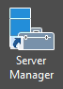

1. Once open, click **File and Storage Services** and once expanded, click **Storage Pools**.

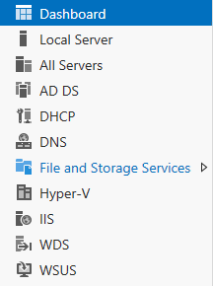 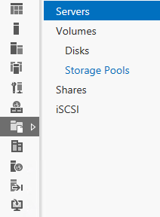

1. In the upper right hand side of the **Storage Pool** detail pane select **Tasks** | **New Storage Pool**.

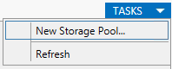

1. On the **New Storage Pool Wizard** start page click **Next**.
2. On the **Specify a storage pool name and sub system** page, type **POOL1** in the **Name** field and ensure **DC01** is selected, and then click **Next.**

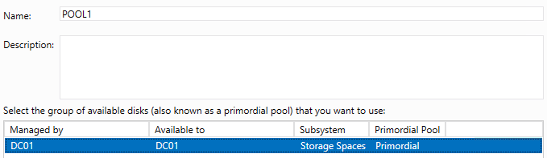

1. On the **Select physical disks for the storage pool** page, select all of the physical disks. For **PhysicalDisk4**, change the Allocation from **Automatic** to **Hot Spare** and then click **Next**.

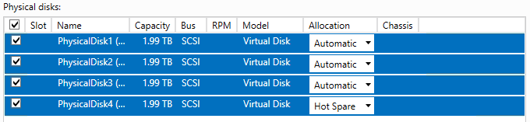

1. On the **Confirm selections** page, click **Create**.
2. In the **View results** page, click **Close**. Upon completion of the wizard, the **POOL1** Storage Pool will populate in the **Storage Pools** detail pane. Windows Server 2012 has aggregated the individual physical disks into a dynamic pool of capacity, which can grow or shrink on demand.

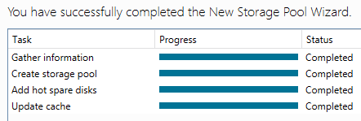

1. Select **POOL1** and note in the **Physical Disks** section that the total capacity of **POOL1** is made up of the 4 physical disks that were selected in the **Storage Pool** creation process.



1. At the Virtual Disk pane, select **Tasks** | **New Virtual Disk**.

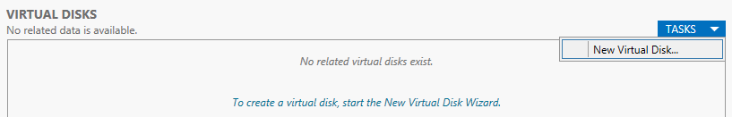

1. On the **New Virtual Disk Wizard** start page click **Next**.
2. On the **Select storage pool** page ensure that **POOL1** is selected and click **Next**.

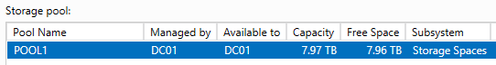

1. On the **Specify the virtual disk name** page, type **SPACE1** in the Name field and click **Next**.
2. On the **Select the storage layout** page, select **Mirror**. This will ensure than any data is duplicated across multiple physical disks for added resiliency. Other options include Simple and Parity. Click **Next**.

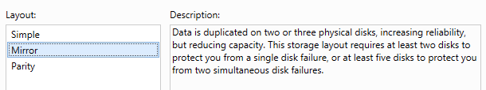

1. On the **Specify the provisioning type page**, ensure that **Fixed** is selected and click **Next**.

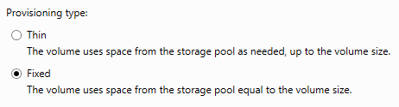

1. On the **Specify the size of the virtual dis**k page, select **Maximum size** and click **Next**.

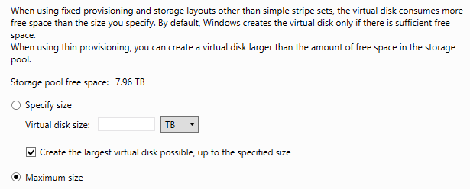

1. On the **Confirm selections** page, the settings should match below. Once checked, click **Create**.

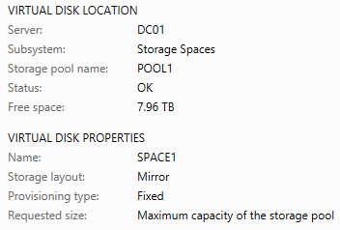

1. On the **View results** page, ensure that the **Create a volume when this wizard closes** check box is selected and click **Close**. The **New Volume Wizard** will launch automatically when closing the **New Virtual Disk Wizard** and this is expected.

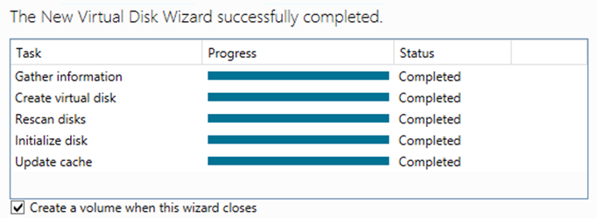

1. On the **New Volume Wizard** start page, click **Next**.
2. On the **Select server and disk** page, ensure that **DC01** is selected and click **Next**.

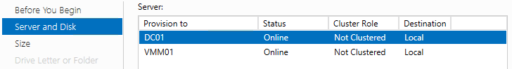

1. On the **Specify the size of the volume** page, review the volume size information, and click **Next**.
2. On the **Assign to a drive letter or folder** page, select **Drive Letter:** and choose the letter **V** from the drop down list, and then click **Next**.

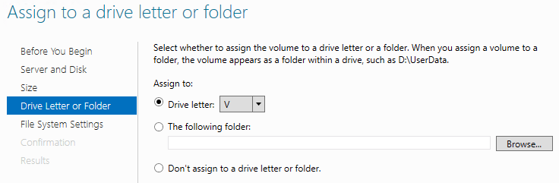

1. On the **Select file system settings** page, change the volume label to **VMs,** and click **Next**.

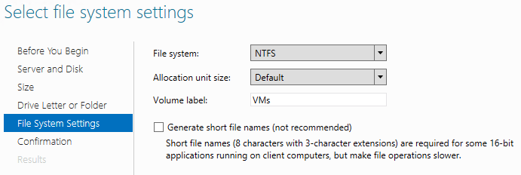

1. On the **Confirm selections** page, the settings should match those below. Once confirmed, click **Create**.

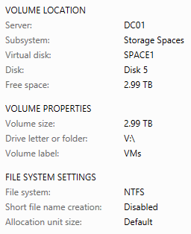

1. On the **Completion** page, click **Close**.
2. Within **Server Manager** on the dashboard pane select **File and Storage Services | Volumes.**

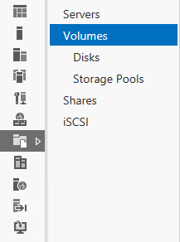

1. In the **Volumes** detail pane under VMM01 (2), observe the deduplication savings that have been realized with Windows Server 2012 deduplication for Volume E:. The contents of E: on VMM01 are VM templates, VHDs, WSUS Updates and other related files. VHDs (Virtual Machine virtual hard disks) can deduplicate significantly, however this is for offline VHDs.

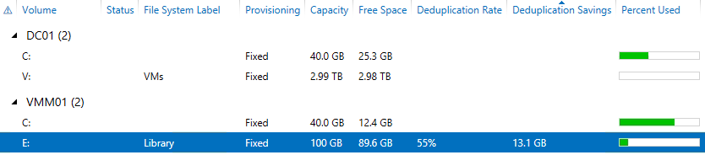

1. In the **Volumes** detail pane under **DC01 (2)** ensure that volume **V** with the files system labeled **VMs** is present.

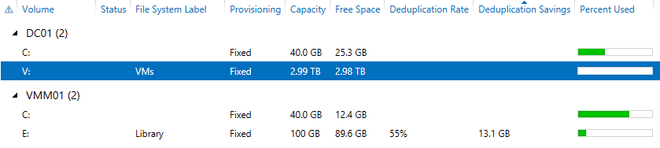

1. While remaining in **Server** **Manager**, select **Shares.**

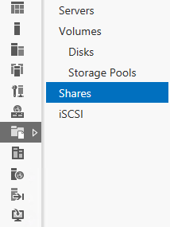

1. Select **Tasks** | **New** **Share** to launch the new Share Wizard.

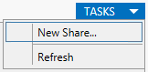

1. On the **Select the profile for this share** page, choose **SMB Share – Applications** and click **Next**.

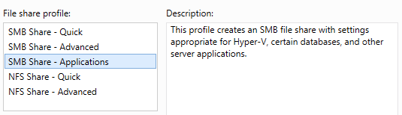

1. On the **Select** **the** **server** **path** **for** **this** **share** page, under **Server** ensure that **DC01** selected.

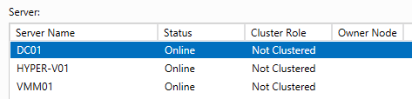

1. Under **Share** **location**, ensure **Select by** volume is selected, then choose Volume **V:** and click **Next**.

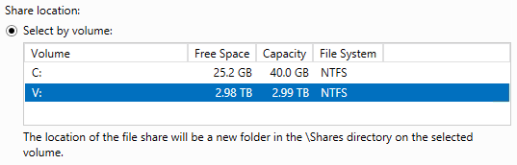

1. On the **Specify** **share** **name** page, type **VMShare1** in the **Share** **name** field, and click **Next**.

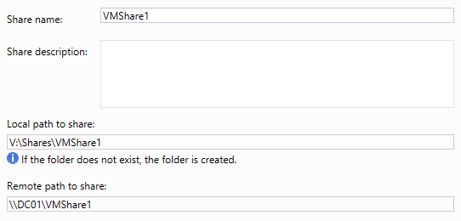

1. On the **Configure share settings** page, click **Next**.
2. On the **Specify permissions to control access** page, click **Next.**
3. On the **Confirm** **selections** page, ensure the settings match the screenshot below, then click **Create**.

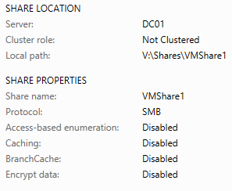

1. Once the Create Share wizard has completed, click **Close**.
2. **Minimize Server Manager**.
3. Select **File Explorer** from the Task bar.

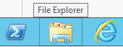

1. Navigate to **Libraries**, **Documents**, then right-click **CreateShares** and click **Edit**. This will launch the new PowerShell ISE. This may take a few moments to open. This script will update the NTFS and Share permissions for the Hyper-V hosts to access VMShare1, and then create VMShare2 and VMShare3 with matching permissions.

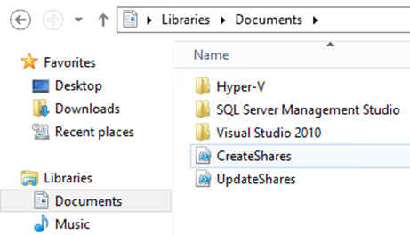

1. Click inside the **CreateShares.ps1** then click the **Run Script** button (Green Arrow).

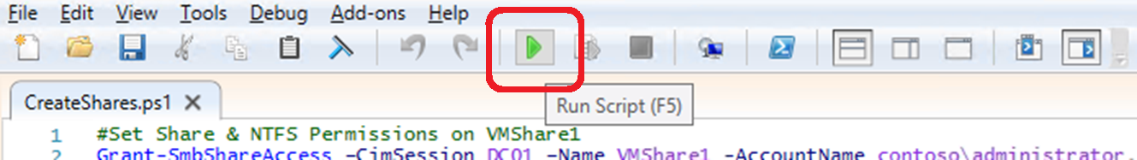

1. The script will take a few seconds to run, but once complete, **scroll** through and observe the output in the **PowerShell ISE Window**. Do not exit the window until the process has completed. This is ready when the PowerShell prompt can process a new command: **PS C:\Users\administrator.CONTOSO\Documents>**
2. Close the **PowerShell ISE**, and then close **Windows** **File** **Explorer**.
3. Re-Open **Server** **Manager** | **File and Storage Services** | **Shares**, to observe the new shares. If the shares are not visible, click **Tasks** then **Refresh**.

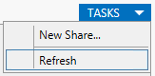

1. The new File Shares should now be visible. If they are not, click **Refresh** again.

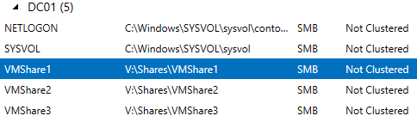

1. **Right-Click VMShare1** and click **Properties**.

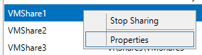

1. Select **Permissions** from the left hand column.
2. Observe the NTFS Permissions that were set as part of the PowerShell script that was executed earlier. The script was significantly faster than adding each account/computer manually.

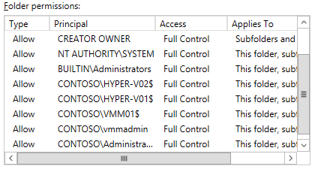

1. Click **Cancel.**
2. Minimize **Server Manager.**

Exercise 1.2: Configure Host NIC Teaming

**This lab will configure NIC Teaming on a Hyper-V host. NIC Teaming can be used to aggregate up to 32 network adaptors, enabling greater levels of resiliency and throughput.**

**Estimated time to complete: 5 minutes**

 *Perform the following on* ***VMM01***

1. From **VMM01** open **Server Manager.**



1. From the left hand navigation, select **All Servers.**

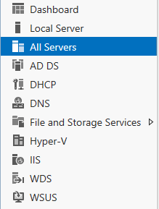

1. Right-click **All Servers** and select **Add Servers.**
2. In the Add Servers wizard, click **Find Now.**

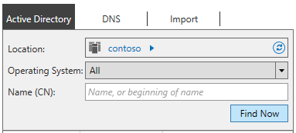

1. Select **HYPER-V02** and clickthe **right arrow**, then click **OK.**

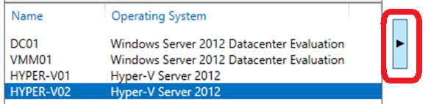

1. It will take a few moments to add HYPER-V02, but once complete (when the list of IP addresses appears next to HYPER-V02), in **Server Manager | All Servers**, right-click **HYPER-V02** and click **Configure NIC Teaming** to launch the NIC Teaming work pane.

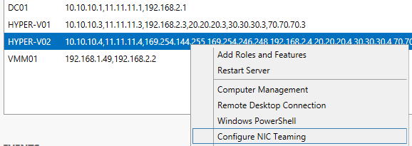

1. Within the **Teams** pane, select **Tasks**, then **New Team.**

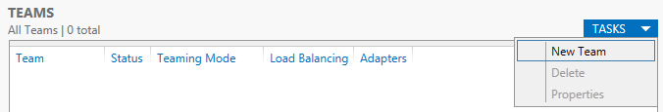

1. On the **Teams** detail pane, click **Tasks** and select **New Team**.
2. Name the team **VMTEAM1** and select **VMNIC1** and **VMNIC2** as the two NICs that will comprise this team.

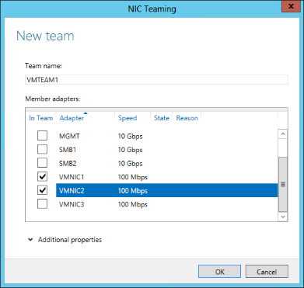

1. Click **Additional properties** and select the dropdown menu for Standby adapter to observe the options but leave the selection on **None (all adapters active)** and select **OK**. This may take a few moments to complete. Not all of the NIC teaming options are available as the Hyper-V Hosts are themselves virtualized.

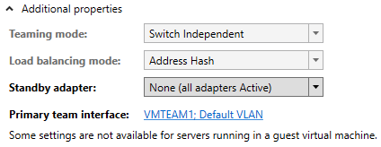

1. Select **VMTEAM1** in the **Teams** Detail Pane and observe that **VMNIC1** and **VMNIC2** appear in the **Adapters** **and** **Interfaces** detail pane under the **Network** **Adapters** tab.

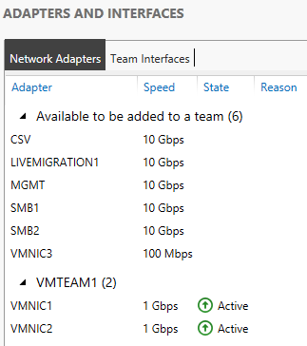

1. Close the **NIC Teaming** window and minimize **Server Manager**.

------------------------------------------------------------END OF LAB 1------------------------------------------------------------

**Lab 2: Virtual Machine Configuration with Hyper-V**

Exercise 2.1: Enable Remote Host Management

**In this exercise, VMM01 will be configured to remotely manage two Hyper-V hosts, and then remote SMB storage settings will be assigned.**

**Estimated time to complete: 5 minutes**

 *Perform the following on* ***VMM01***

1. From **VMM01** open **Hyper-V Manager.**

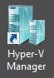

1. Right-click **Hyper-V Manager** in the navigation pane, and click **Connect to Server**.

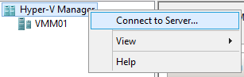

1. In the **Select Computer** dialog, type **HYPER-V01** in the **Another Computer** field, and click **OK**.

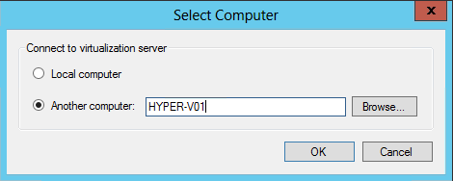

1. Repeat this process, and add **HYPER-V02.**
2. In **Hyper-V Manager**, select **HYPER-V01** in the left navigation pane.

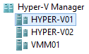

1. In the **Actions** pane, in the top right of the screen, click **Hyper-V Settings**.

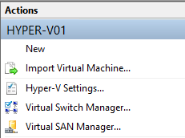

1. In the Hyper-V Settings for **HYPER-V01**, select **Virtual Hard Disks** in the Server workspace pane, and select **Browse**.

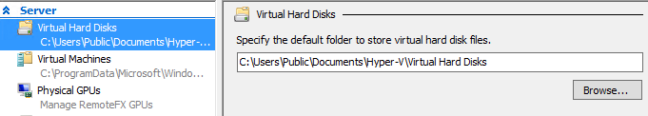

1. At the **Select Folder** dialog, type **\\dc01.contoso.com**, and press **Enter** to populate the details pane.

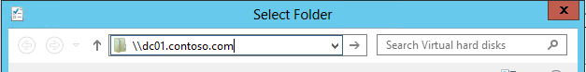

1. Select **VMShare1** from the details pane, and click **Select Folder**.

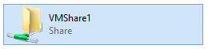

1. Back at the Hyper-V Settings for HYPER-V01, under Virtual Hard Disks, select the text **\\dc01.contoso.com\VMShare1** in the Specify the default folder to store virtual hard disks.

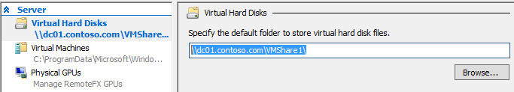

1. Copy the text **\\dc01.contoso.com\VMShare1** for use in the next several steps.
2. In the **Hyper-V Settings** for **HYPER-V01**, select **Virtual Machines** in the Server workspace pane.

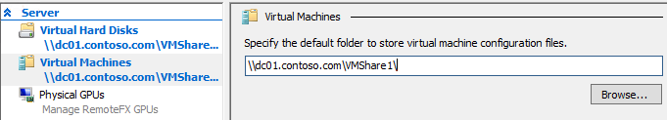

1. Paste the text **\\dc01.contoso.com\VMShare1** in the **Specify the default folder to store virtual machine configuration files** field.
2. In the Hyper-V Settings for **HYPER-V01**, click **Apply**, and then click **OK**.

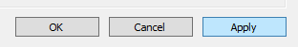

1. Repeat Steps 6 through 14 for HYPER-V02.

Exercise 2.2: Create a Virtual Machine

**In this exercise, a virtual machine will be created using Hyper-V, with the VM’s storage placed on the file share that was configured earlier.**

**Estimated time to complete: 5 minutes**

 *Perform the following on* ***VMM01***

1. From **VMM01** open **Hyper-V Manager**.



1. Select **HYPER-V02** from the navigation pane and in the **Actions** pane, select **New** | **Virtual Machine.**

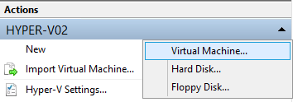

1. On the **New Virtual Machine Wizard** start page, click **Next**.
2. On the **Specify Name and Location** page, type **VM01** in the **Name** field and then click **Next**.

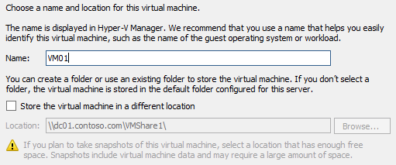

1. On the **Assign Memory** page, type **128** in the **Startup memory** field. Leave the **Use Dynamic Memory for this virtual machine blank,** and click **Next**.

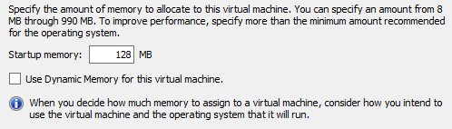

1. On the **Configure Networking** page, click the drop-down menu for **Connection** and note that no connections are currently available. Click **Next.**

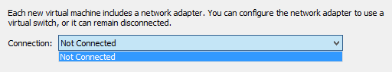

1. On the **Connect Virtual Hard Disk** page, verify that **Create a virtual hard disk** is selected, type **5** in the **Size** field, and click **Next**.

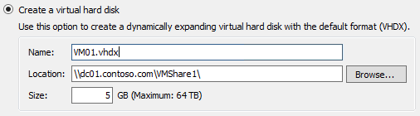

1. On the **Installation Options** page, verify that **Install an operating system later** is selected, and click **Next**.

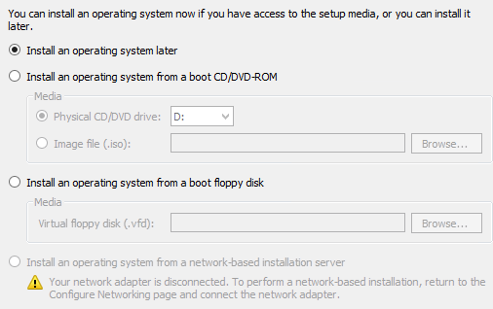

1. On the **Completing the New Virtual Machine Wizard** page, verify the settings match those below, and then click **Finish**.

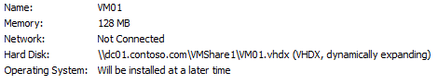

------------------------------------------------------------END OF LAB 2------------------------------------------------------------

**Lab 3: Virtual Machine Settings with Hyper-V**

Exercise 3.1: Configure a Virtual Switch

**In this exercise, a Hyper-V External Network Switch will be configured, which will allow virtual machines to communicate with each other, and the rest of the network. Next some of the different network configuration options will be reviewed.**

**Estimated time to complete: 10 minutes**

 *Perform the following on* ***VMM01***

1. Open VMM01 then open Hyper-V Manager.



1. Select **HYPER-V02** and then in the actions pane, click **Virtual Switch Manager**.

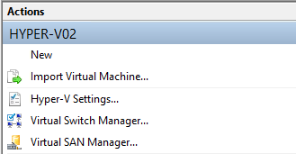

1. Highlight **External** and then select **Create Virtual Switch**.

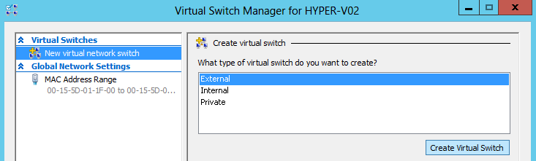

1. Enter **vSwitch1 (Important: this is case sensitive so enter it exactly as show)** in the name box, and in the dropdown menu under **Eternal network** choose **Microsoft Network Adapter Multiplexor Driver.** Thisis VMTEAM1, which was created earlier.

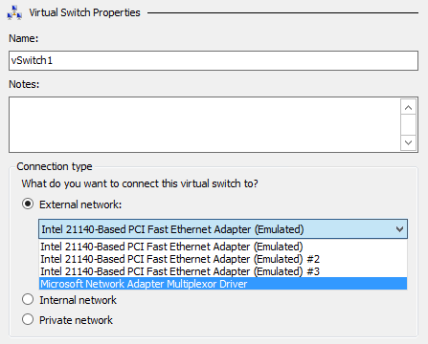

1. Uncheck the **Allow management operating system to share this network adapter** box.

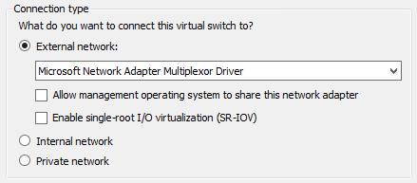

1. Click **Apply**, and then click **Yes** on the warning pop up.

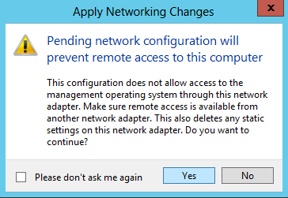

1. Once the settings have been applied, click the **[+]** next to **vSwitch1** to view the vSwitch extensions, and click on **Extensions**. There are currently 2 extensions installed by default, with 1 enabled. Other Microsoft and Partner extensions, such as those from Cisco (Nexus 1000v), 5nine (Security Manager), InMon (sFlow) and NEC (PF1000), would appear in this list and can be enabled/disabled as required.

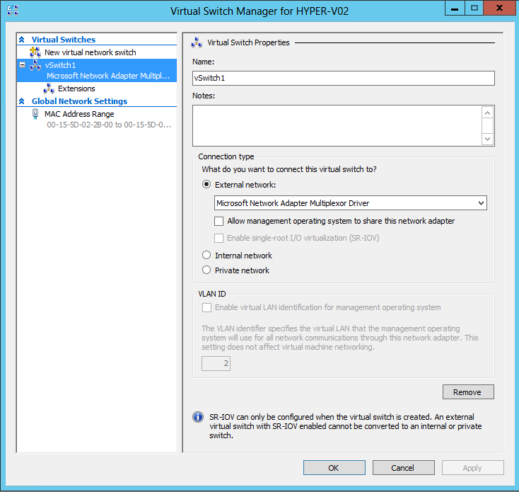

1. Click **OK** to close the **Hyper-V Settings** window. The vSwitch1 has already been created on HYPER-V01, so there is no requirement to repeat the process for that host In this exercise.

Exercise 3.2: Configure a Virtual Machine

**In this exercise, the VM that was created earlier will be configured, including adding an additional hard drive and attaching the network adaptor to the new vSwitch. Some additional configuration options will be explored.**

**Estimated time to complete: 5 minutes**

 *Perform the following on* ***VMM01***

1. Open **VMM01** then open **Hyper-V Manager.**



1. Select **HYPER-V02**, right-click **VM01** in the **Virtual Machines** pane and select **Settings**.

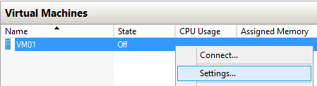

1. Review the **Add Hardware** page. Notice that Hyper-V supports adding additional Virtual SCSI controllers which allows more storage to be added to the VM. Additional network adaptors can also be added, along with Virtual Fibre Channel adaptors to connect the VM directly to a Fibre Channel storage array. Finally a RemoteFX 3D Video Adaptor can be added. In VDI scenarios the RemoteFX Adpater connects the virtual machine directly to a GPU(s) installed in the Hyper-V host, for advanced graphic rendering capabilities inside the VM.

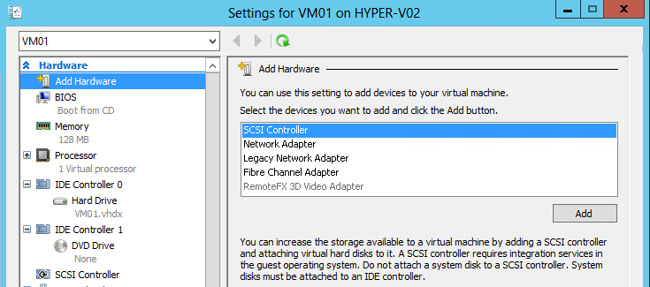

1. Click **BIOS** and review the options available to change the boot order of the VM.

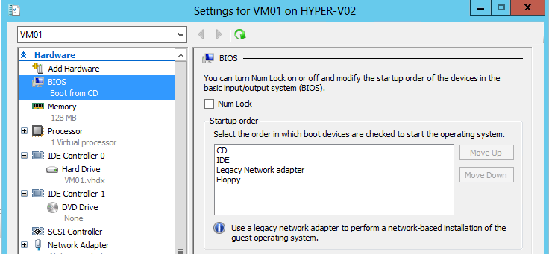

1. Under **Memory,** check the box next to **Enable Dynamic Memory** and set the **Minimum RAM** to **64 MB** and the **Maximum RAM** to **192 MB**. This means that the VM will start with 128 MB, but if the VM is idle, or demand is low, Hyper-V will reclaim the spare memory, down to a minimum of 64 MB. In times of need, Hyper-V can give the VM additional memory, up to 192 MB.

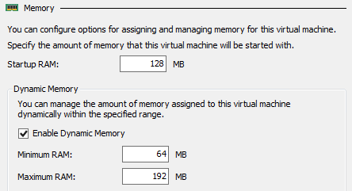

1. Change the Memory Weight to **Low** to configure the memory priority for this virtual machine.

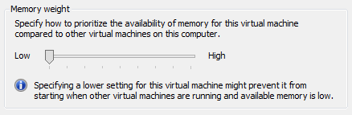

1. **Review** the configuration options for the **Processor**.

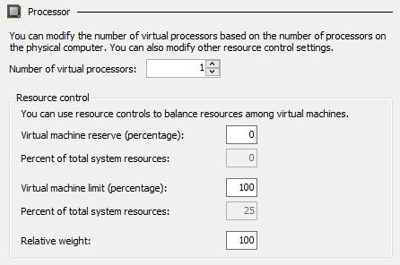

1. Expand the **[+]** next to **Processor** and click **Compatibility**. This setting is used when a running virtual machine is live migrated between hosts that have processors with different features, but they must still be from the same manufacturer (Intel or AMD).

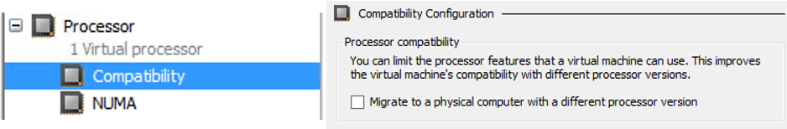

1. Under **IDE Controller 0** select **Hard Drive** and then with **Virtual hard disk** selected click on **Inspect**.

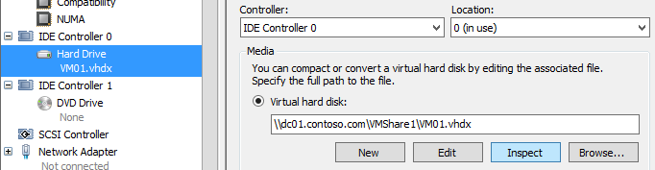

1. **Review** the Hard Disk Properties. This is a Dynamic VHDX file which means that it only uses disk space that it actually needs, but it will continue to grow until it reaches the maximum of **5GB**. Click **Close**.

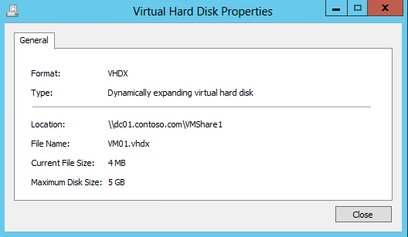

1. Select **SCSI Controller** and ensure that the **Hard Drive** is selected, then click **Add.**

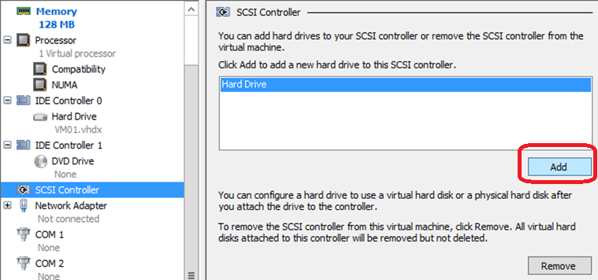

1. Under **Virtual hard disk** select **New** to launch the **New Virtual Hard Disk Wizard**.

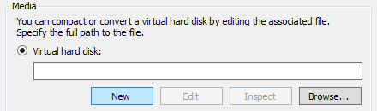

1. Click **Next** on the **Before You Begin** page.
2. On the **Choose Disk Format** page, ensure **VHDX** is selected and click **Next**.

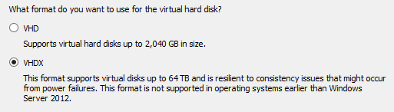

1. On the **Choose Disk Type** page, ensure **Dynamically expanding** is selected and click **Next**.

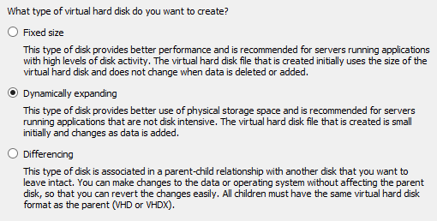

1. Type **2ndDisk.vhdx** in the name box on the **Specify Name and Location** page and click **Next**.

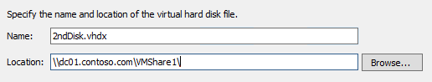

1. On the **Configure Disk** page, ensure that the **Create a new blank virtual hard disk** is selected and change the size to **1GB** and click **Next**.

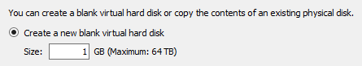

1. On the summary page, ensure the settings match those in the screenshot below, and then click **Finish**.

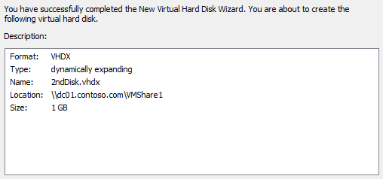

1. From the **Settings for VM01 on HYPER-V02** window, click **Apply**.

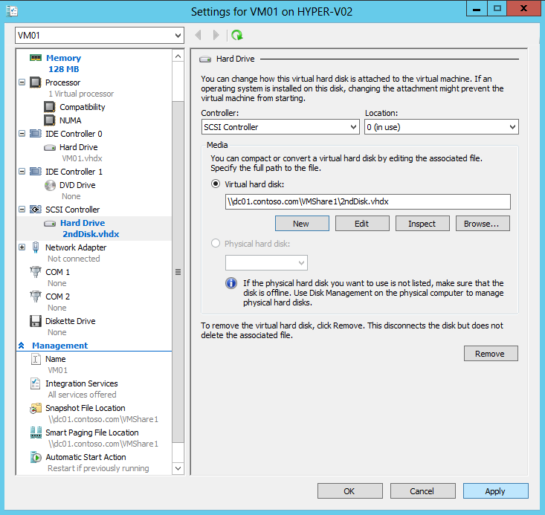

1. On the left hand navigation, select **Network Adapter** and under Virtual Switch select **vSwitch1**.

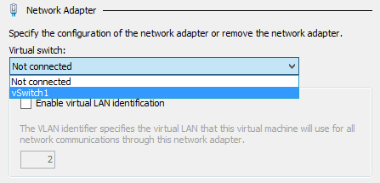

1. Check the box next to **Enable bandwidth management**, thenset the **Minimum bandwidth** to **25 Mbps** and the **Maximum bandwidth** to **75 Mbps** and click **Apply**.

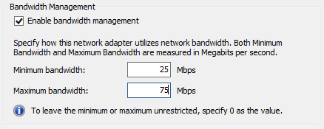

1. Expand the **[+]** next to **Network Adaptor** andclick **Hardware Acceleration** to review the hardware offloads that can be enabled on the Hyper-V vSwitch. These include Dynamic VMQ, IPsec Task Offload and SR-IOV.

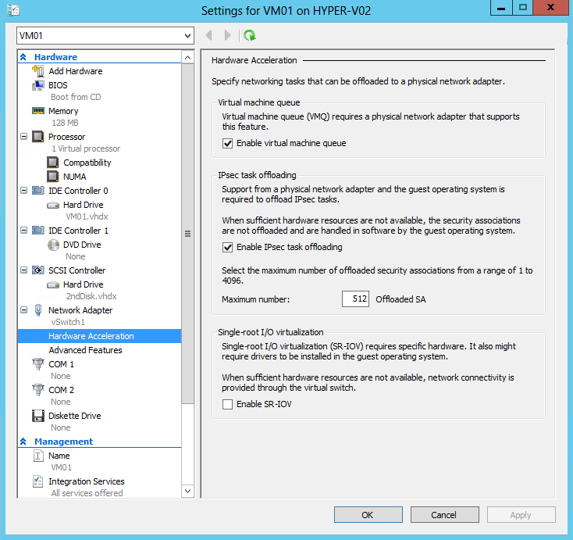

1. Click **Advanced Features** to review some of the more granular Hyper-V configuration options, such as DHCP and Router Guard, Port Mirroring and In-Guest NIC Teaming.

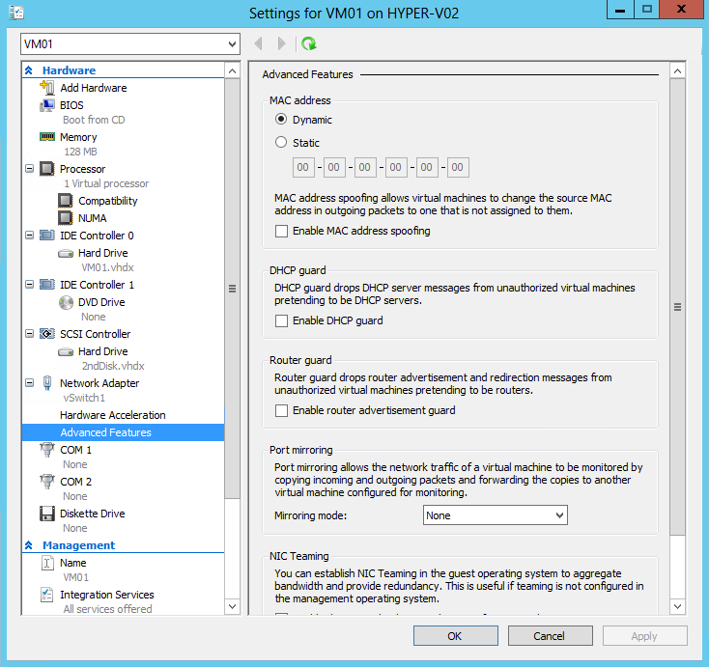

1. Scroll down in the left hand navigation and select **Automatic Start Action.**

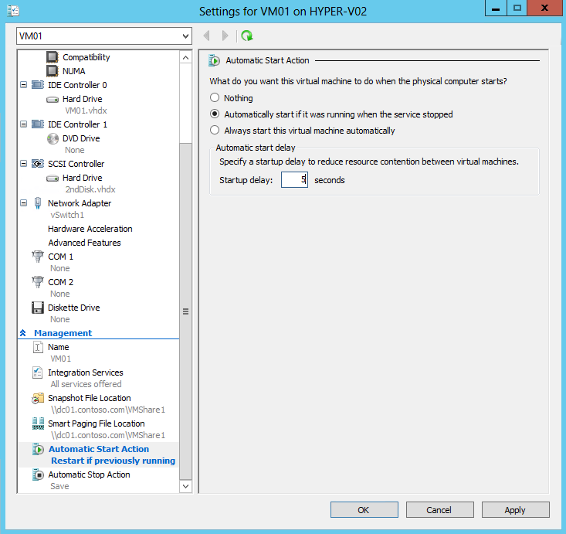

1. Ensure that **Automatically start if it was running when the service stopped** radio button is selected, and in the **startup delay** box enter **5** seconds.

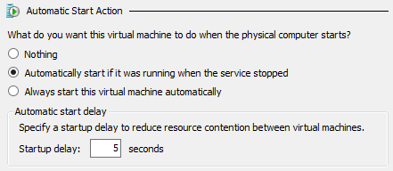

1. Select **Automatic Stop Action** from the left hand navigation, and choose the option to **Shut down the guest operating system**. This ensures that if the host shuts down cleanly, the VMs will also shut down cleanly. If the host is a cluster node, these settings are rarely used as the VMs would instead move to a different node.

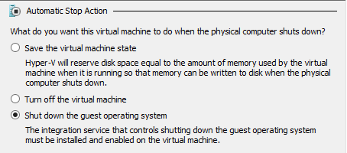

1. Click **Apply** and then click **OK**. Minimize **Hyper-V Manager**.

------------------------------------------------------------END OF LAB 3------------------------------------------------------------

**Lab 4: Clustering & Resiliency with Hyper-V**

Exercise 4.1: Deploy a Failover Cluster

**In this exercise, the existing configuration will be validated to ensure it is suitable to run in a clustered configuration and support highly available workloads. Next a Failover Cluster will be deployed, which will provide high availability for virtual machines running on the clustered Hyper-V hosts. In the event of a node (host) failure, VMs will automatically restart on another available node in the cluster. For this exercise the Failover Clustering and MPIO features have already been enabled on both Hyper-V hosts.**

**Estimated time to complete: 10 minutes**

 *Perform the following on* ***VMM01***

1. Open **VMM01** then open **Failover Cluster Manager**.

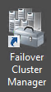

1. After Failover Cluster Manager opens, under the **Management** tab, click **Validate Configuration…**

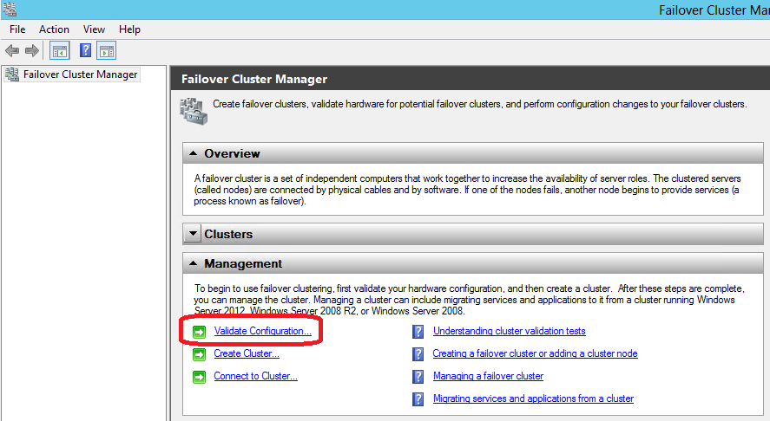

1. After the **Validate a Configuration Wizard** opens, click **Next**.
2. On the Select Servers or a Cluster page, on the Enter name box, enter **HYPER-V01, HYPER-V02** and click **Add**.

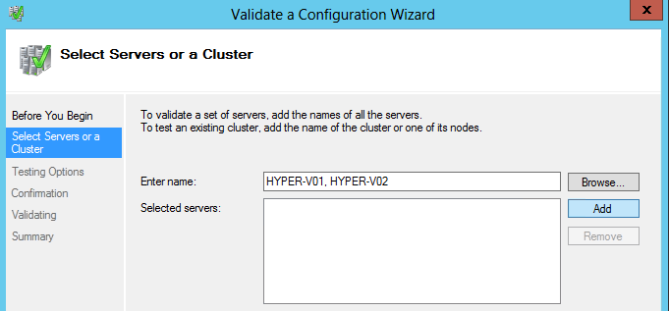

1. After the servers have been verified, click **Next**.

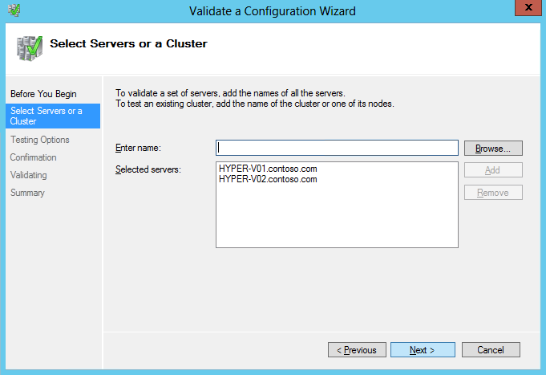

1. On the **Testing Options** page, select the **Run only tests I select** option and click **Next**.

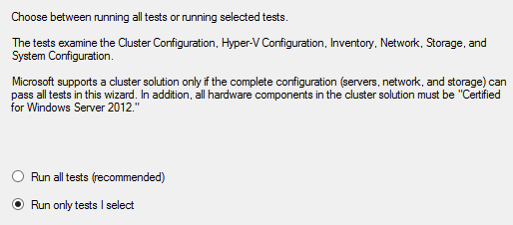

1. Expand each of the **[+]** symbols next to the **Hyper-V Configuration**, **Inventory**, **Network**, **Storage** and **System Configuration** test options. Scroll down to review the list of individual tests that the Failover Cluster Validation will run to confirm the configuration is suitable for clustering. Once reviewed, click **Previous.**

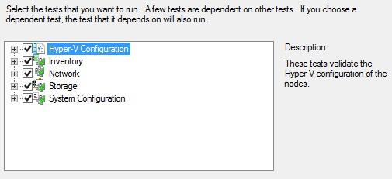

1. Back on the **Testing** Options page, select **Run all tests (recommended)** and click **Next**.

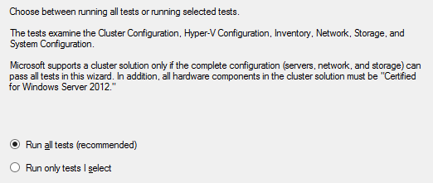

1. Click **Next** on the confirmation page.

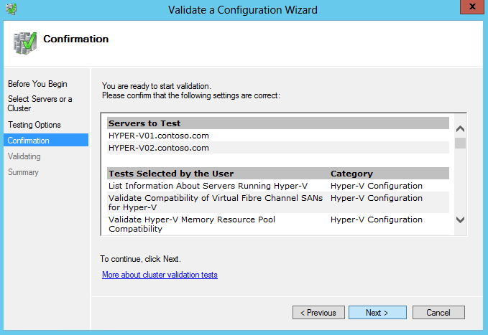’

1. The cluster validation will now run against both of the Hyper-V nodes. This will take a few moments to complete.

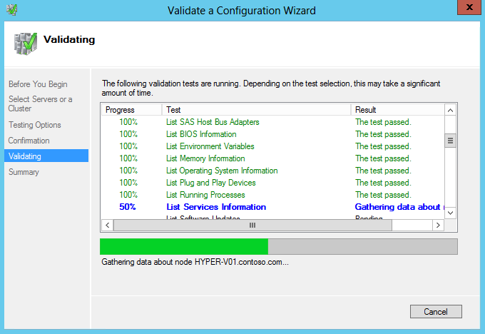

1. After the **Validate a Configuration Wizard testing** is complete, a warning is displayed which means the configuration is suitable for clustering, and would be supported by Microsoft, but a best practice is not being followed. Click the **View Report…** button. This launches Internet Explorer, which displays the validation report. This lists the set of tests that were performed, and the result ensures that the cluster is suitable to continue.

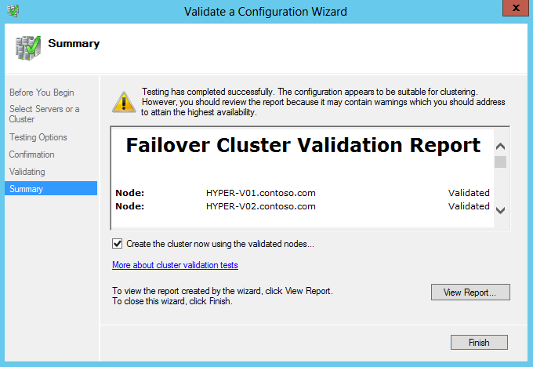

1. When the report opens, **maximize** the Internet Explorer window, and under **Results by Category**, select **Network**.

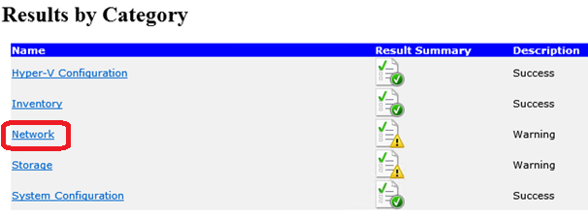

1. Select **Validate IP Configuration.**

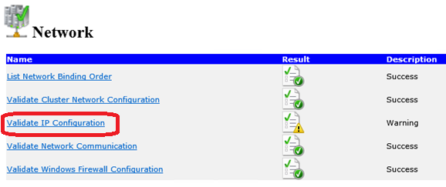

1. **Scroll down**, observe the **warnings** for **HYPER-V01** and **HYPER-V02**, and select **Back to Top**.

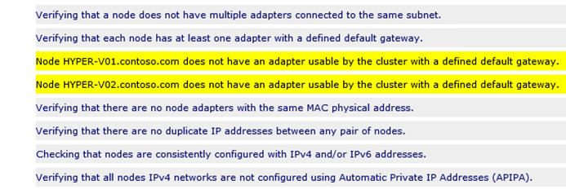

1. Select **Storage**.

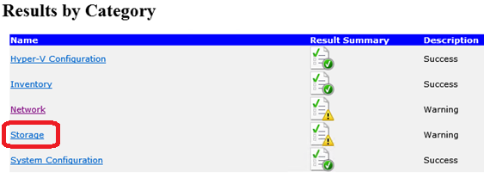

1. Select **Validate Disk Access Latency**.

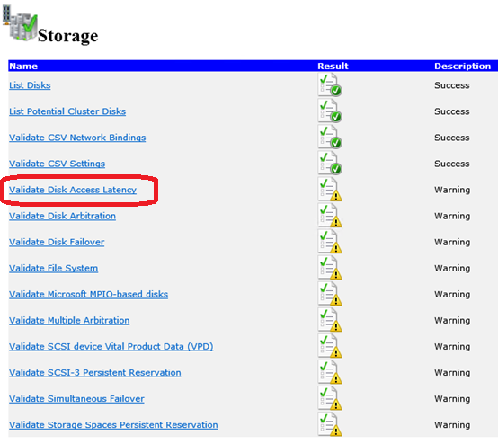

1. **Observe** the **no disks were found** messageand click **Back to Top.** This is because a SAN is not being used for the cluster. For shared storage the SMB 3.0 File Shares that were created earlier will be used, as these provide shared access and are often cheaper and easier to configure.

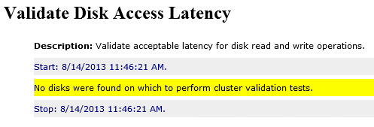

1. **Close** the **Internet Explorer** window**.**
2. With the **Validate a Configuration Wizard** still open, ensure the **Create the cluster now using the validated nodes** box is selected, and click **Finish.**

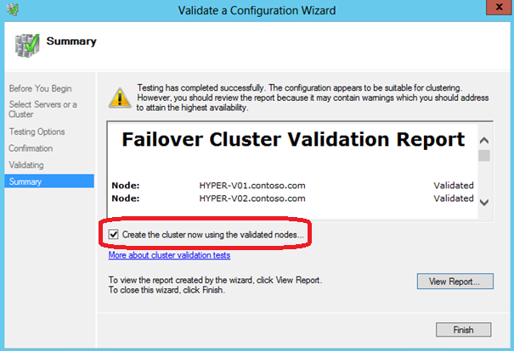

1. Click **Next**.
2. On the **Access Point for Administering the Cluster** screen, in the **Cluster Name** box, enter **CLUSTER1**.

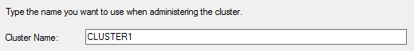

1. **Clear** all of the **check boxes next to the I.P. addresses** leaving the **box next to 192.168.2.0/24 checked.** Below the Address cell, click on the dialog which says “**Click here to type an address**” and enter “**100**” in the far right text box so the Address is 192.168.2.100, as shown in following screenshot. Click **Next**.

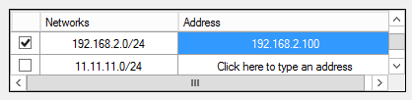

1. On the **Confirmation** screen, ensure the settings match those on the screenshot below, and that the checkbox for **Add all eligible storage to the cluster** is selected, and then click **Next** to begin cluster creation.

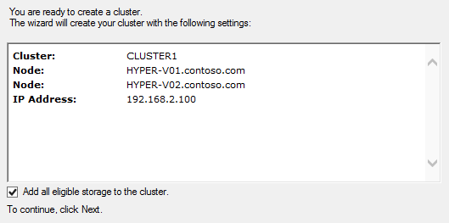

1. After the cluster has been created, a confirmation will appear, however there is still a warning. Click **View Report** to review this warning.

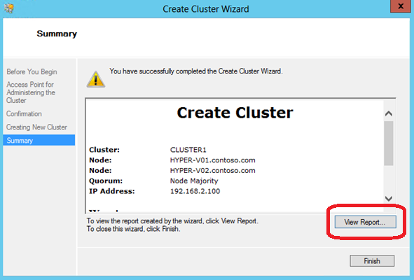

1. When the report opens **maximize the Internet Explorer window** and **scroll down** to the bottom of the report, to the following warnings.

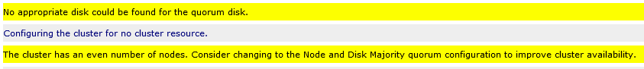

1. The cluster warning indicates that there are no disks available for the quorum/witness disk, and that the current configuration is not optimal in ensuring complete cluster availability. The quorum/witness disk allows nodes to arbitrate for ownership of resources in the event that there is a network partition and nodes cannot communicate with each other (this is also known as a “split brain”). The cluster recommends changing the configuration to **Node and Disk Majority** so that a disk can be used for ownership arbitration. Only one node at a time can mount this disk, and that node will also know that it should host the other clustered roles. The node that cannot mount this disk (because it is already mounted by the other node) will not attempt to run any other clustered roles until it can rejoin the rest of the cluster.
2. In this exercise a file share will be used, rather than a disk, to provide an equivalent ownership concept. In this case, one of the nodes will open a file on the share, and this node will also run all other clustered roles. The other node will recognize that there is already an open file handle and will not attempt to run any other clustered roles until it can rejoin the rest of the cluster.
3. Close the **Internet Explorer** window.
4. With the **Create Cluster Wizard Summary** screen still open, click **Finish.**

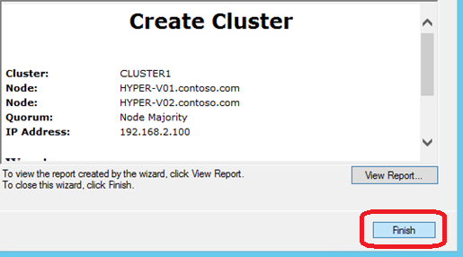

Exercise 4.2: Configure a Failover Cluster

**In this exercise, several cluster-wide settings will be configured, including the quorum, network and live migration settings. The quorum disk is an unused disk or file share that functions as an arbitrator between cluster nodes when the nodes cannot communicate with each to decide which of the hosts should run the workloads.**

**Estimated time to complete: 5 minutes**

 *Perform the following on* ***VMM01***

1. Open **VMM01** then open **Failover Cluster Manager**.



1. In the top left navigation pane of **Failover Cluster Manager**, right-click on **CLUSTER1.contoso.com**, select **More Actions** and then **Configure Cluster Quorum Settings.**

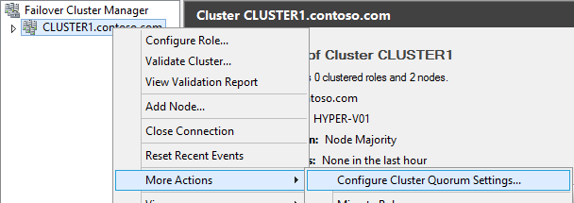

1. Read the **Before You Begin page** and click **Next**.
2. Select **Advanced Quorum Configuration and witness selection** on the Quorum Configuration Option page and click **Next**.

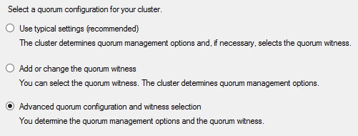

1. On the **Select Voting Configuration** page, ensure **All Nodes** is selected, and then click **Next**.

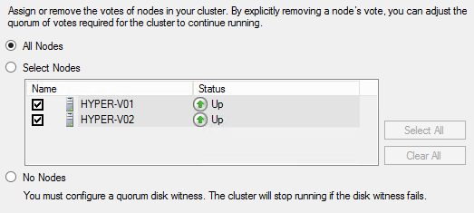

1. On the **Configure Quorum Management** page, ensure that the **Allow cluster to dynamically manage the assignment of node votes (recommended)** is selected, and then click **Next.**

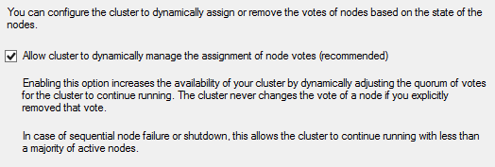

1. On the **Select Quorum Witness** page, choose **Configure a file share witness** **(recommended for special configurations)** and then click **Next**.

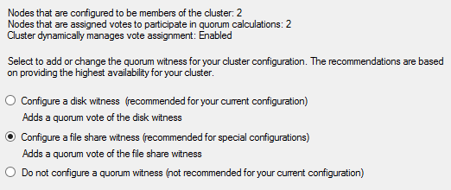

1. On the **Configure File Share Witness** page, type: **\\dc01.contoso.com\VMShare2** in the **File Share Path** and click **Next**.

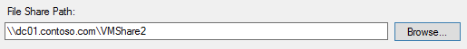

1. On the **Confirmation** page, ensure the settings match those in the screenshot below, and then click **Next.**

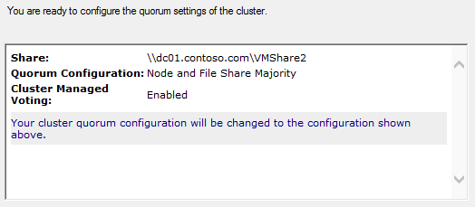

1. Once the process has completed, click **Finish** on the **Configure Cluster Quorum Settings** page.

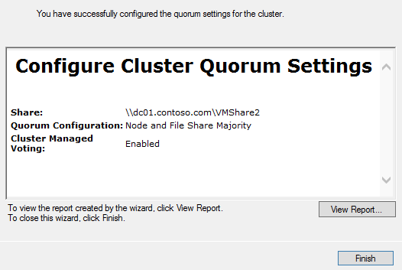

1. In the left navigation pane, expand **Cluster1.contoso.com,** and then expand **Nodes**, **Storage** and **Networks**.

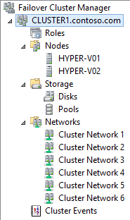

1. Click on each of the **Cluster Networks**, from 1 through 7, until the **Cluster Network** with **LIVEMIGRATION1** appears in the main details window. Make a note of the number of the network for **Cluster Network**. In the example below, Cluster Network 6 is the network with LIVEMIGRATION1 in the details window.

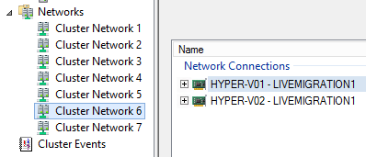

1. Right-click on **Networks** and select **Live Migration Settings.**

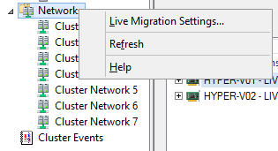

1. **Deselect** all of the networks *except* for the Cluster Network that was previously noted (in this example Cluster Network 6). Then use the **Up** button to **move that network to the top of the list**, making it the highest priority for Live Migration traffic. Once complete, click **Apply**, then **OK.**

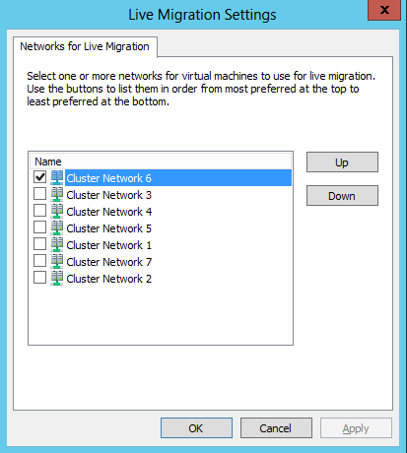

1. Minimize **Failover Cluster Manager** and then Select **File Explorer** from the Task bar.



1. Navigate to **Libraries**, **Documents**, and then right-click **UpdateShares** and click **Edit**. This will launch the PowerShell ISE. This script will update the NTFS and Share permissions for CLUSTER1 using the File Shares that were created in Exercise 1.

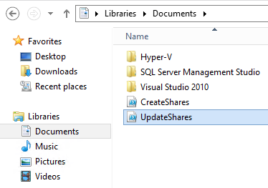

1. Click inside the **UpdateShares.ps1** then click the **Run Script** button (Green Arrow).

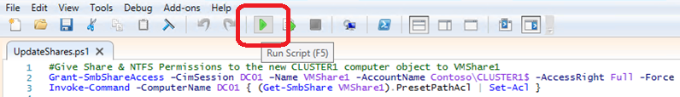

1. The script will take a moment to complete. Once it is complete, **scroll** through and observe the output in the **PowerShell ISE Window**.

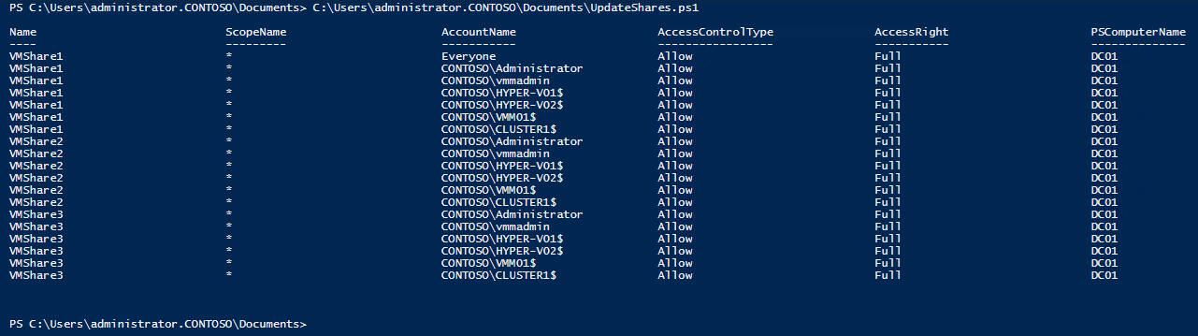

1. Close the **PowerShell ISE**, and then close **Windows** **File** **Explorer**.

Exercise 4.3: Create a Highly Available VM

**In this exercise, the VM that was created earlier (VM01) will be made highly-available. Next, a new VM will be created directly from Failover Cluster Manager, which automatically becomes highly available. As these VMs are now managed by the cluster, so they are highly-available and resilient to unplanned downtime. If a node fails, the VMs will automatically restart on another node in the cluster.**

**Estimated time to complete: 5 minutes**

 *Perform the following on* ***VMM01***

1. Open **VMM01** then open **Failover Cluster Manager**.



1. In the left navigation pane, expand **CLUSTER1.contoso.com**, right-click **Roles**, and select **Configure Role**.This will open the **High Availability Wizard**, which is used to make a role (VM or other server role) highly available.

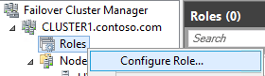

1. Click **Next** on the **Before You Begin** page.
2. On the **Select Roles** page, **scroll down**, and select **Virtual Machine**, and click **Next**.

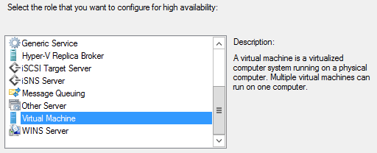

1. On the **Select Virtual Machine** page, select the box next to **VM01** and click **Next**. This is the VM which was created earlier.

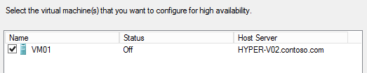

1. Click **Next** on the **Confirmation** page.

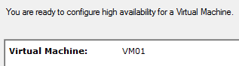

1. Click **Next** on the **Configure High Availability** page. The wizard will then make VM01 a clustered resource, and subsequently, highly available and resilient to host failure.

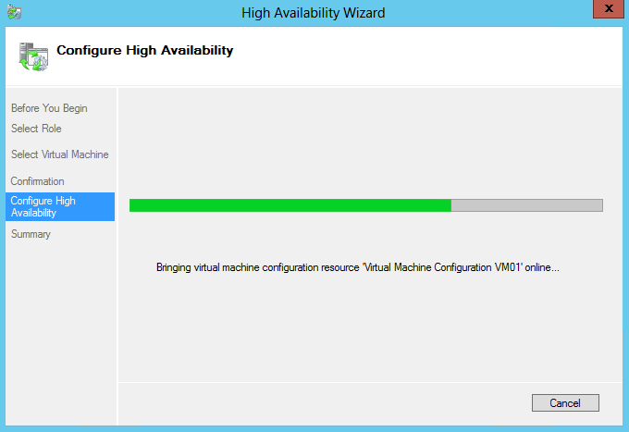

1. On the summary page, click **Finish** to close out the wizard.

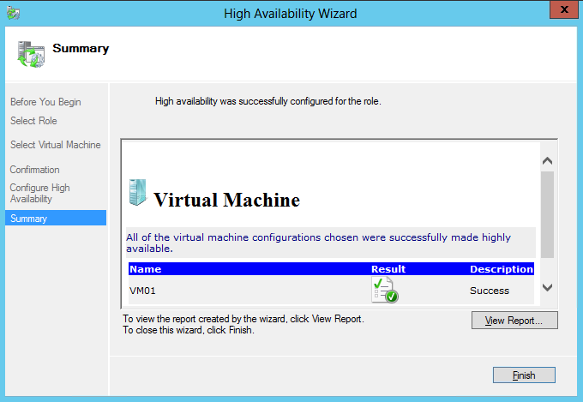

1. From the top left navigation, right-click on the **Roles** node and navigate to **Virtual Machines | New Virtual Machine.**

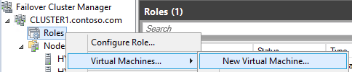

1. In the **New Virtual Machine** window select **HYPER-V01** and click **OK** to launch the **New Virtual Machine Wizard**.

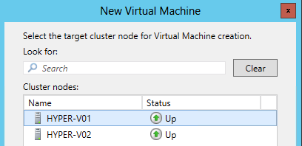

1. Click **Next** on the **Before You Begin** page.
2. On the **Specify Name and Location** screen, under the **Name** entry enter **VM02**. Ensure that the storage location is set to **\\dc01.contoso.com\VMShare1** and click **Next**.

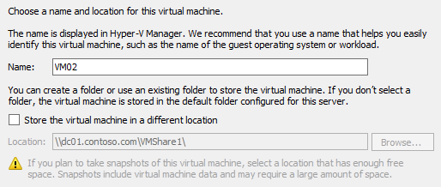

1. **Type** 128 in the **Startup Memory** box and click **Next**. Leave the **Dynamic Memory** box empty.

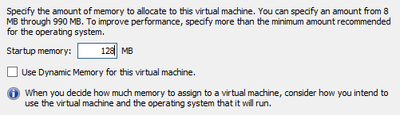

1. Use the Dropdown to select **vSwitch1** and click **Next** on the Configure Networking screen.

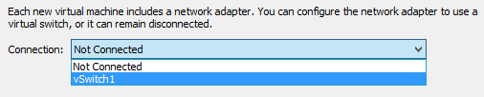

1. Change the disk size to **5** and click **Next** on the **Connect Virtual Hard Disk** screen.

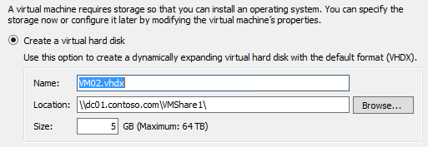

1. On the **Installation Options** screen, ensure **Install an operating system later** is selected, then click **Next.**

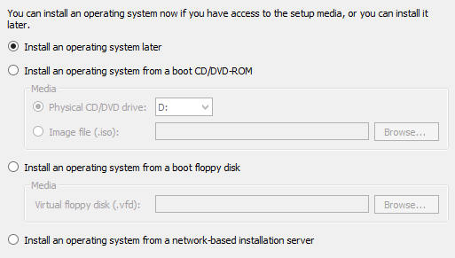

1. Ensure the settings match those of the screenshot below, and then click **Finish**.

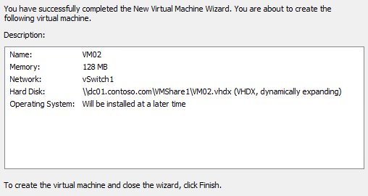

1. The **New Virtual Machine Wizard** will complete and close. The **High Availability Wizard** will automatically open, start running, and deploy a VM on the cluster. The VM will be in an offline state so that advanced features can be configured before starting the VM and consuming host resources.

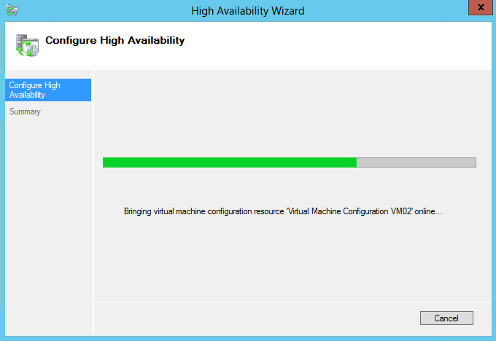

1. Click **Finish** to close the wizard.

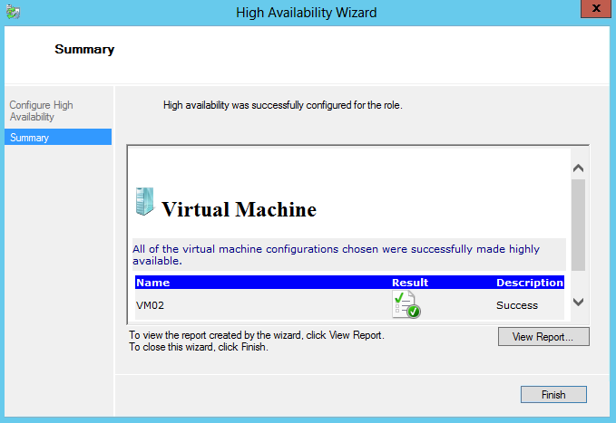

1. Right-click **VM02** on the roles detail pane and select **Change Startup Priority**, then select **High**. This will prioritize the start order of the VMs (High is first) when multiple VMs are being started, such as after a host failure.

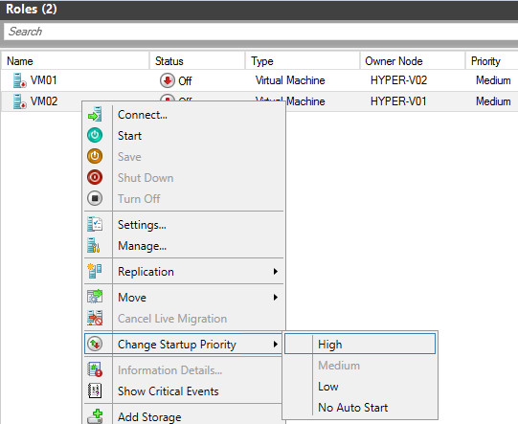

1. At the bottom of the central details pane, to the right, next to **Preferred Owners**, click **Any Node.**



1. Select **HYPER-V01** as the preferred owner of this VM. Click **Apply** and then **OK** to close the window. This setting will make a VM always try to run on its preferred host(s), if they are available.

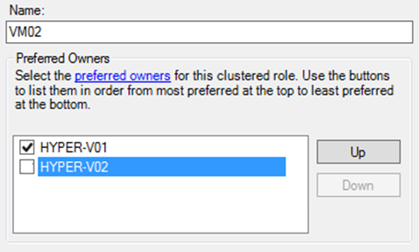

1. At the bottom of the central detail pane, on the bottom tab select **Resources**.

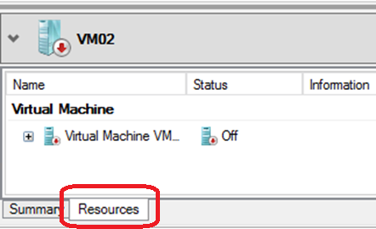

1. Expand the **Virtual Machine resource**, right-click the bottom **Virtual Machine Configuration**, and select **Properties**.

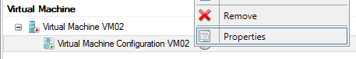

1. Select **Advanced Policies** from the row of tabs.

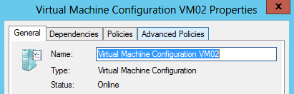

1. Ensure that both of the Hyper-V hosts are set as **Possible Owners**. This setting will allow a VM to run on this host, but by default it will run on a preferred owner. If this checkbox is deselected, a VM will not be permitted to run on that host.

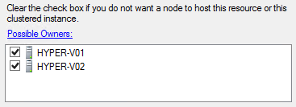

1. Click **Cancel** to close the VM properties window and minimize **Failover Cluster Manager****.**

Exercise 4.4: Implement Cluster-Aware Updating

**In this exercise, the Cluster-Aware Updating (CUA) wizard will be configured and tested. CUA allows the administrator to automate the patching of Windows Server 2012 Failover Clusters, in conjunction with an existing patching mechanism such as WSUS. CUA allows the administrator to manually run the updating wizard, or configure it to run on a schedule.**

**Estimated time to complete: 10 minutes**

 *Perform the following on* ***VMM01***

1. Open **VMM01** then open **Server Manager**



1. From the left hand navigation, select **WSUS**, and in the central details pane, right-click **VMM01** and select **Windows Server Update Services**.

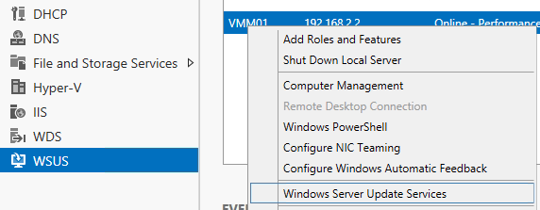

1. In the **Update Services** window, select **VMM01** from the left hand navigation.

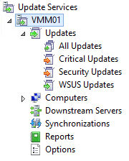

1. Select **Updates needed by computers** from the central details pane.

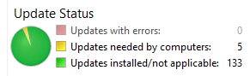

1. **Select the following updates**, but leave the **Update for Windows Server 2012 (KB2863058)** unselected.

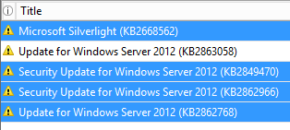

1. From the right hand navigation, select **Decline**.

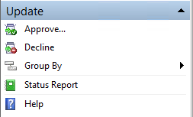

1. In the **Decline Updates** warning prompt, select **Yes.** These updates will not be applied in this lab.

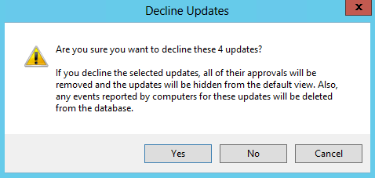

1. Close the **Update Services** window. Minimize **Server Manager**.
2. From VMM01, open **Cluster-Aware Updating**.

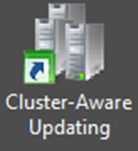

1. Once opened, use the dropdown menu to select **CLUSTER1**, and then click **Connect**.

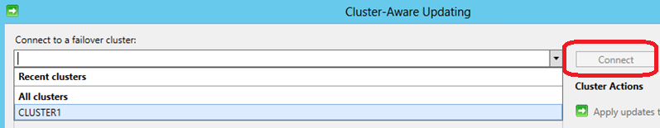

1. Once successfully connected, the list of the two Hyper-V hosts will appear.

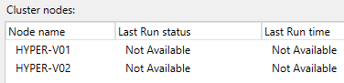

1. From the right-hand menu, click **Analyze Cluster Updating Readiness.** This will check whether the cluster is correctly configured for Cluster-Aware Updating. This will take a few moments to complete.

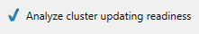

1. Review the report that is created in the results window. In this lab environment, expect two warnings. Both of these can be ignored for this lab. Once the results have been reviewed, click **Close.**

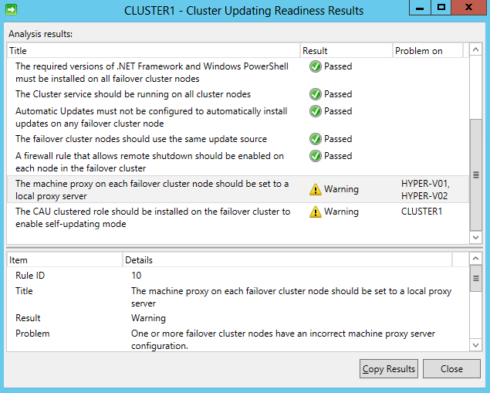

1. Click **Preview updates for this cluster** on the right hand navigation.

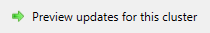

1. The **Preview Updates** window will open. Click **Generate Update Preview List**. This will trigger the host to compare any patches that have already been applied to patches that are available in WSUS/Windows Update. **Only two patches should be shown**, which both begin with **8d591f8f**.If any other number of patches (or no patches) are shown, wait a few moments for WSUS to refresh, and then click **Generate Update Preview List.** Repeat until only two updates are shown**.** Once completed, click **Close**.

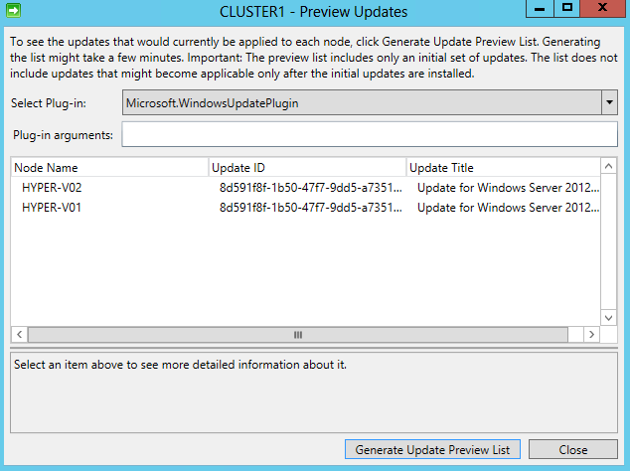

1. Click **Apply updates to this cluster** to launch the **CLUSTER1 – Cluster–Aware Updating Wizard**.

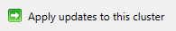

1. Read the Getting Started page and click **Next**.
2. On the Advanced Options page, scroll down and review the different configuration options that are available, but leave the default settings. Then click **Next**.

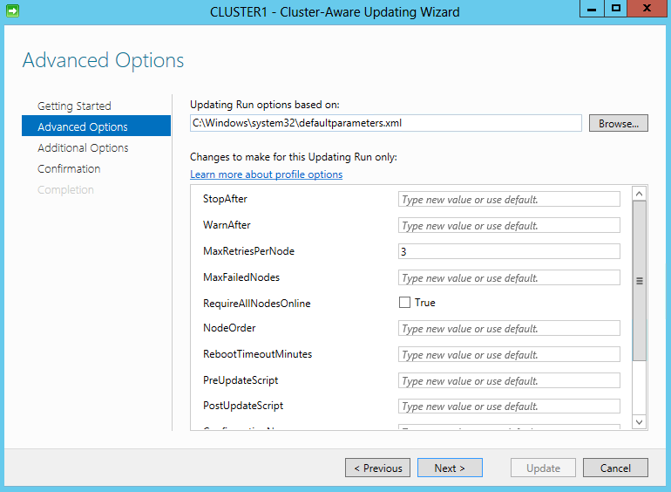

1. Ensure the box next to **Give me recommended updates the same way that I receive important updates** on the **Additional Update Options** page, is **unchecked**.

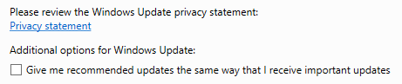

1. Click **Next**.
2. Review the **Confirmation** page and click **Update,** and then click **Close** on the **Completion** page.

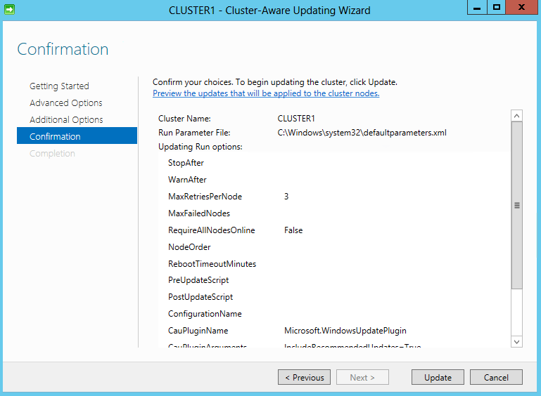

1. The **scanning** and **patching** will then take place. This will take several moments, but continue to the next step.

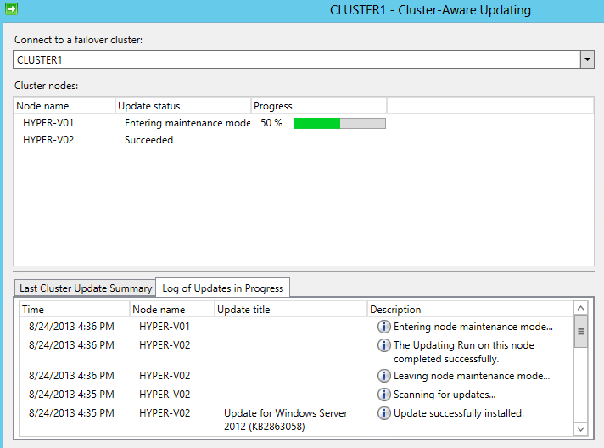

1. While one of the hosts is in the process of being updated, open **Failover Cluster Manager.**



1. In the top left navigation, expand **CLUSTER1.contoso.com.** Expand **Nodes** and then click on **Roles.** Note that the host that is being updated has been **paused**, and the roles (VMs) are hosted on the other node. CUA will orchestrate the failover and failback of the VMs to their original nodes once the process has completed.
   * Note: The VMs will live migrate between hosts, if possible. This lab is built using virtual machines. It is not possible to run VMs within Hyper-V VMs (“nested virtualization”). A user can create and configure VMs, but cannot start the VM.

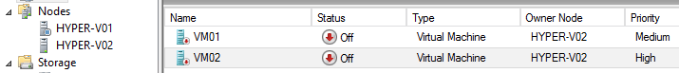

1. Minimize **Failover Cluster Manager** and return to the **Cluster-Aware Updating console** and observe the process.

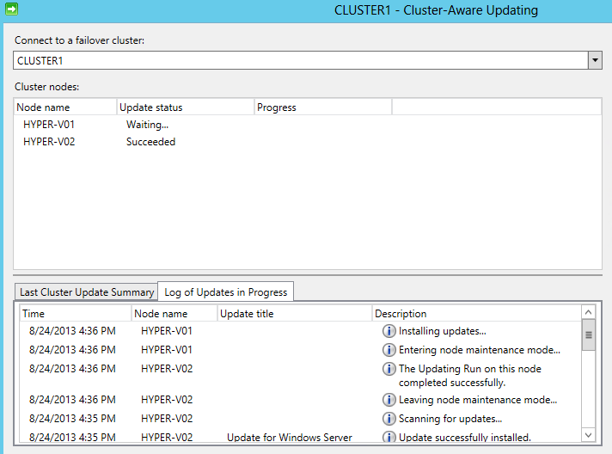

1. Whilst the process is ongoing, click **Configure Cluster Self-Updating Options** on the right-hand menu. This will run the CUA process directly on the cluster itself, allowing it to self-patch itself.

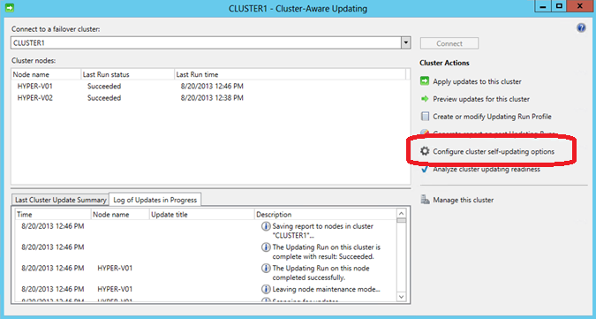

1. Read the **Getting Started** page and click **Next.**
2. On the **Add CAU Cluster Role** page, check the box next to **Add the CAU cluster Role with Self-Updating mode enabled.** Leave the **I have a prestaged computer object for the CAU clustered role** box unselected and click **Next**.

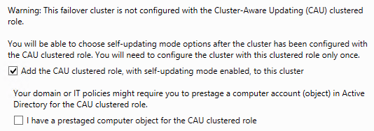

1. On the **Self-updating schedule** page, ensure that **monthly** is selected. For the starting date, **select a date** several days in the future, and then click **Next.**

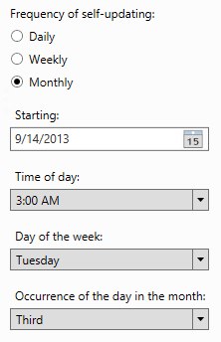

1. On the **Advanced Options** page, leave the default options and click **Next.**

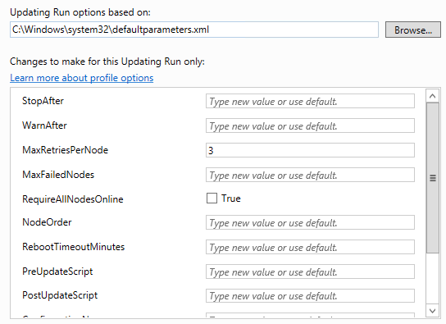

1. On the **Additional Update Options** page, ensure the box for **Give me recommended updates the same way I receive important updates is unchecked** and click **Next**.



1. Review the **Confirmation** page, and then click **Apply.** This will configure the self-updating CAU capability, which will automatically download and apply approved patches to the cluster nodes. It will follow the user-defined schedule and keep VMs and other roles running by moving them between nodes using a live migration or failover.

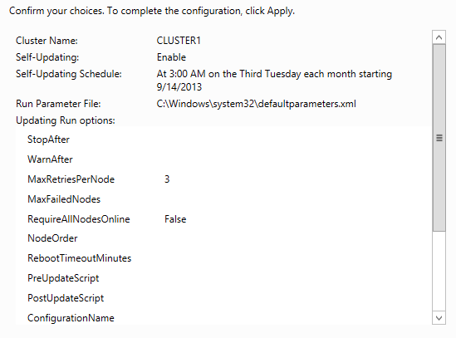

1. The CAU role will be created for the cluster. Once it is complete click **Close.**

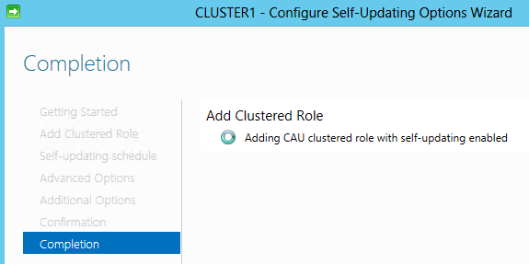

1. These changes may take several minute to configure. Leave the wizard open to allow it to continue running.

------------------------------------------------------------END OF LAB 4------------------------------------------------------------

**Lab 5: VM Mobility with Hyper-V**

Exercise 5.1: Configure VM Migration

**In this exercise, some advanced host settings will be configured, including the number of simultaneous live migrations and storage migrations.**

**Estimated time to complete: 5 minutes**

 *Perform the following on* ***VMM01***

1. Open **VMM01** then open **Hyper-V Manager**.



1. In the navigation menu, select **HYPER-V01**, then in the **Actions** menu on the right, click **Hyper-V Settings**.
2. Select **Live Migrations.**
3. Make sure **Enable incoming and outgoing live migrations** is checked. Under **Authentication protocol,** select **Use Kerberos**.
4. Under **Simultaneous live migrations** specify **4**.

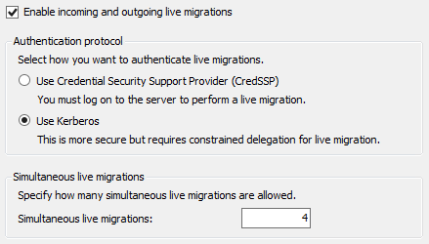

1. Observe the settings for the **Incoming Live Migrations**. The network should match the LIVEMIGRATION1 network was configured earlier in Failover Cluster Manager (in the previous example this was Cluster Network 6).

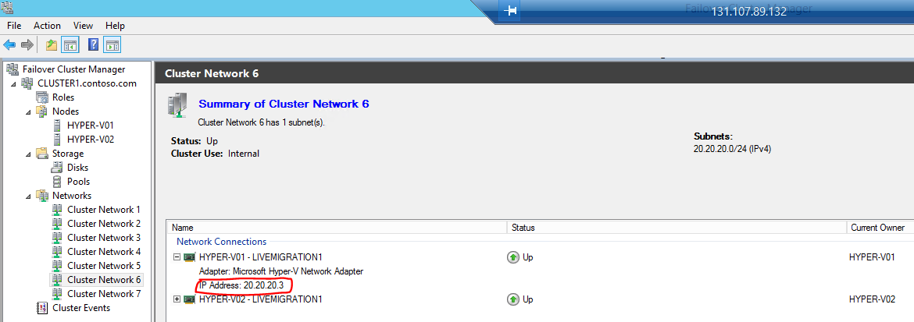

1. Click **Apply**.
2. Select **Storage Migrations.**
3. Under **Simultaneous storage migrations** specify **2**.

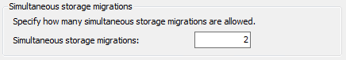

1. Click **Apply** and then **OK**.
2. **Repeat Steps 2 through 10** on **HYPER-V02**. Once complete, minimize **Hyper-V Manager**.

Exercise 5.2: Test a Migration

**In this exercise, a Quick Migration will be tested. Due to limitations of the virtualized lab environment, it is not possible to show a Live Migration of a VM. However, a Quick Migration will show the basic functionality. Next, a Storage Migration will be tested to move the VM’s configuration and virtual disk files to an alternative location.**

**Estimated time to complete: 10 minutes**

 *Perform the following on* ***VMM01***

1. Open **VMM01** then open **Failover Cluster Manager**.



1. In the left navigation pane, expand **CLUSTER1.contoso.com**, and click **Roles**.
2. Select **VM02**, right-click and click **Move**, then choose **Live Migration.** Note the options are greyed out because the VM is not running.
   1. Note: This lab is built using virtual machines. It is not possible to run VMs within Hyper-V VMs (“nested virtualization”). A user can create and configure VMs, but cannot start the VM.
3. Select **Move** again, and then select **Quick Migration.** If the VM were running, a Quick Migration would save the state of the VM to the shared storage for the duration of the migration, and there would be some downtime. A Live Migration would have no downtime while the VM moves between the cluster nodes as the memory is copied directly between the hosts.
4. Click **Select Node.**

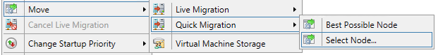

1. Select **HYPER-V02** and click **OK** to perform the Quick Migration.
2. From the **Roles** pane, right-click **VM01,** select **Move**, then **Virtual Machine Storage**.
3. Choose Virtual Machine **VM01** and expand the tree.

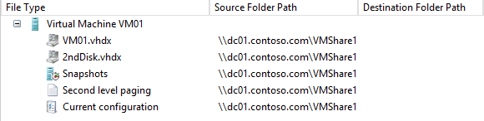

1. Click **Add Share**.
2. Type in **\\dc01.contoso.com\VMShare3** and click **OK**.

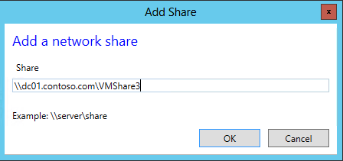

1. Select **2ndDisk.vhdx**, **Snapshots**, **Second Level Paging** and **Current Configuration files**, then click **Copy**.

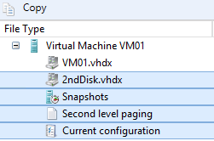

1. Click on the share that was just added, **\\dc01.contoso.com\VMShare3**, and then click **Paste**.

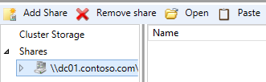

1. The settings should look like the screenshot below. Click **Start**.

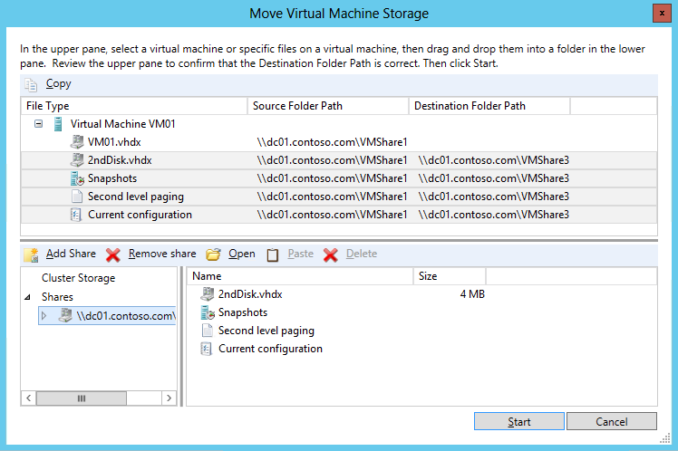

1. Now switch back to **Hyper-V Manager**.
2. Select **HYPER-V01** from the navigation in the top left
3. Now select **New** and then **Virtual Machine** from the **Actions** pane.
4. Click **Next**.
5. In the **Name** field, type **VM03** and click **Next.**
6. Set Startup memory to **128 MB** and click **Next**.
7. For **Configure Networking**, select **vSwitch1** from the drop-down list and click **Next**.
8. Under **Connect Virtual Hard Disk,** change the size to **5 GB** and click **Next**.
9. Choose to **Install an Operating System Later** and click **Next**.
10. Confirm the settings match the screenshot below, and then click **Finish.**

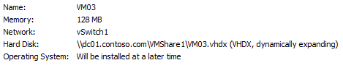

1. Now right-click on **VM03** and choose **Move**
2. The **Move Wizard** will appear, click **Next**.
3. For **Move** Type, select **Move the virtual machine** and click **Next**

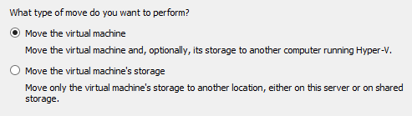

1. Specify **HYPER-V02** asthe name of the destination computer and click **Next**
2. Under **Choose Move Options**, select **Move the virtual machine’s data to a single location** and click **Next**

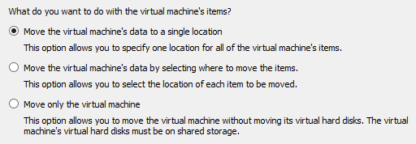

1. For the **Choose a new location for virtual machine** click **Browse.**
2. **Browse** to **C:\** and click **Select Folder**

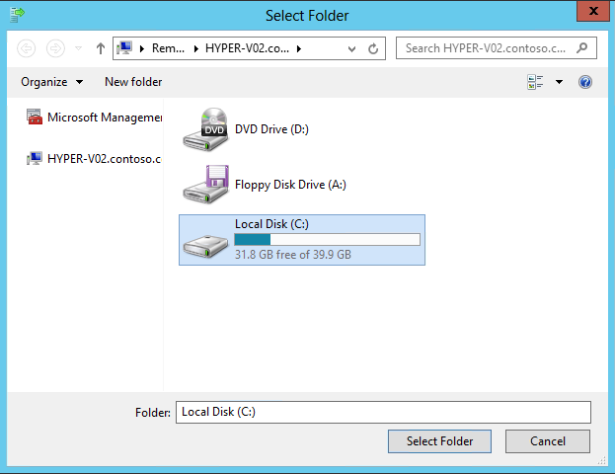

1. Click **Next**.
2. Confirm the settings match those below, and then click **Finish**.

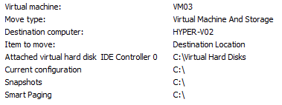

1. Once complete, select **HYPER-V02** from the navigation in the top left
2. Right-click **VM03** and click **Settings**

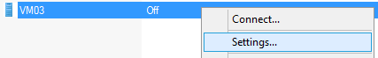

1. Under **IDE Controller 0**, confirm that the VHDX of the Virtual Machine now resides on the C:\ of HYPER-V02. A **Shared Nothing Live Migration** allows the administrator to move the running state of the VM *and* its storage, from one location to another with no downtime to the VM. The VMs can be moved between standalone hosts, clusters or any combination of hosts and clusters with either local or shared storage. A network connection is used for the transition of the memory and storage data.

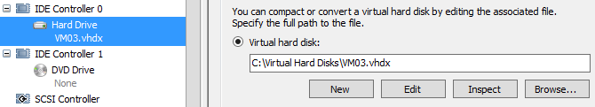

1. Click **Cancel** to close the settings window. Minimize **Hyper-V Manager** and **Failover Cluster Manager**.

------------------------------------------------------------END OF LAB 5------------------------------------------------------------

**Lab 6: Backup & Replication with Hyper-V**

Exercise 6.1: Backup a VM

1. **In this exercise, a basic Windows Server Backup will be performed which can be used to protect Hyper-V virtual machines.**
2. **Estimated time to complete: 5 minutes**

 *Perform the following on* ***VMM01***

1. Open **VMM01** then open the **MMC** interface located on the **Desktop**

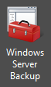

1. Once opened, click **File** and then **Add/Remove Snap-In**

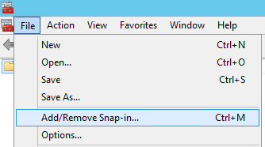

1. Scroll down to the bottom of the list of Available snap-ins and click **Windows Server Backup,** then click **Add**

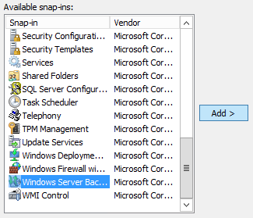

1. Select **Another Computer** and type **HYPER-V02,** and then click **OK.**

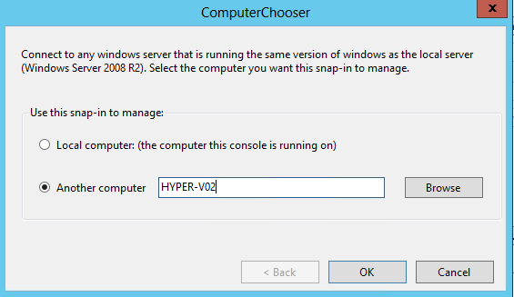

1. Back in the **Add/Remove Snap-Ins wizard**, click **OK**

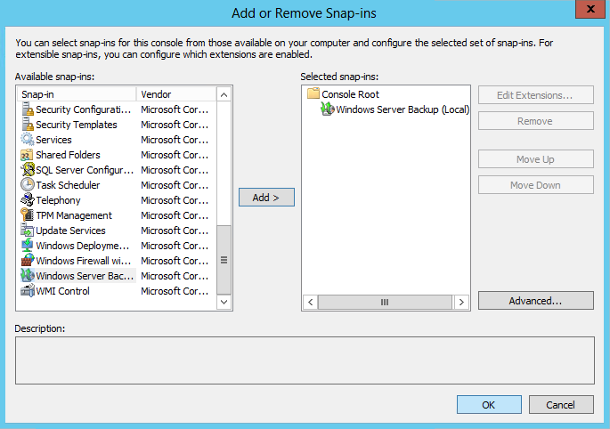

1. Click and Expand the **Windows Server Backup (HYPER-V02)** navigation and click **Local Backup.** This may take a few moments.

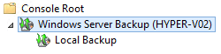

1. In the **Actions** pane, click **Backup Once**.

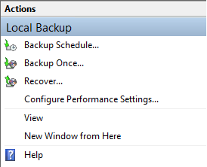

1. Select **Different options** then click **Next**. Note that Windows Server Backup can also be configured on a schedule.

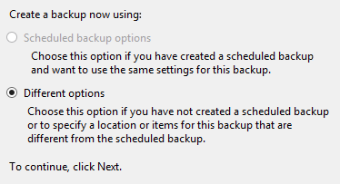

1. Select **Custom**, then click **Next**.

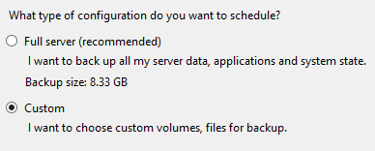

1. On the **Select Items for Backup,** click **Add Items**.

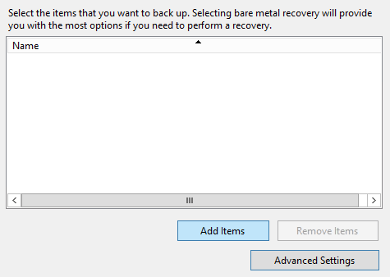

1. Expand the Hyper-V Tree, and select **VM03 (Backup Using Saved State)** then click **OK.**

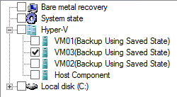

1. Upon returning to the **Backup Once** Wizard, click **Next.**

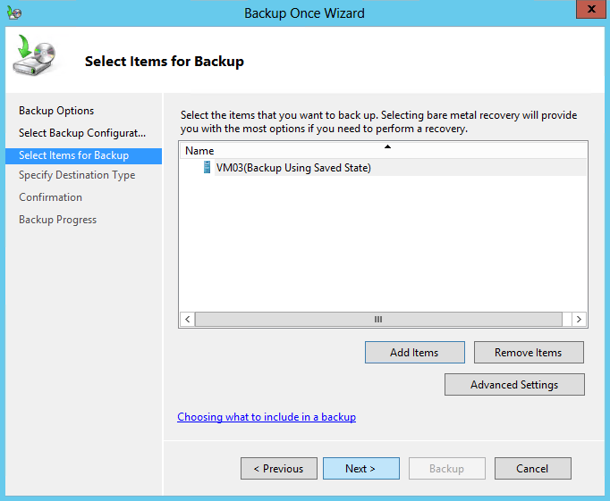

1. For the **Destination Type**, select **Remote shared folder**, then click **Next**.

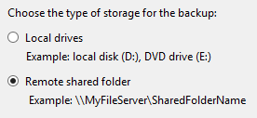

1. Enter **\\dc01.contoso.com\VMShare2** and ensure that **Inherit** is selected, then click **Next.**

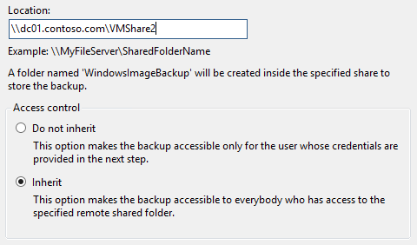

1. Enter credentials in the security pop-up, then click **OK**.
   * User name: **contoso\administrator**
   * Password: **Passw0rd!**

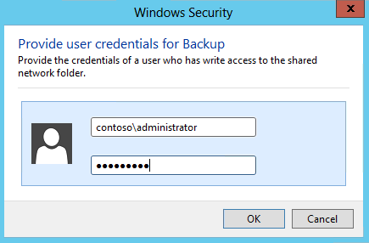

1. The confirmation page should resemble the screenshot below. If that is correct, click **Backup.**

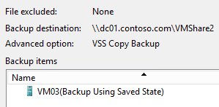

1. Wait for backup to complete, then click **Close**. Once this is complete, VM03 has been successfully backed up.

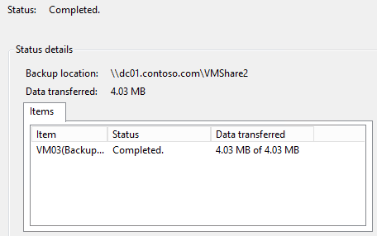

1. Close the **Windows Server Backup** console, and choose **not** to save the settings.

Exercise 6.2: Configure a Hyper-V Replica

**In this exercise, the Hyper-V Replica feature will be configured. Hyper-V Replica is an in-box Hyper-V feature which enables asynchronous replication of the VMs VHD file between different locations, replicating every 5 minutes. In the event of a disaster, VMs can quickly be restarted in the secondary location.**

**Estimated time to complete: 4 minutes**

 *Perform the following on* ***VMM01***

1. Open **VMM01** then open **Hyper-V Manager.**



1. From the navigation, select **VMM01** and on the right actions pane select **Hyper-V Settings…**

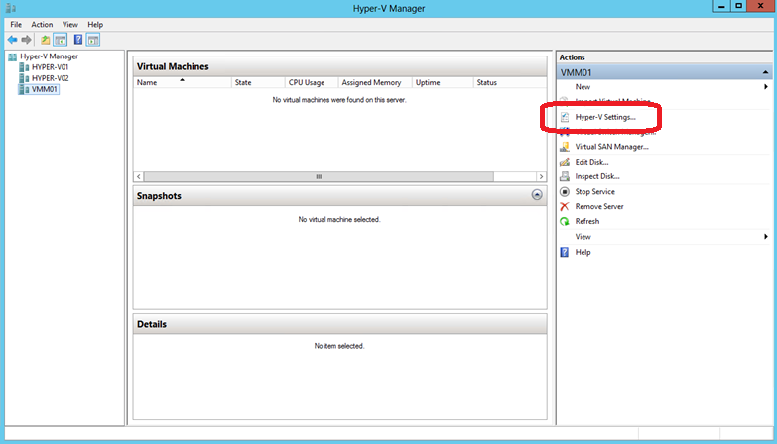

1. Under the **Server** settings, select **Replication Configuration**.

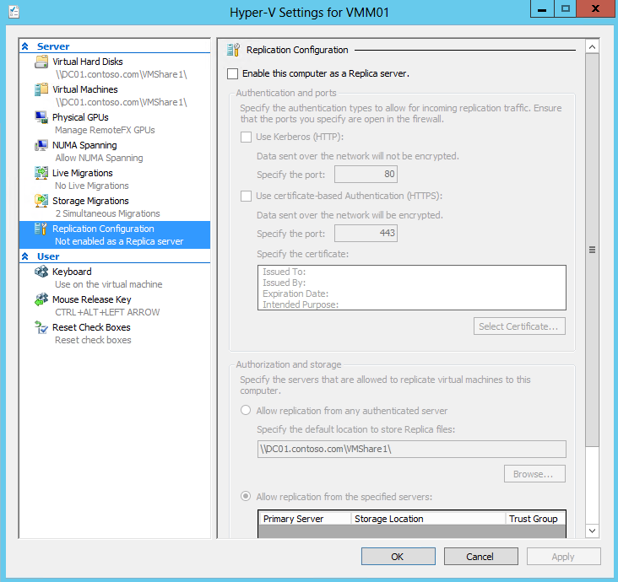

1. Select the checkbox for **Enable this computer as a Replica server** and check the **Use Kerberos** box.

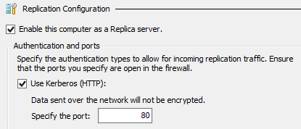

1. Under **Authorization and Storage** select the option for **Allow replication from any authenticated server** and update the default storage location to **\\dc01.contoso.com\VMShare2**

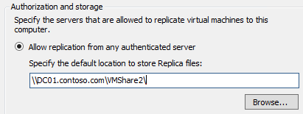

1. Click **Apply**.
2. On the **Settings** notification, click **OK**. This firewall port has already been enabled for this lab.

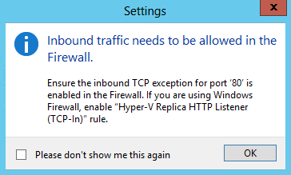

1. Click **OK**. Minimize **Hyper-V Manager**.

Exercise 6.3: Configure a Hyper-V Replica Broker

**In this exercise, the Hyper-V Replica Broker will be configured. The Hyper-V Replica Broker is a clustered role that makes the Hyper-V Replica replication process highly-available, so that replication will always happen as long as the cluster is online. Replication can happen between clusters, between standalone hosts or between a cluster and a standalone host, however it cannot take place between nodes in a single cluster.**

**Estimated time to complete: 3 minutes**

 *Perform the following on* ***VMM01***

1. Open **VMM01** then open **Failover Cluster Manager**.



1. In the left navigation pane, expand **CLUSTER1.contoso.com**, right-click **Roles** and click **Configure Role**

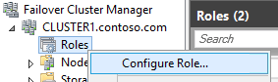

1. On the **Before You Begin** window, click **Next**.
2. On the **Select Role** screen, select **Hyper-V Replica Broker** and click **Next.**

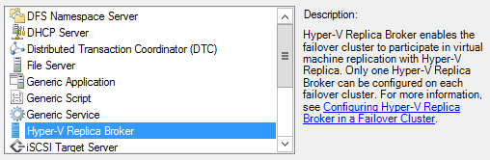

1. On the **Client Access Point** screen, in the Name box, enter **HVRB**.

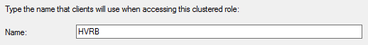

1. Below the Address cell, click on the dialog which states: “**Click here to type an address**” and enter “**101**” in the far right text box so the Address is **192.168.2.101**. Click **Next**.

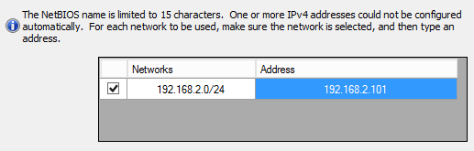

1. On the Confirmation screen, check that the configuration matches the screenshot below, then select **Next**.

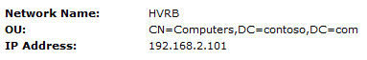

1. After the wizard completes successfully, click **Finish**.

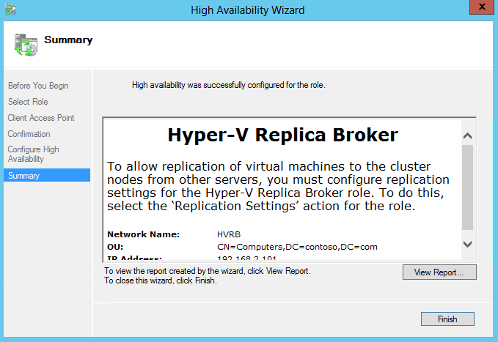

1. After a few seconds, the **Hyper-V Replica Broker Role** will be **Online**. This is indicated by the **Status** showing Running.



1. Right-click on the Hyper-V Replica Broker **HVRB** and select **Replication Settings**.

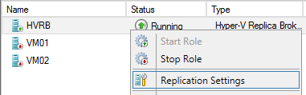

1. On the **Hyper-V Replica Broker Configuration** screen, select the checkbox for **Enable this cluster as a Replica server** and select **Use Kerberos** as the authentication mechanism. Leave the default **port 80**. Click **OK** if a firewall notification appears.

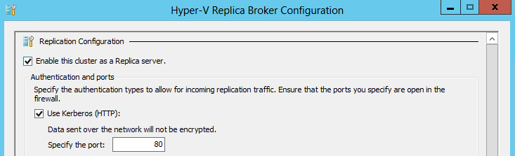

1. Under **Authorization and storage** select the option for **Allow replication from any authenticated server**. Enter **\\dc01.contoso.com\VMShare3** as the **default location to store Replica files**.

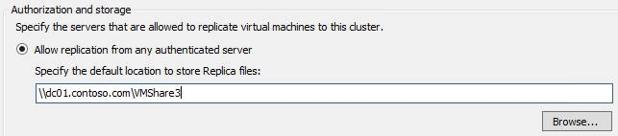

1. Click **Apply** and on the Settings popup, click **OK**. This firewall port has already been enabled for this lab.

Exercise 6.4: Replicate a VM

**In this exercise, replication for a virtual machine will be enabled, then other replication settings will be configured. After the initial replication has happened, if there is a disaster then this VM can be recovered at the secondary location.**

**Estimated time to complete: 5 minutes**

 *Perform the following on* ***VMM01***

1. Open **VMM01** then open **Failover Cluster Manager.**



1. Expand **CLUSTER1.contoso.com** and click **Roles.**

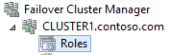

1. Right-click **VM01**, select **Replication**, then **Enable Replication.**

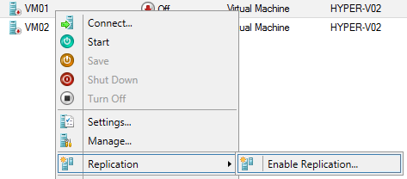

1. In the **Before You Begin** window, click **Next**.
2. In the **Specify Replica Server** window, type **VMM01** and click **Next.**

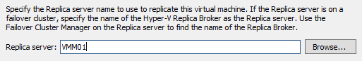

1. On the **Specify Connection Parameters** window, leave all the defaults, and click **Next.**

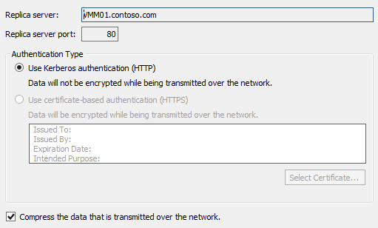

1. On the **Choose Replication VHDs** window, ensure both VHDX files are selected, and click **Next.**

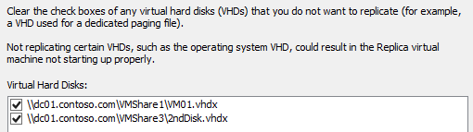

1. For **Configure Recovery History**, select **Only the Latest Recovery Point** and click **Next.**

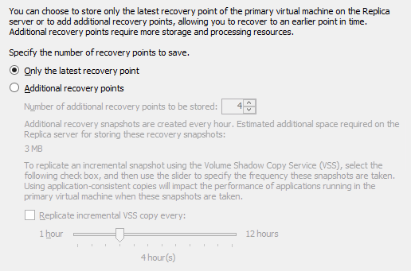

1. For **Initial Replication Method** select **Send Initial Copy Over the Network** and ensure replication starts immediately. Click **Next**.

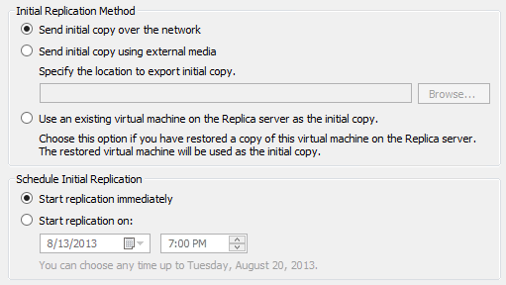

1. On the summary window, ensure the settings are the same as the screenshot below, and click **Finish.**

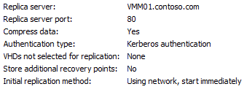

1. A prompt will appear confirming that replication has been enabled. Click **Close.**

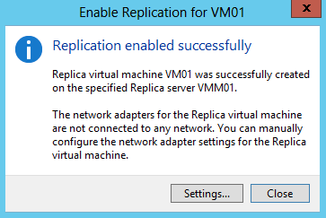

1. Right-click **VM01**, select **Replication** and observe the options that are available, such as a Planned Failover, which is useful if the VMs need to be moved to the alternative location for maintenance or if a disaster is forecast. Navigate away from this menu.

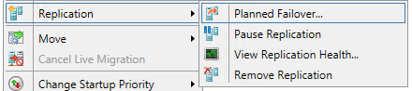

1. **Minimize Failover Cluster Manager**, then open **Hyper-V Manager.**
2. Select **VMM01** from the left hand navigation.
3. Click **VM01**, and at the bottom of Hyper-V Manager, click the **Replication** tab. Observe some of the information, such as the **primary and destination servers** and the **last synchronization time**.

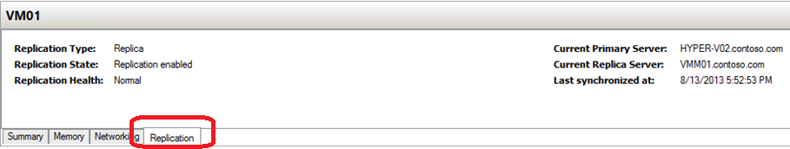

1. Right-click **VM01**. Select **Replication**. This is the replicated machine. Notice the option to Failover the VM (if the primary site was unavailable), or even Test Failover, in order to prepare and test for a potential disaster on the primary site. Select **View** **Replication Health.**

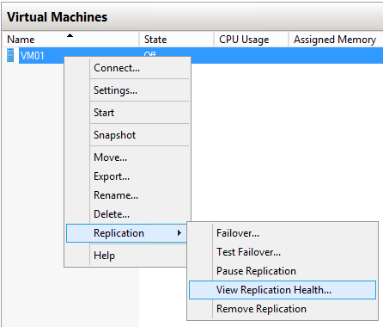

1. Observe some of the information presented in the window, then click **Close.**

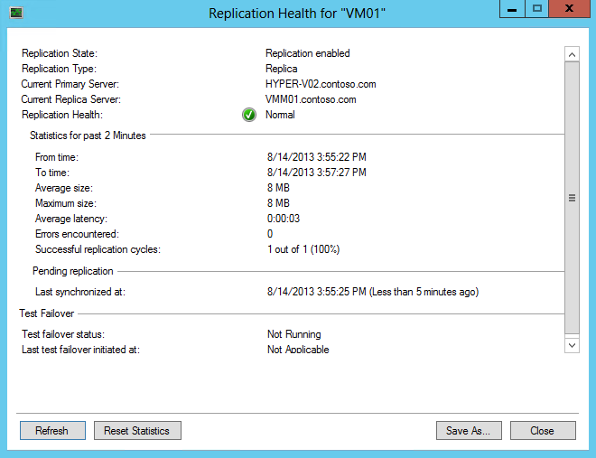

1. Right-click **VM01** and click **Settings.**

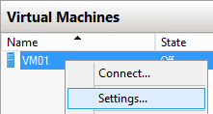

1. In the Hardware navigation, expand **Network Adaptor**, and select **Failover TCP/IP.**

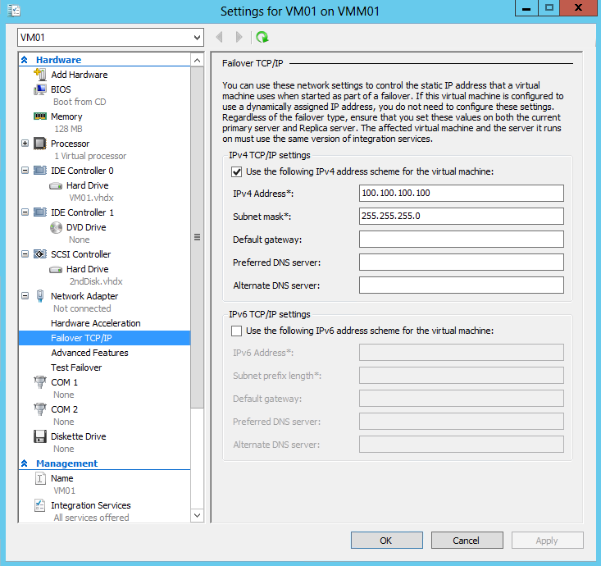

1. Select the **Use the following IPv4 Address Scheme for the Virtual Machine** box, and enter **100.100.100.100** as the IP address, and **255.255.255.0** as the subnet mask. These network settings would be injected into the VM upon failover to the second site.

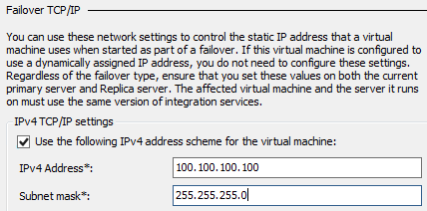

1. Click **OK** to close the VM01 settings.
2. Close **Hyper-V Manager** and **Failover Cluster Manager**.

------------------------------------------------------------END OF LAB 6------------------------------------------------------------

**Lab 7: Host Configuration with VMM**

Exercise 7.1: Add Hyper-V Hosts to VMM

1. **In this exercise, the Hyper-V Cluster will be placed under the management control of System Center Virtual Machine Manager 2012 SP1. First, Host Groups will be created to organize the VMs, then Run As Accounts will be configured which manage user permissions to access resources and actions.**
2. **Estimated time to complete: 10 minutes**

 *Perform the following on* ***VMM01***

1. Open **VMM01,** then open the **Virtual Machine Manager Console**.

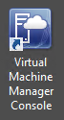

1. On the **Connect to Server** window, ensure **Use current Microsoft Windows session identity** is selected, and click **Connect**.

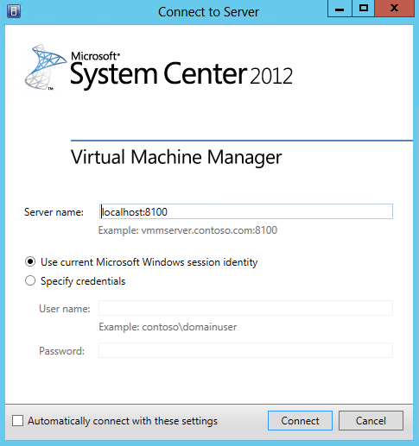

1. Click the **VMs and Services** workspace.

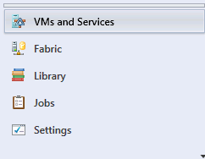

1. On the top ribbon, click **Create Host Group**.

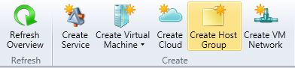

1. When the host group appears in the left hand navigation, under **All Hosts**, change the name to **PRODUCTION.**

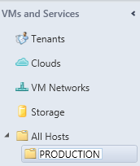

1. Right-click **PRODUCTION** and select **Add Hyper-V Hosts and Clusters.**

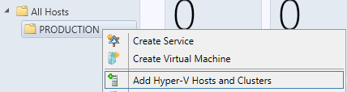

1. In the **Add Resource Wizard,** on the Resource location page,leave the default selection of **Windows Server computers in a trusted Active Directory domain**, and click **Next**.

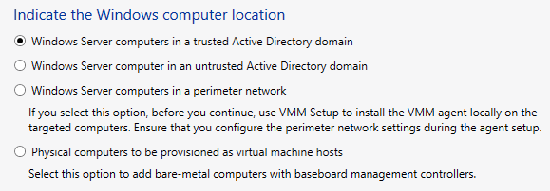

1. On the **Credentials** page, ensure that **Use an existing Run As Account** is selected, and click **Browse.**

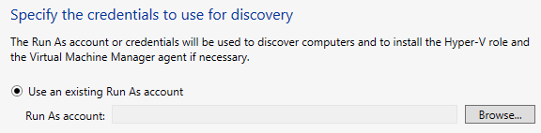

1. In the **Select a Run As Account** window, click **Create Run As Account.**

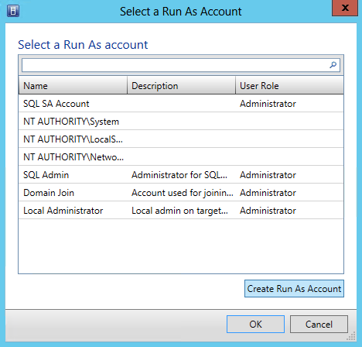

1. In the **Create Run As Account** window, ensure that **Validate domain credentials** is selected, type the following, and then click **OK**:

* Name: **VMM Admin**
* User Name: **contoso\vmmadmin**
* Password: **Passw0rd!**
* Confirm password: **Passw0rd!**

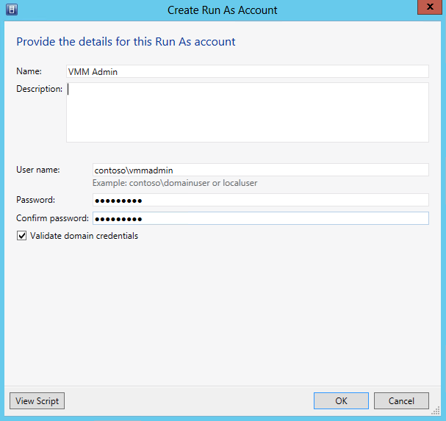

1. Back on the **Select a Run As** Account window, select **VMM Admin** and click **OK**.

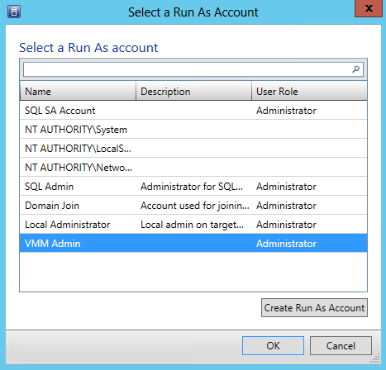

1. Back on the **Add Resource Wizard** window, click **Next.**

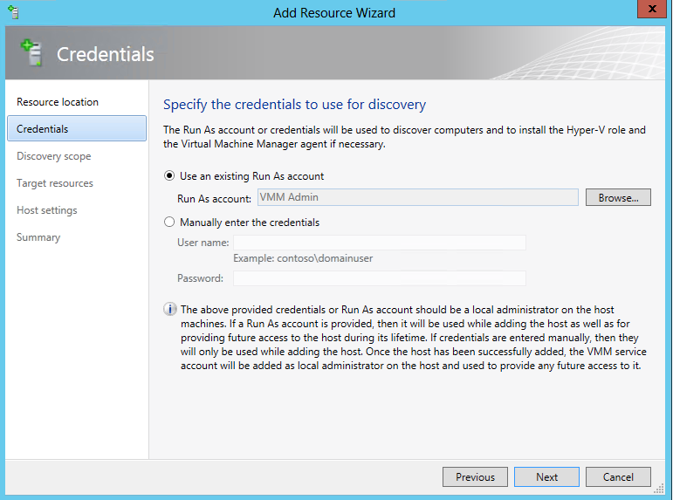

1. On the **Discovery Scope** page, ensure that **Specify Windows Server computers by names** is selected, and type **HYPER–V01** in the computer names box. Ensure the **Skip AD verification** box is not selected, and click **Next**.

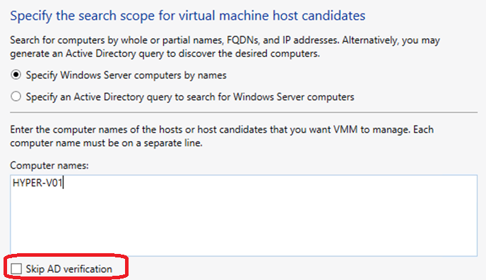

1. The wizard will scan for **HYPER-V01**. If an error pops up, ignore this, click **OK**, and then click **Refresh**.
2. When complete, on the **Target Resources** page, select **CLUSTER1** and click **Next**.

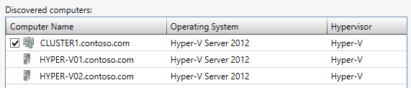

1. On **Host** Settings, ensure that **PRODUCTION** is the selected **Host** group and click **Next.**

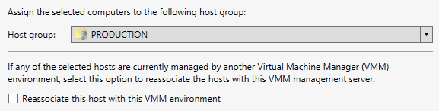

1. On the **Migration Settings** page, leave the defaults and click **Next**. VMM will update these settings from the cluster/hosts once imported.

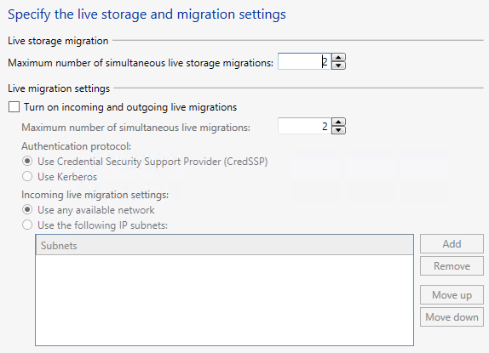

1. On the **Summary** page, ensure the settings match those of the screenshot below and click **Finish**.

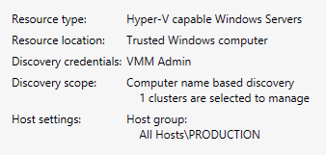

1. The **Jobs** window will automatically open and the host/cluster import process will begin. This will take several moments to complete.

Exercise 7.2: Configure Host Optimization

**In this exercise, Dynamic Optimization and Power Optimization capabilities will be configured for the Hyper-V cluster. Dynamic Optimization will automatically balance VMs across the cluster nodes. Power Optimization will turn off unnecessary hosts during times of lower server utilization.**

**Estimated time to complete: 5 minutes**

 *Perform the following on* ***VMM01***

1. Open **VMM01** then open the **Virtual Machine Manager Console**. If the **Connect to Server** window appear, ensure **Use current Microsoft Windows session identity** is selected, and click **Connect**.



1. Select the **Fabric** workspace.

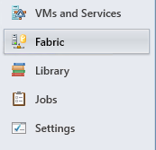

1. Expand **Servers**, expand **All Hosts**, expand **PRODUCTION**, right-click **CLUSTER1.contoso.com** and select **Properties.**

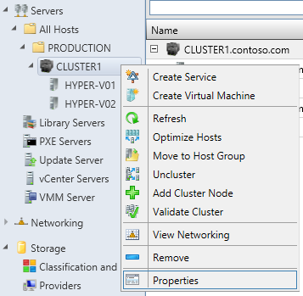

1. On the **CLUSTER1.contoso.com Properties** screen, on the General page, reduce the **Cluster Reserve (nodes)** to **0**, then click **OK.**

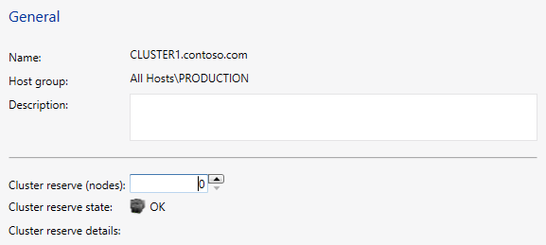

1. In the left hand navigation, right-click the **PRODUCTION** host group and select **Properties**.

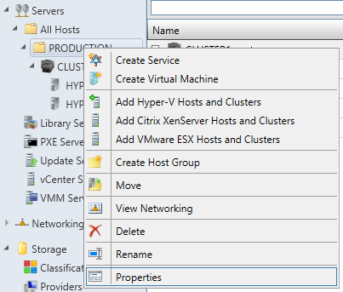

1. Under **PRODUCTION Properties** page, select **Host Reserves**.

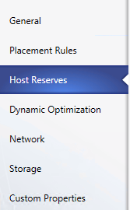

1. On the **Host Reserves** page, unselect the **Use the host reserve settings from the parent host group** and change the settings for **Memory** amount to **5** and the **Unit** to **%**.

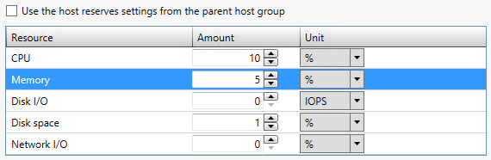

1. Click the **Dynamic Optimization** tab.

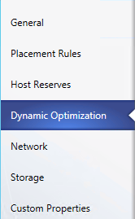

1. On the **Dynamic Optimization** page, unselect the **Use dynamic optimization settings from the parent host group** and slide the **Aggressiveness** slider to **High**. Then select the box for **Automatically migrate virtual machines to balance load at this frequency (minutes)** and enter **5** in the box.

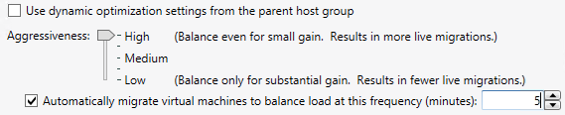

1. Select the **Enable power optimization** box and click **Settings.**

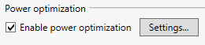

1. **Review** the default threshold values and under **Schedule**, click one of the blue squares **between 8am and 6pm**, **Monday to Friday.** The square will turn **white** when clicked, to indicate no power optimization will operate during those times. By pressing the keyboard arrow keys plus the space bar the squares can be changed. Change a few of these squares, then click **OK.**

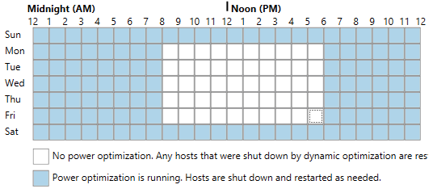

1. Back on the **PRODUCTION Properties** page, click **OK** to close the window.

------------------------------------------------------------END OF LAB 7------------------------------------------------------------

**Lab 8: Storage Configuration with VMM**

Exercise 8.1: Manage a File Server

1. **In this exercise, the File Server will be added under the management of Virtual Machine Manager. This enables VMM to create and provision File Shares to Hyper-V hosts, for use with Virtual Machines.**
2. **Estimated time to complete: 10 minutes**

 *Perform the following on* ***VMM01***

1. Open **VMM01** then open the **Virtual Machine Manager Console**. If the **Connect to Server** window appear, ensure **Use current Microsoft Windows session identity** is selected, and click **Connect**.



1. Select the **Fabric** workspace.



1. On the left hand navigation, expand **Storage** and click **File Servers**.

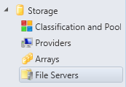

1. On the ribbon navigation, click **Add Resources**, and then click **Storage Devices.**

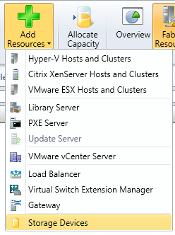

1. The **Add Storage Devices** Wizard will open. On the **Select Provider Type** page, select **Add a Windows-based file server as managed storage device** option and click **Next**.

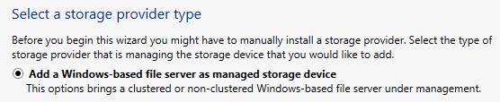

1. On the **Specify Discovery Scope** page, leave the **This computer is in an untrusted Active Directory domain** box unchecked**.** In the box under **Provider IP address or FQDN:** enter **dc01.contoso.com**
2. For the **Run As account:** click **Browse**.

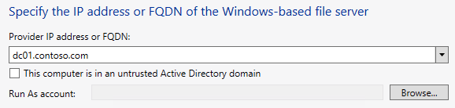

1. In the **Select a Run As Account** window, click **Create Run As Account.**



1. In the **Create Run As Account** window, ensure that **Validate domain** credentials is selected, type the following, and then click **OK**:

* Name: **Storage Admin**
* User Name: **contoso\administrator**
* Password: **Passw0rd!**
* Confirm password: **Passw0rd!**

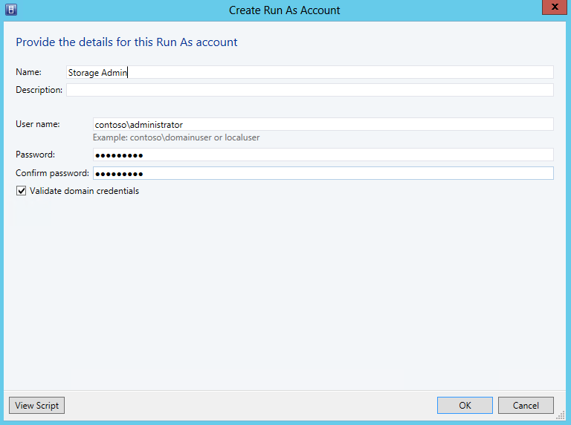

1. Back on the **Select a Run As** Account window, select **Storage Admin** and click **OK**.

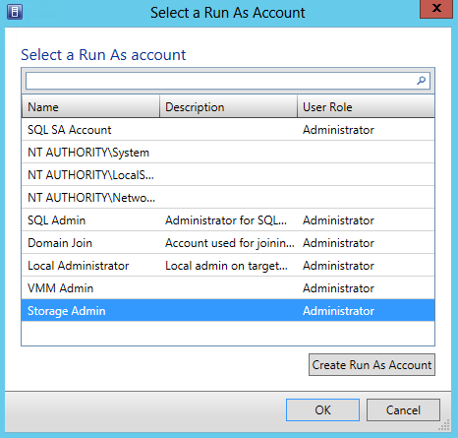

1. After returning to the **Specify Discovery Scope** page, click **Next**. VMM will automatically scan DC01 and return the results below. Review the results, and then click **Next.**

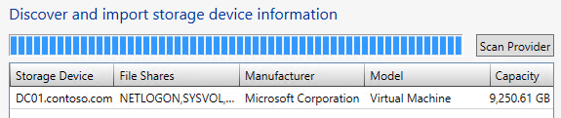

1. On the **Select Storage** Devices page, check **VMShare1**, **VMShare2**, and **VMShare3**, and click **Next.**

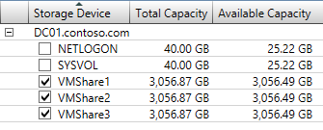

1. On the **Summary** screen, ensure the settings match the screenshot below, then click **Finish.** VMM will then bring these File Shares under its management.

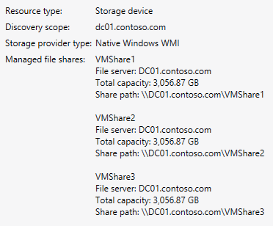

1. The **Jobs** screen will appear. Review the results, then close the **Jobs** screen. There should now be a number of File Shares listed, and three of these will be managed by VMM.

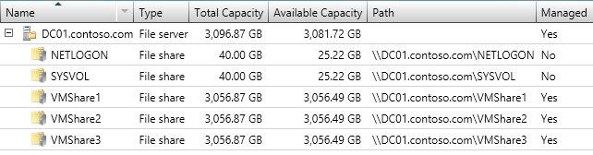

1. From the top ribbon, click **Create File Share**.

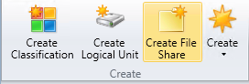

1. A **Create File Share** window will open. In the **Name** box type in **VMShare4**, and for **Local Path** enter **V:\Shares\VMShare4,** then click **Add.**

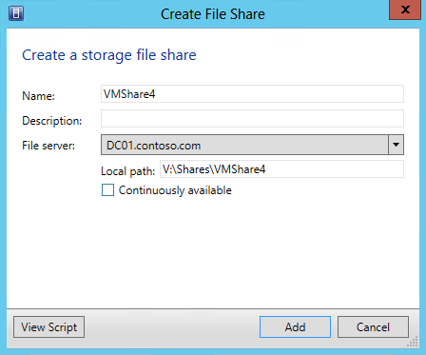

1. Minimize the **Virtual Machine Manager Console**, and open **Server Manager.**



1. Select on **File and Storage Services** | **Shares.**

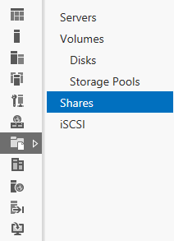

1. The **VMShare4** should now appear in the list of shares on **DC01**. Close **Server Manager**.

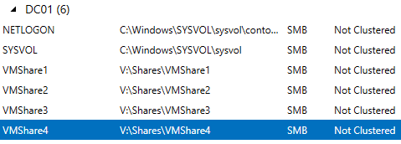

1. **Maximize** the **Virtual Machine Manager Console**.
2. Select the **Fabric** workspace.
3. Expand **Servers | All Hosts | PRODUCTION**, right-click on **CLUSTER1** and select **Properties.**

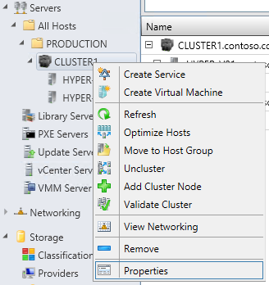

1. In the **CLUSTER1 Properties** window, click on **File Share Storage**.

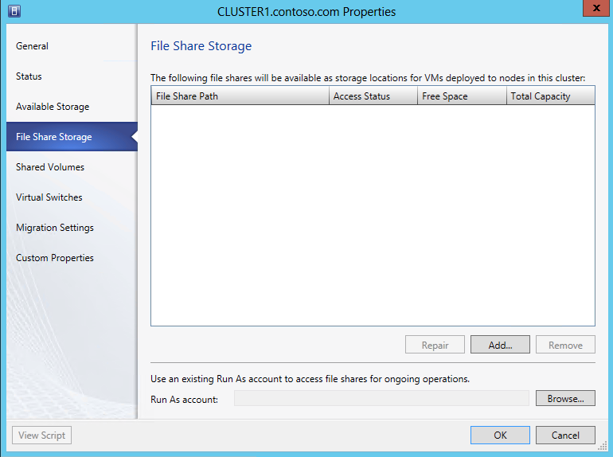

1. On the **File Share Storage** page, click **Add**.

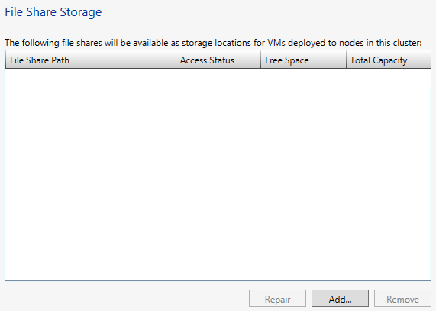

1. In the **Add File Share** dialog box, for **File share path:** use the drop down and choose **\\DC01.contoso.com\VMShare1**, and click **OK.**

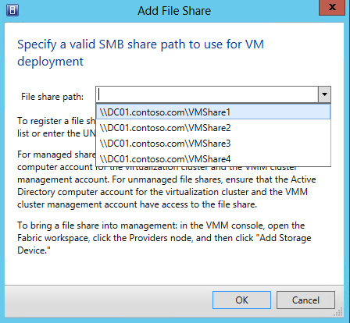

1. Repeat the **previous two steps** for the remaining three file shares. Once all the files shares been added, the **File Share Storage** window should match the following screenshot.

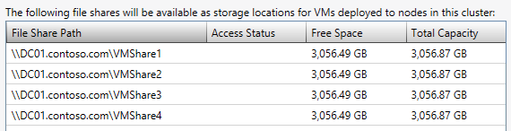

1. Click **Browse** to choose a **Run As Account**, and select **Storage Admin**, then click **OK**.

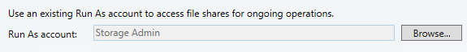

1. Back on the **File Share Storage** window, click **OK**. This will take a few moments to close.
2. Select the **VMs and Services** workspace.

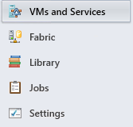

1. Select **All Hosts** from the left hand navigation.

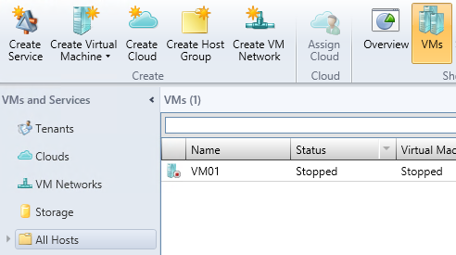

1. Select **VMs** from the ribbon navigation.



1. The VMs may show an **Unsupported VM Configuration**. This is due to VMM not having had time to refresh on its default schedule after the File Shares were added to VMM’s management.

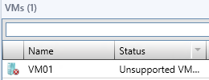

1. Right-click each of the VMs listed with Unsupported VM Configuration, and select **Refresh.** Within a few moments, the VM should return to a **Stopped** state**.**

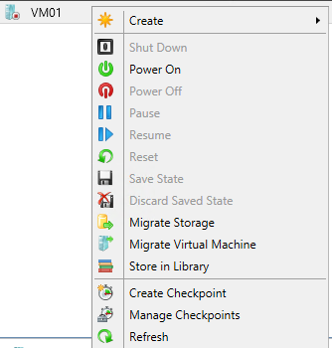

Exercise 8.2: Integrate and Manage SANs

1. **In this exercise, an iSCSI SAN will be added under the management of VMM, through integration with a SMI-S provider. This provider enables VMM to provision and allocate storage to hosts and clusters, and to provide storage for virtual machines.**
2. **Estimated time to complete: 5 minutes**

 *Perform the following on* ***VMM01***

1. Open **VMM01** then open the **Virtual Machine Manager Console**. If the **Connect to Server** window appear, ensure **Use current Microsoft Windows session identity** is selected, and click **Connect**.



1. Select the **Fabric** workspace.



1. On the left hand navigation, expand **Storage,** right-click on **Providers** and choose **Add Storage Devices**.

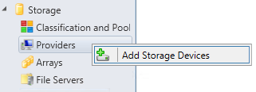

1. For the **Storage Provider Type**, select **Add a storage device that is managed by an SMI-S provider** and click **Next.**

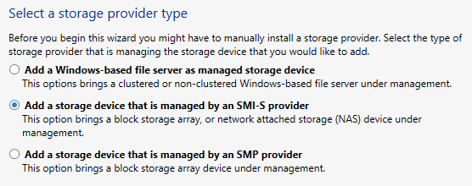

1. On the **Specify Discovery Scope** page, for **Protocol:** use the drop down and select **SMI-S WMI**, and in the **Provider IP address or FQDN:** type in **VMM01.contoso.com**.

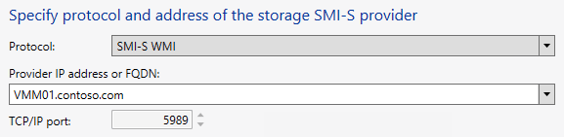

1. For the **Run As Account,** click **Browse**.

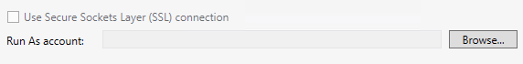

1. Choose **VMM Admin** and click **OK**.

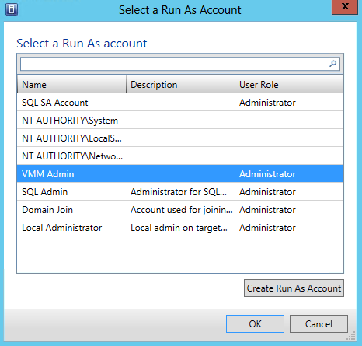

1. Back on the **Specify Discovery Scope** page, click **Next**.

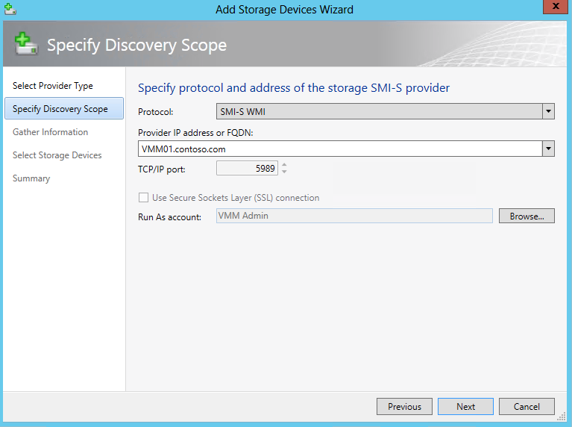

1. Discovery against the target will now take place. Once complete, select **VMM01** and click **Next**.

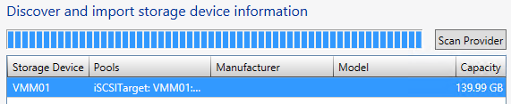

1. On the **Select Storage Devices** page, click **Create classification…**

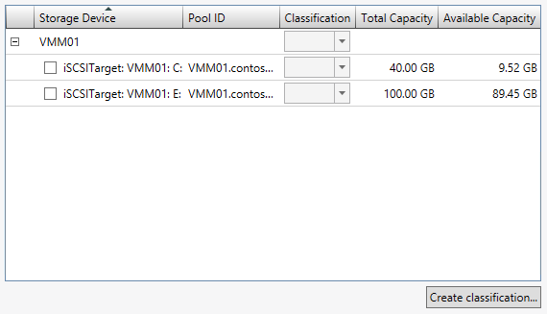

1. In the **Name:** box type in **Gold Tier** and click **Add**.

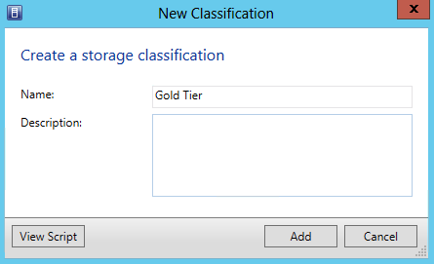

1. Back on the **Select Storage Devices** page, select the box next to **iSCSITarget: VMM01: E:** and under **Classification**, select **Gold Tier** from the drop down list, then click **Next.**

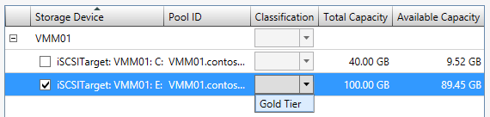

1. On the Summary page, ensure the settings match those in the screenshot below, and click **Finish**.

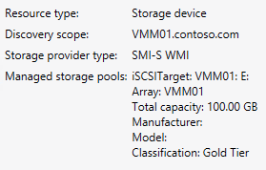

1. The **Jobs** window will open. Reviewthe completed jobs, and then close the **Jobs** window.

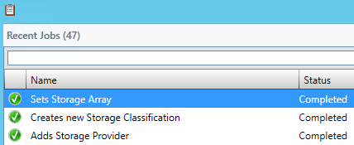

Exercise 8.3: Provision iSCSI Storage

1. **In this exercise, VMM will be used to provision and allocate storage to hosts and clusters to provide storage for virtual machines.**
2. **Estimated time to complete: 5 minutes**

 *Perform the following on* ***VMM01***

1. Open **VMM01** then open the **Virtual Machine Manager Console**. If the **Connect to Server** window appear, ensure **Use current Microsoft Windows session identity** is selected, and click **Connect**.



1. Select the **Fabric** workspace.
2. Using the left hand navigation, Under **CLUSTER1** right-click **HYPER-V01** and choose **Properties**.

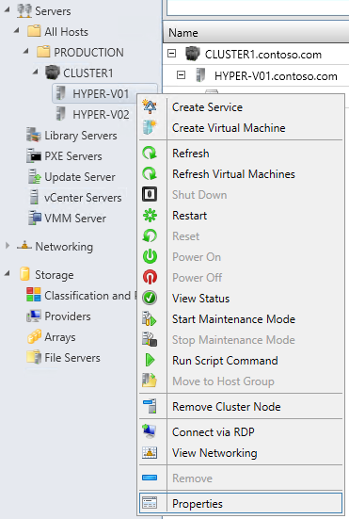

1. In the **HYPER-V01.contoso.com Properties,** click **Storage**.

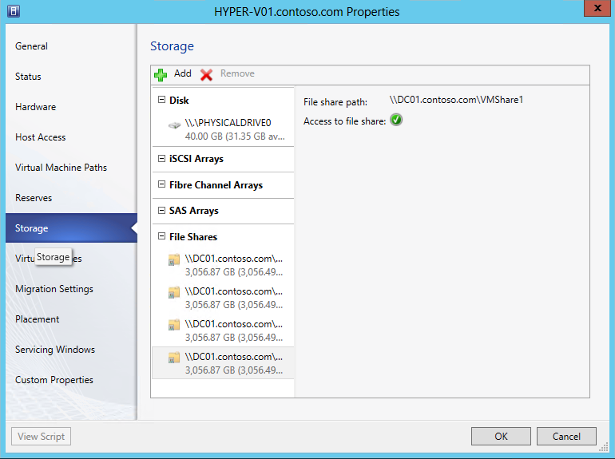

1. Click **Add** | **Add iSCSI Array**.

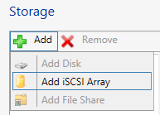

1. In the drop down of **Array:** choose **VMM01**, and then click **Create**.

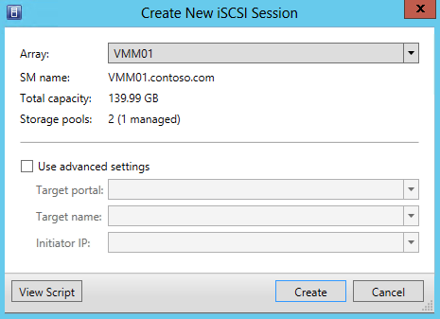

1. From the **HYPER-V01.contoso.com Properties,** click **OK**.

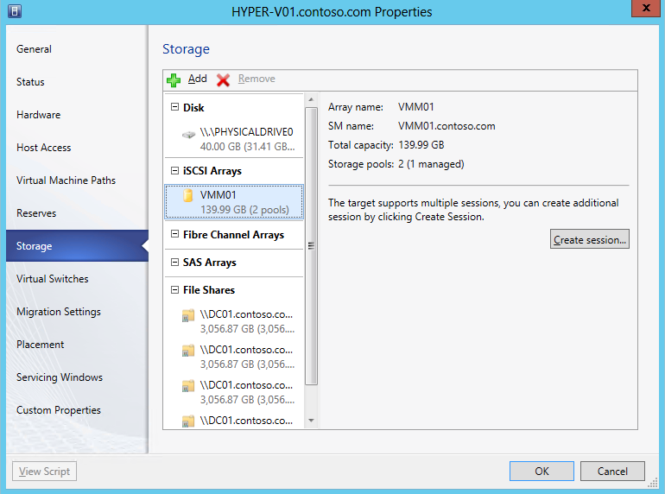

1. **Repeat Steps 3 through 7** on **HYPER-V02.**
2. In the left hand navigation, under **Storage**, click on **Classification and Pools.**

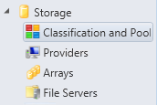

1. From the navigation ribbon, click on **Allocate Capacity**.

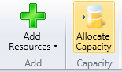

1. In the **Allocate Storage Capacity** window, under **Host groups:** choose **PRODUCTION** from the drop down list.



1. Click **Allocate Storage Pools…**

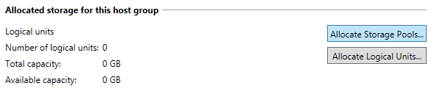

1. On the **Allocate Storage Pools** page, select the **Display as available only storage arrays that are visible to any host in the host group** check box.

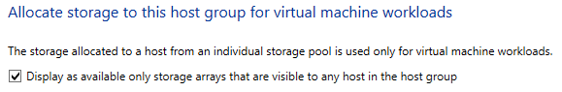

1. Select the **iSCSITarget: VMM01 E:** from the list of **Available Storage** Pools and click **Add**, then click **OK.**

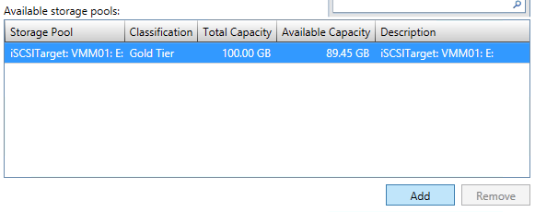

1. On the **Allocate Storage Capacity** page, click **Close**.

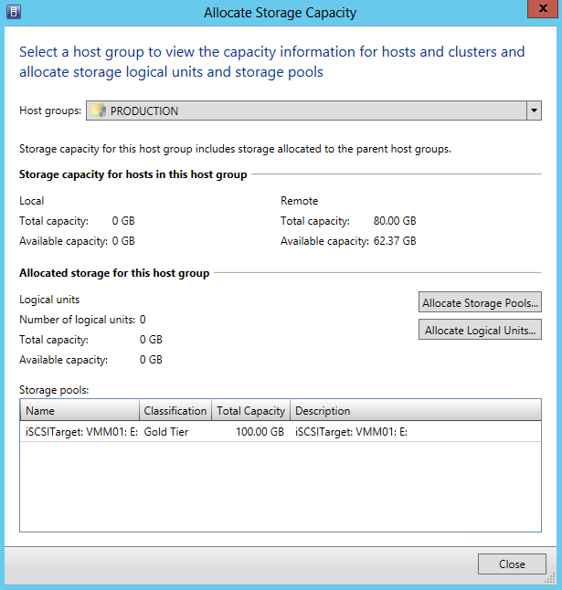

1. Right-click on **CLUSTER1** and choose **Properties**.

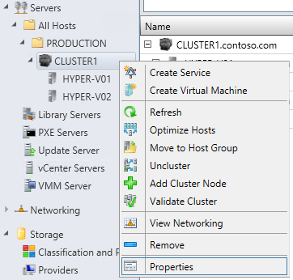

1. In the **CLUSTER1.contoso.com Properties** window, click **Shared Volumes**, and then click **Add.**

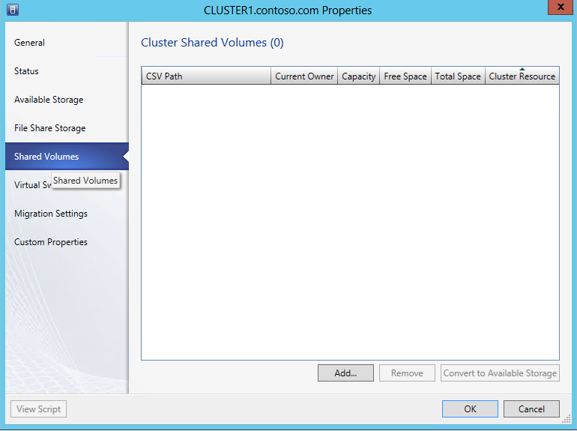

1. On the **Add Cluster Shares Volume** wizard, click **Create Logical Unit**.

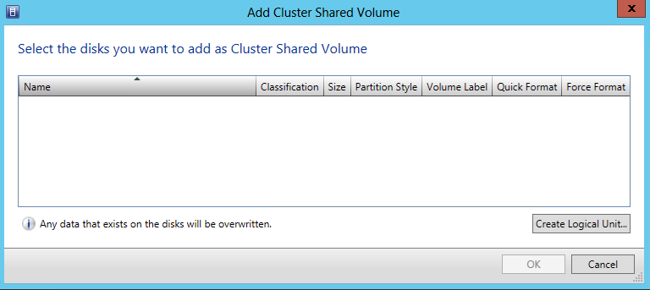

1. In the **Create Logical Unit** window, in the **Name:** box type **CSV1** and click **OK**.

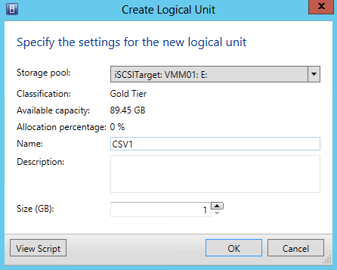

1. From the **Add Cluster Shared Volume** window, in the white **Volume Label** box type **CSV1** and check mark **Quick Format** and **Force Format**, and then click **OK.**



1. From the **Cluster Shared Volumes** page, click **OK**. VMM will then provision a LUN from the iSCSI Target, then create a Cluster Shared Volume from this LUN. This LUN will be presented to all nodes in the cluster.

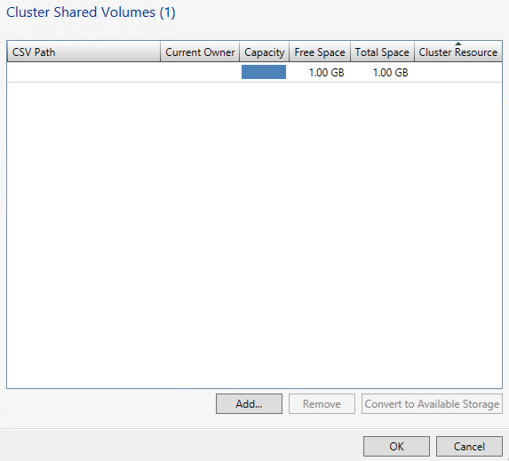

------------------------------------------------------------END OF LAB 8------------------------------------------------------------

**Lab 9: Network Configuration with VMM**

Exercise 9.1: Create Logical Networks

1. **In this exercise, a Logical Network and a group of IP Addresses will be created that can be used on that network, known as an IP Pool. A logical network in VMM is a container for network sites (also called logical network definitions) and IP subnet information, virtual local area network (VLAN) information, or both. Creating the Logical Networks will form the foundation of the networking configuration used in future exercises.**
2. **Estimated time to complete: 6 minutes**

 *Perform the following on* ***VMM01***

1. Open **VMM01** then open the **Virtual Machine Manager Console**. If the **Connect to Server** window appear, ensure **Use current Microsoft Windows session identity** is selected, and click **Connect**.



1. Select the **Fabric** workspace.



1. On the left hand navigation, expand **Networking** and click **Logical Networks**.

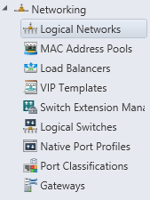

1. Then in the upper left hand corner, on the ribbon navigation, click **Create** | **Create Logical Network**.

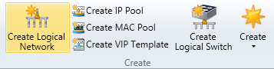

1. In the **Create Logical Network Wizard** window, for the **Name:** enter **BACKEND**. Select the box next to **Allow new VM networks created on this logical network virtualization**, then click **Next.**

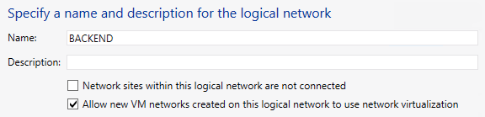

1. On the **Network Site** page, under **Network sites** click **Add**.

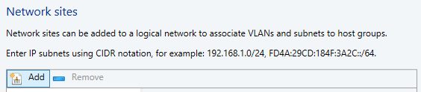

1. BACKEND_0 will appear in the window below. Under **Host groups that can use this network site:** select **PRODUCTION.**

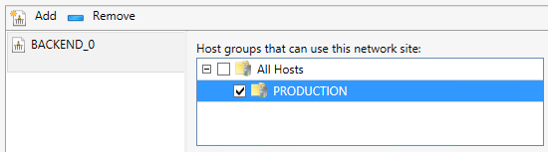

1. Under **Associated VLANs and IP subnets:** click **Insert row** and Input **0** for **VLAN** and **192.168.5.0/24** for **IP subnet**, then click **Next**.

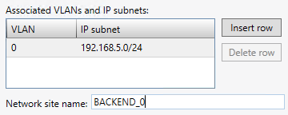

1. On the **Summary** page, review the settings and click **Finish**.

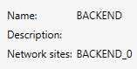

1. **Review** the completed jobs on the **Jobs** screen, and then close the window.

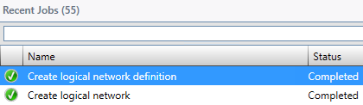

1. **In the Logical Networks and IP Pools** window, right-click **BACKEND** and **Create IP Pool**.

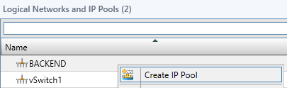

1. In the **Create Static IP Pool Wizard** window, specify the **Name:** as **BACKEND IP Pool**, ensure that the Logical Network that is selected is **BACKEND** and then click **Next.**

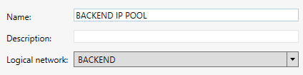

1. On the **Network Site** page, ensure that the **Use an existing network site** radio button is selected, and click **Next**.

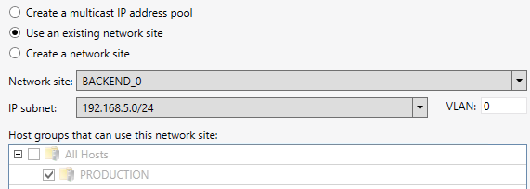

1. On the **IP Address Range** page,change the **Ending IP address:** to **192.168.5.50** and click **Next**.

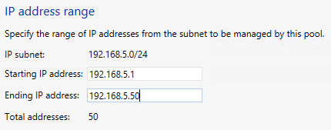

1. On the **Gateway** page, leave the entry blank and click **Next**.

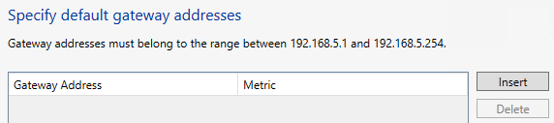

1. On the **DNS** page, leave the entry blank and click **Next**.

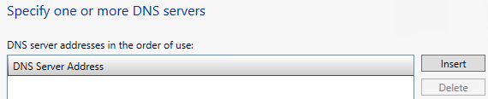

1. On the **WINS** page, leave the entry blank and click **Next**.

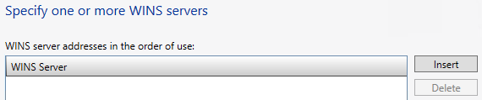

1. On the **Summary** screen, ensure the settings match the screenshot below, andClick **Finish**.

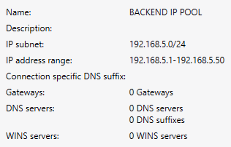

1. **Review** the completed jobs on the **Jobs** screen, and then close the window.

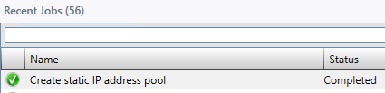

Exercise 9.2: Create Native Port Profiles

1. **In this exercise, an Uplink Port Profile that binds to physical adapters will be created. Next, a Virtual Network Adapter Port Profile will be configured. This is usually used by virtual machines, but hosts can also utilize virtual port profiles too**. **A native port profile for uplinks (also called an uplink port profile) specifies which logical networks can connect through a particular physical network adapter. A virtual network adapter port profile specifies capabilities for those adapters, and makes it possible to control how bandwidth is used on the adapters.**
2. **Estimated time to complete: 5 minutes**

 *Perform the following on* ***VMM01***

1. Open **VMM01** then open the **Virtual Machine Manager Console**. If the **Connect to Server** window appear, ensure **Use current Microsoft Windows session identity** is selected, and click **Connect**.



1. Select the **Fabric** workspace.



1. On the left hand navigation, expand **Networking**, right-click **Native Port Profiles** and select **Create Native Port Profile**.

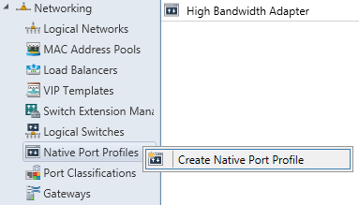

1. In the **Create Native Port Profile** Wizard, on the **General page,** for **Name:** enter **BACKEND-UPLINK**.

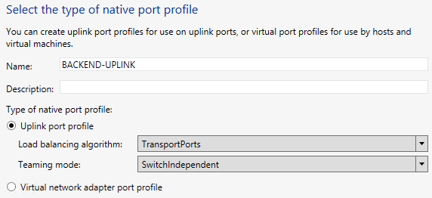

1. Select the radio button for **Uplink port profile**, then from the **Load balancing algorithm:** dropdown select **TransportPorts**, then click **Next.**
2. On the **Network Configuration** page**,** under **Network Site** select **BACKEND_0** and also select the box for **Enable Windows Network Virtualization** below, then click **Next**.

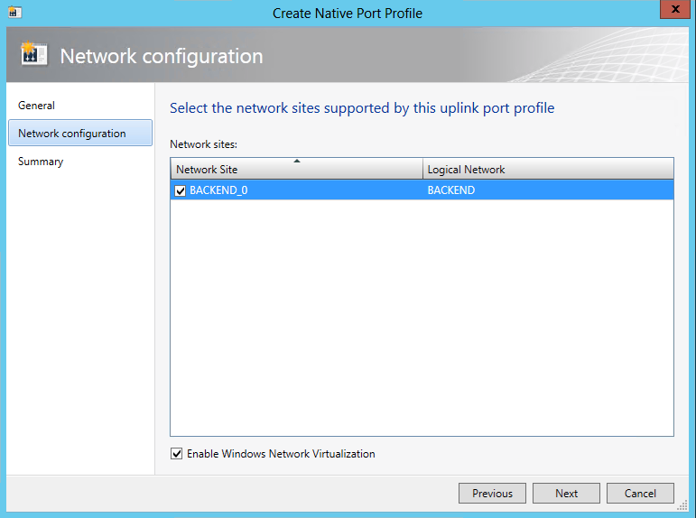

1. On the **Summary** screen, ensure the settings match the screenshot below, and click **Finish**.

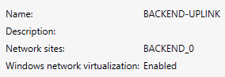

1. **Review** the completed jobs on the **Jobs** screen, and then close the window.

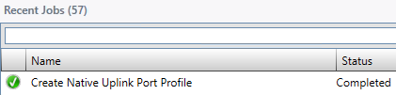

1. On the left hand navigation, right-click **Native Port Profiles** and select **Create Native Port Profile**



1. This time, in the **Create Native Port Profile** Wizard, on the **General page,** for **Name:** type **BACKEND-vNIC**, select the radio button for **Virtual network adapter port profile** and then click **Next.**

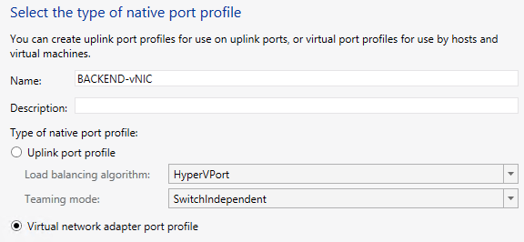

1. On the **Offload Settings** page, review the choices that can be enabled for this particular vNIC port profile, but leave them all unselected, then click **Next**.

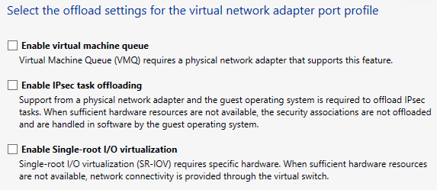

1. On the **Security Settings** page, select **Enable DHCP guard** and **Allow router guard**, and then click **Next**.

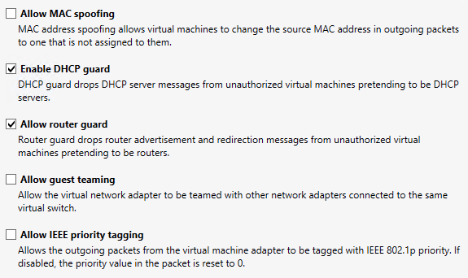

1. On the **Bandwidth Settings** page,change the **Maximum bandwidth (Mbps):** to **100**, then click **Next**.

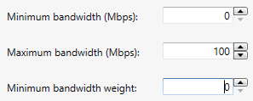

1. On the **Summary** screen, ensure the settings match the screenshot below, and click **Finish**.

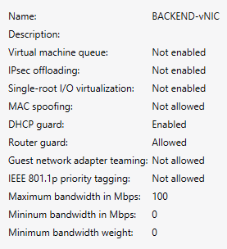

1. **Review** the completed jobs on the **Jobs** screen, and then close the window.

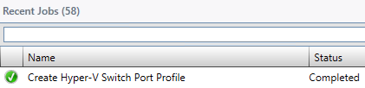

Exercise 9.3: Create Port Classifications

1. **In this exercise, a Port Classification will be created. A port classification provides a global name for identifying different types of virtual network adapter port profiles. As a result a classification can be used across multiple logical switches while the settings for the classification remain specific to each logical switch. For example, one port classification named FAST may be created to identify ports that are configured to have more bandwidth, and one port classification named SLOW to identify ports that are configured to have less bandwidth.**
2. **Estimated time to complete: 2 minutes**

 *Perform the following on* ***VMM01***

1. Open **VMM01** then open the **Virtual Machine Manager Console**. If the **Connect to Server** window appear, ensure **Use current Microsoft Windows session identity** is selected, and click **Connect**.



1. Select the **Fabric** workspace.



1. On the left hand navigation, expand **Networking**, right-click **Port Classifications** and select **Create Port Classification.**

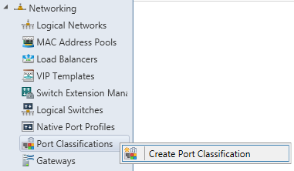

1. In the **Create Port Classification Wizard**, under **Name:** type **BACKEND PORT** and click **OK**.

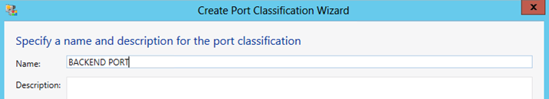

Exercise 9.4: Create a Logical Switch

1. **In this exercise, a Logical Switch will be created. A logical switch brings together all of the different Uplink Port Profiles, Native Port Profiles, Port Classifications and Switch Extensions. It is essentially a template that contains an administrator defined set of parameters (port profiles, classifications, etc.), which can be used to create Hyper-V Virtual Switches on any of the Windows Server 2012 host computers that connect to that network.**
2. **When a Logical Switch is used to create a Hyper-V Switch on a host computer, it is possible to select the most appropriate combination of Port Profiles, Classifications and Switch Extensions from the list of those defined in the Logical Switch.**
3. **Estimated time to complete: 5 minutes**

 *Perform the following on* ***VMM01***

1. Open **VMM01** then open the **Virtual Machine Manager Console**. If the **Connect to Server** window appear, ensure **Use current Microsoft Windows session identity** is selected, and click **Connect**.



1. Select the **Fabric** workspace.



1. On the left hand navigation, expand **Networking**, right-click **Logical Switches**, and click **Create Logical Switch.**

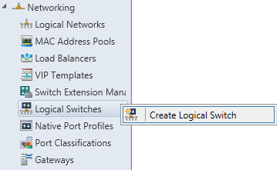

1. Read the **Getting Started** information, and then click **Next**.

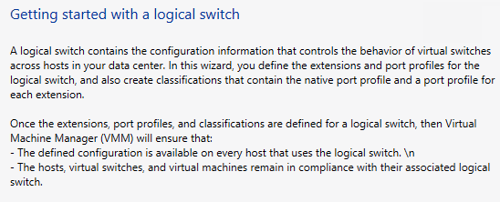

1. On the **General page, i**n the **Name:** field type **BACKEND SWITCH** and click **Next**.

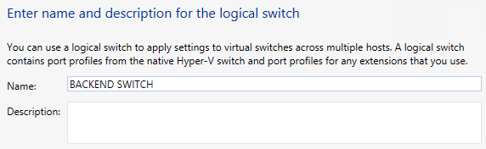

1. On the **Extensions** page **review** the currently installed **Extensions** and notice that one of them is already enabled, then click **Next**.

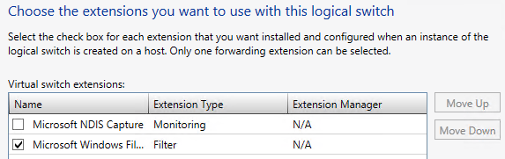

1. On the **Uplink page,** ensure **No Uplink Team** is selected, and Click **Add…**

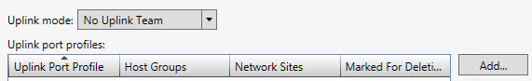

1. The **Add Uplink Port Profile** window opens. Select the **BACKEND-UPLINK** that was created earlier. Note that it already has the information about the Network sites it will support, and that Network Virtualization support is enabled. Click **OK**.

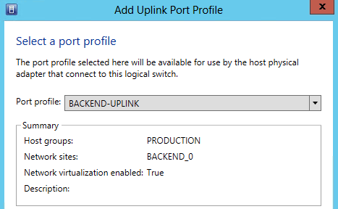

1. Back on the **Uplink** page, review the selection and click **Next**.

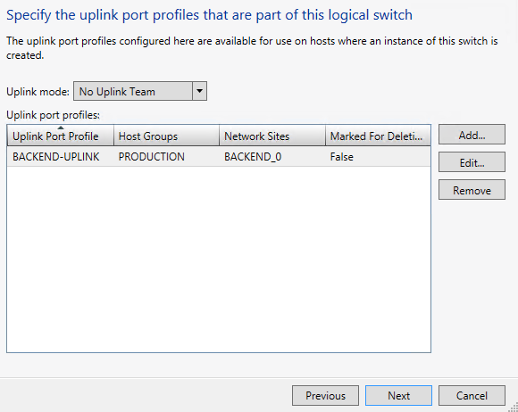

1. The **Virtual Port** page allows us to specify which vNIC configurations *can* be used with this particular logical switch. Click **Add.**



1. The **Add Virtual Port** window will open. Next to **Port Classification**, click **Browse**.

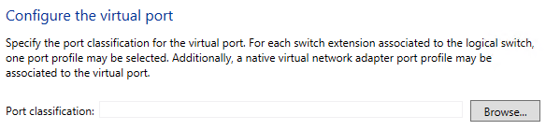

1. On the **Select a Port Profile Classification** window, select **BACKEND PORT** and click **OK.**

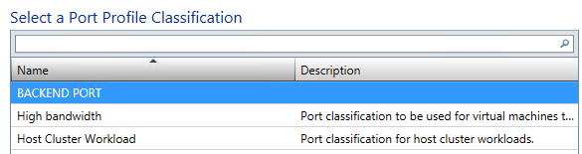

1. Back in the **Add Virtual Port** window, at the bottom, select the **Include a virtual network adapter port profile in this virtual port** box, and select **BACKEND-vNIC** from the drop-down list, then click **OK.**

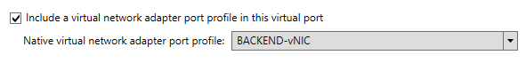

1. Back on the **Create Logical Switch Wizard** page, select the **BACKEND PORT** and click **Set Default,** then click **Next**.

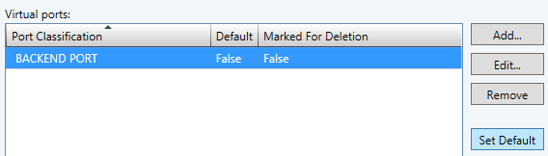

1. On the **Summary** screen, ensure the settings match the screenshot below, and click **Finish**.

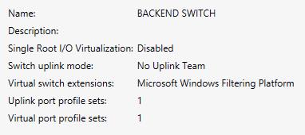

1. **Review** the completed jobs on the **Jobs** screen, and then close the window.

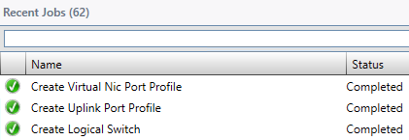

Exercise 9.5: Apply a Logical Switch

1. **In this exercise, the Logical Switch template that was just created will be applied to an unused network adapter on each of the Hyper-V hosts. This will automatically configure the appropriate settings and configuration options based on the Logical Switch that was created in the previous exercise.**
2. **Estimated time to complete: 7 minutes**

 *Perform the following on* ***VMM01***

1. Open **VMM01** then open the **Virtual Machine Manager Console**. If the **Connect to Server** window appear, ensure **Use current Microsoft Windows session identity** is selected, and click **Connect**.



1. Select the **Fabric** workspace.



1. Expand **Servers**, **All Hosts**, **PRODUCTION**, **CLUSTER1**. Right-click on **HYPER-V01** and choose **Properties**.

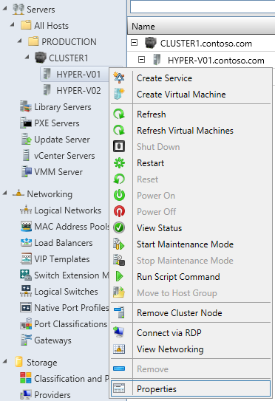

1. In the **HYPER-01.contoso.com Properties** window, on the left hand navigation, click on **Hardware.**

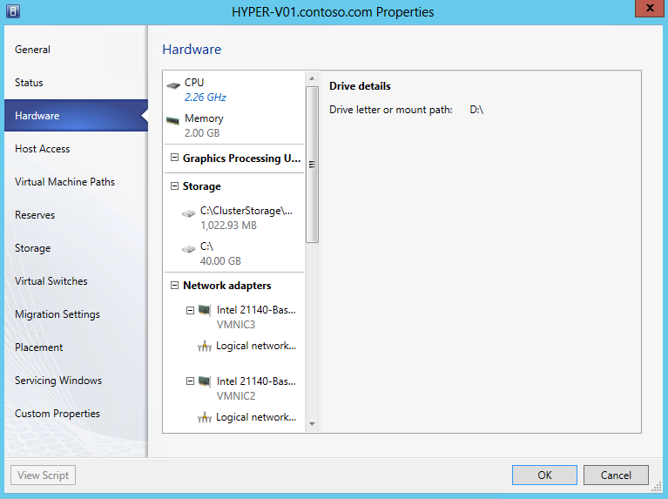

1. On the **Hardware** page, scroll down to **Network Adapters** and click on **VMNIC3.**

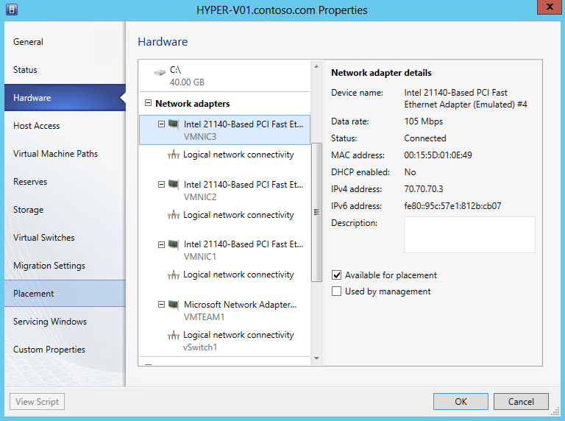

1. Under **Network adapter details**, make a note of the **Device name.** This will be used in Step 10. In the example below it is #4.

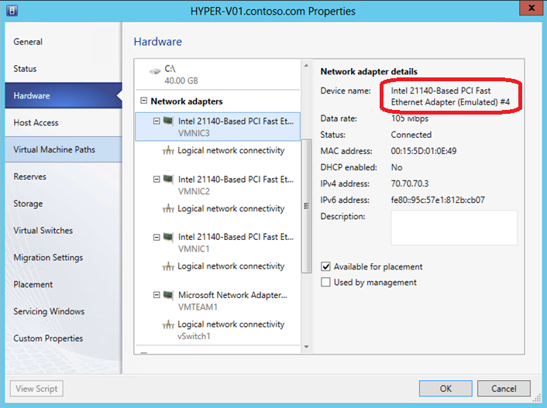

1. On the left hand navigation, click on **Virtual Switches**.

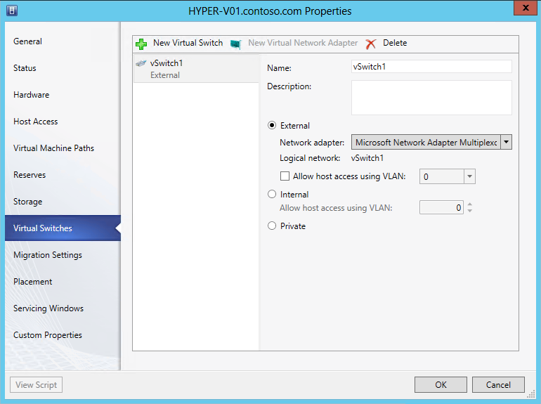

1. On the **Virtual Switches** page, click on the **New Virtual Switch** tab and choose **New Logical Switch**.

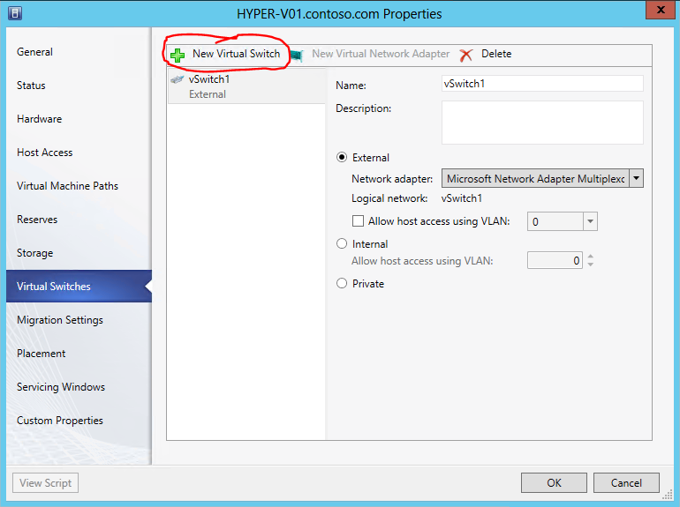

1. Ensure that the **Logical Switch** is **BACKEND SWITCH**.

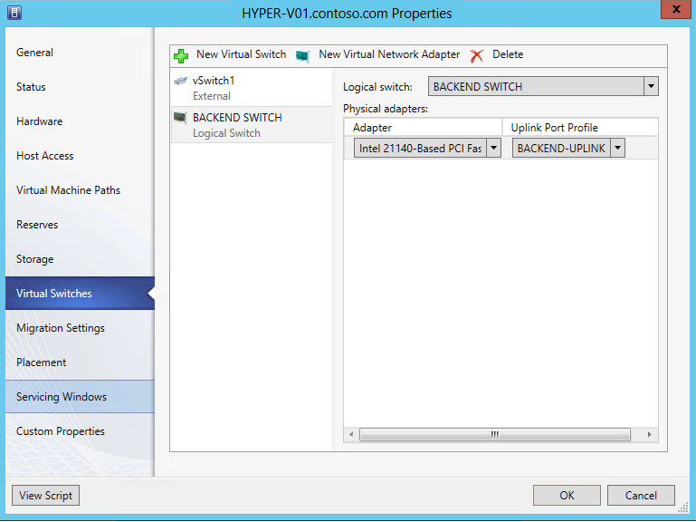

1. Under **Physical adapters:** pull down the drop down for **Adapter**, and select the adapter was noted in **Step 6**. In this example, this would be the **Intel 21140-Based PCI Fast Ethernet Adapter (Emulated) #4**. Ensure that the **Uplink Port Profile** is **BACKEND-UPLINK** and then click **OK.**

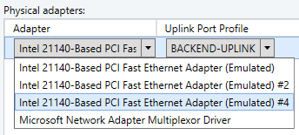

1. A warning message will pop up stating that the host may lose network connectivity whilst the Logical Switch is being applied. Click **OK** to close this window**.**

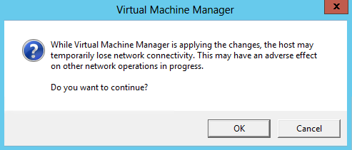

1. From the bottom left navigation, click **Jobs.**
2. Click on the currently executing job.



1. **Review** the details at the bottom of the window to see the individual tasks being performed.

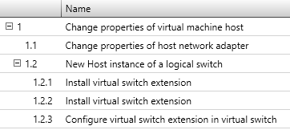

1. The status will change to **Completed w/ Info** once the change is complete**.** More details are provided at the bottom of the screen.



1. Select the **Fabric** workspace.



1. **Repeat Steps 3 through 11** for **HYPER-V02.** Once complete the cluster nodes will start utilizing the Logical Switch**.**

------------------------------------------------------------END OF LAB 9------------------------------------------------------------

**Lab 10: Network Virtualization with VMM**

Exercise 10.1: Create a VM Network

1. **In this exercise, a Virtual Network, or VM Network, will be created which will utilize Hyper-V Network Virtualization to provide isolation between VMs. It will utilize the Logical Switch and Logical Networks that were created in the previous lab.**
2. **Estimated time to complete: 8 minutes**

 *Perform the following on* ***VMM01***

1. Open **VMM01** then open the **Virtual Machine Manager Console**. If the **Connect to Server** window appear, ensure **Use current Microsoft Windows session identity** is selected, and click **Connect**.



1. Select the **VMs and Services** workspace.



1. On the left hand navigation, right-click **VM Networks** and select **Create VM Network.**

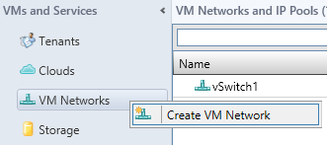

1. In the **Create VM Network Wizard**,for the **Name:** type **DEV VM NETWORK** and ensure that the **Logical Network** selected is **BACKEND,** then click **Next.**

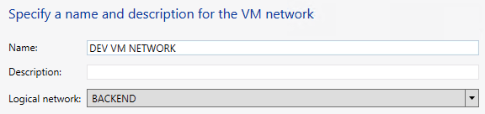

1. On the **Isolation** page, select **Isolate using Hyper-V network virtualization** and click **Next.**

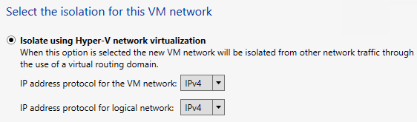

1. On the **VM Subnets** page, click the **Add** button and under **VM subnet** enter the **Name:** as **DEV LAN** and the **Subnet:** at **192.168.6.0/24,** and then click **Next.**

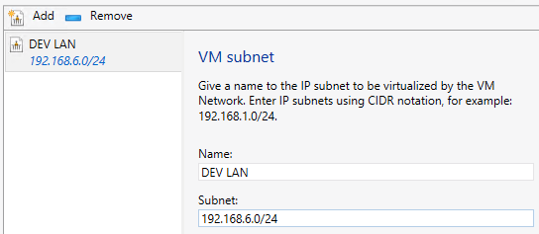

1. On the **Gateway page,** leave the default as **No connectivity** and Click **Next**.

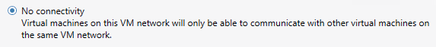

1. On the Summary page, ensure the details match the screenshot below, and click **Finish**.

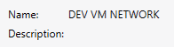

1. **Review** the completed jobs on the **Jobs** screen, and then close the window.

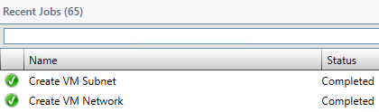

1. **Repeat Steps 3 through 9** with the following details:

* **Name:** **TEST VM NETWORK**
* **Logical Network: BACKEND**
* **Isolation: Isolate using Hyper-V network virtualization**
* **VM Subnets: Name: TEST LAN**
* **VM Subnets: Subnet: 192.168.6.0/24**
* **Gateway: No connectivity**

1. Under the **VM Networks and IP Pools** right-click **DEV VM NETWORK** and choose **Create IP Pool**.

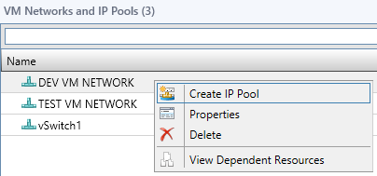

1. In the **Create Static IP Pool** **Wizard** under **Name:** type **DEV IP POOL**. Ensure the **VM Network** is **DEV VM NETWORK** and the **VM Subnet** is **DEV LAN (192.168.6.0/24).** Then click **Next.**

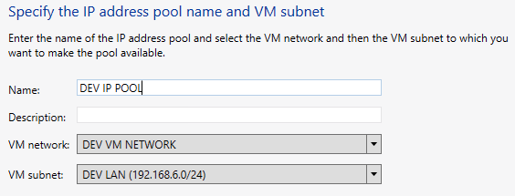

1. On the **IP Address Range** page,change the **Ending IP address:** to **192.168.6.50** and click **Next**.

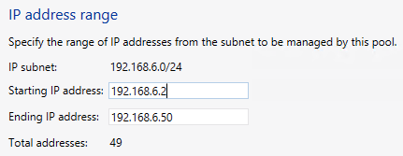

1. On the **Gateway** page, leave the entry blank and Click **Next**.

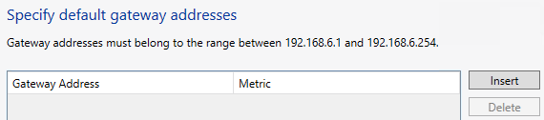

1. On the **DNS** page, leave the entry blank and Click **Next**.

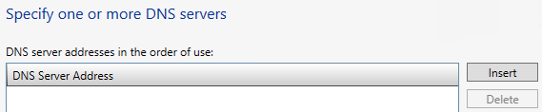

1. On the **WINS** page, leave the entry blank and Click **Next**.

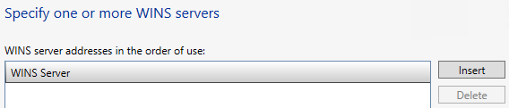

1. On the **Summary** screen, ensure the settings match the screenshot below, andClick **Finish**.

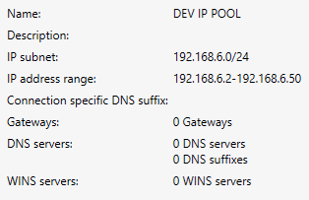

1. **Review** the completed jobs on the **Jobs** screen, and then close the window.

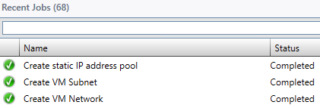

1. **Repeat** **Steps 11 through 18** for the **TEST VM NETWORK**, with the following settings:

* **Name:** **TEST IP POOL**
* **VM Network: TEST VM NETWORK**
* **VM Subnet: TEST LAN (192.168.6.0/24)**
* **IP Address Range: Ending IP Address: 192.168.6.50**
* **Gateway, DNS, WINS – Leave Default**

Exercise 10.2: Assign a VM Network

1. **In this exercise, the newly created VM Networks will be assigned to the existing virtual machines.**
2. **Estimated time to complete: 7 minutes**

 *Perform the following on* ***VMM01***

1. Open **VMM01** then open the **Virtual Machine Manager Console**. If the **Connect to Server** window appear, ensure **Use current Microsoft Windows session identity** is selected, and click **Connect**.



1. Select the **VMs and Services** workspace.



1. In the left navigation pane, select **All Hosts**.
2. From the ribbon navigation, click **Home** andthen click **VMs**.

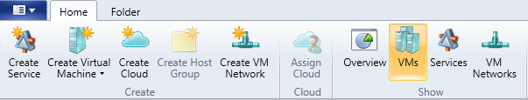

1. Right-click on **VM01** and choose **Properties**.

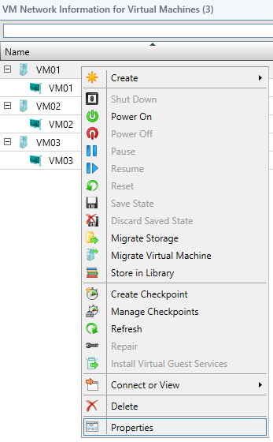

1. In the **VM01 Properties** window, select the **Hardware Configuration** tab.

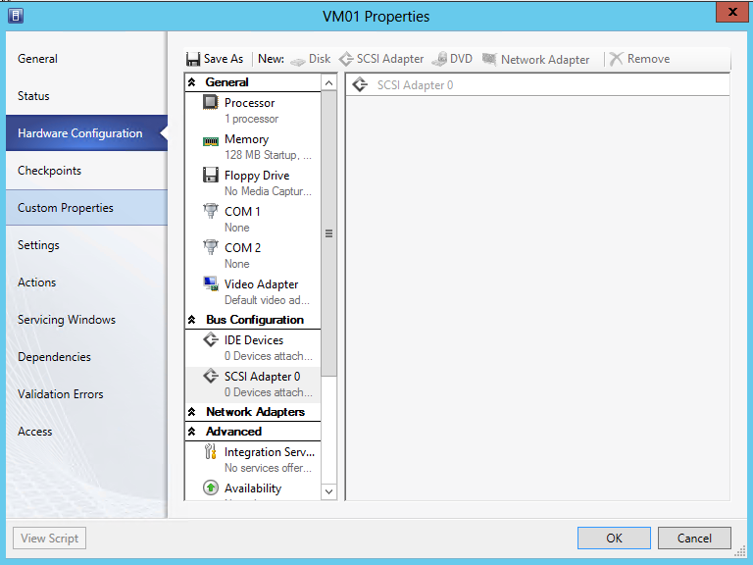

1. In the **Hardware Configuration** window, from the tabs above click on **Network Adapter** and choose **Network Adapter**.

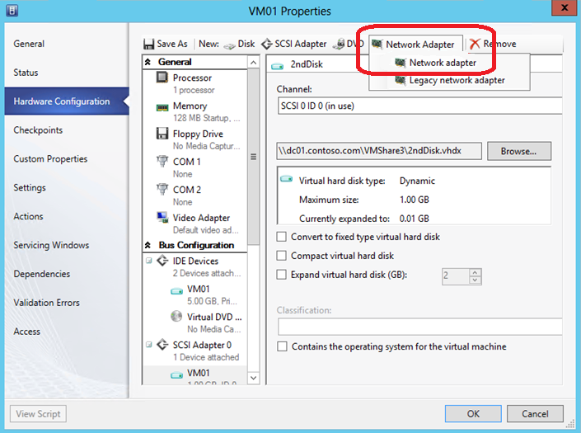

1. Under **Connectivity** choose **Connected to a VM network:** then **Browse…**

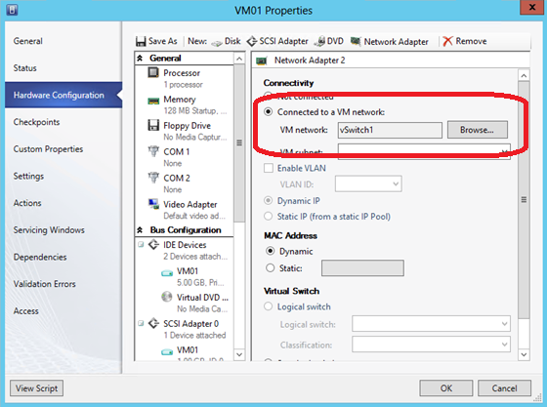

1. In the **Select a VM Network** window,select **DEV VM NETWORK** and click **OK.**

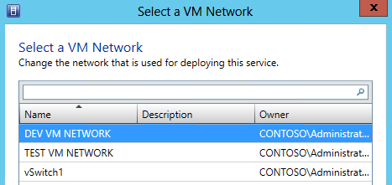

1. Back in the VM01 Properties window, under **Virtual Switch,** where **Logical switch** is selected, use the pull down for **Classification:** and choose **BACKEND PORT** and click **OK**.

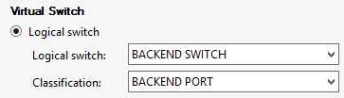

1. **Repeat Steps 4 through 9** for **VM02**, with the following information, then click **OK**.

* **Connected to VM Network: TEST VM NETWORK**
* **VM Subnet: TEST LAN**
* **Logical Switch: BACKEND SWITCH**
* **Classification: BACKEND PORT**

------------------------------------------------------------END OF LAB 10------------------------------------------------------------

**Lab 11: Create VMs & Templates with VMM**

Exercise 11.1: Create a Virtual Machine

1. **In this exercise, a virtual machine will be created. It will utilize the Logical Switch and Logical Networks that were created in the previous exercises.**
2. **Estimated time to complete: 7 minutes**

 *Perform the following on* ***VMM01***

1. Open **VMM01** then open the **Virtual Machine Manager Console**. If the **Connect to Server** window appear, ensure **Use current Microsoft Windows session identity** is selected, and click **Connect**.



1. Select the **VMs and Services** workspace.



1. On the navigation ribbon, click **Create Virtual Machine** from the ribbon menu and then click **Create Virtual Machine**.

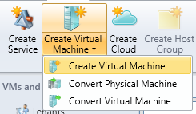

1. On the **Select Source** page, select **Create the new virtual machine with a blank virtual hard disk** and click **Next**.

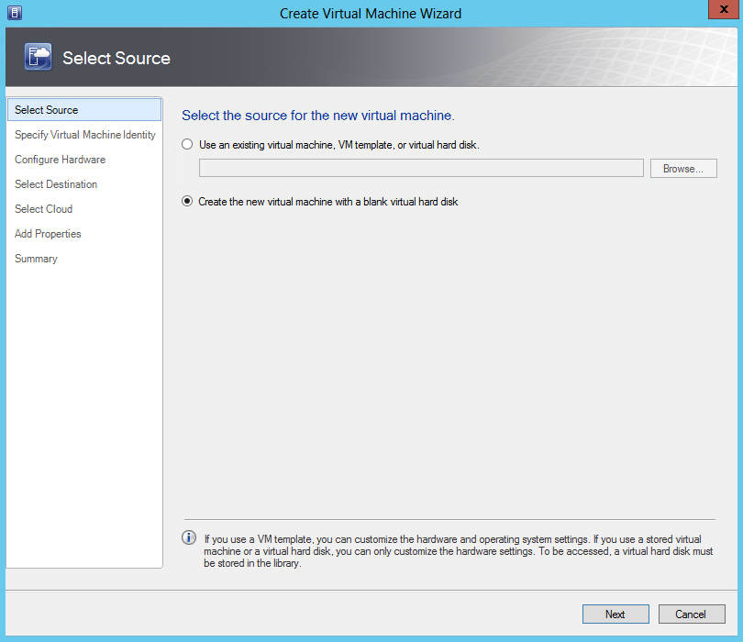

1. On the **Specify Virtual Machine Identity** page, Type **VM04** in the **Virtual Machine Name** field and click **Next**.

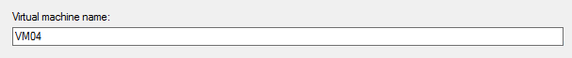

1. On the **Configure Hardware** page, select **Memory** under **General** inthenavigationtree**.** Inthedetails pane, select the **Dynamic** radio button and type **128** for **Startup Memory,** **64** in the **Minimum memory** field and **192** for **Maximum memory.**

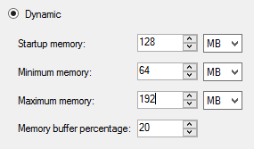

1. On the **Configure Hardware** page, select **VM04_dsk_1** under **Bus Configuration, IDE Devices** inthenavigationtree**.** Setthevirtual hard disk sizeto **5 GB**. Leave all other default settings.

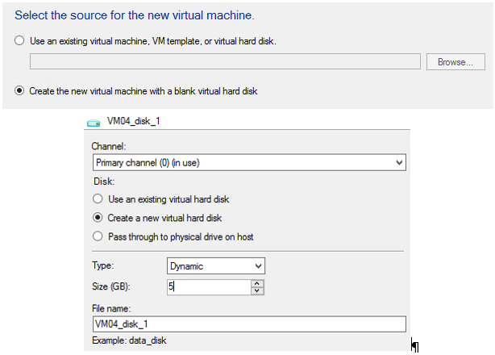

1. On the **Configure Hardware** page, scroll down in the navigation pane and select **Network Adapter 1** under **Network** Adapters. Under **Connectivity**, select the **Connect to a VM network** radio button, and click **Browse**.

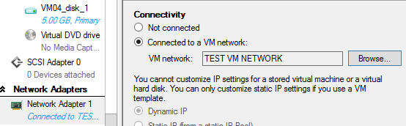

1. In the **Select a VM Network** dialog select **DEV VM NETWORK**.

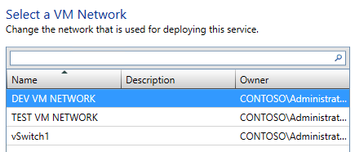

1. In the **Network Adapter 1** details pane, under **Port Profile**, select the **BACKEND PORT** from the **Classification** drop-down menu.

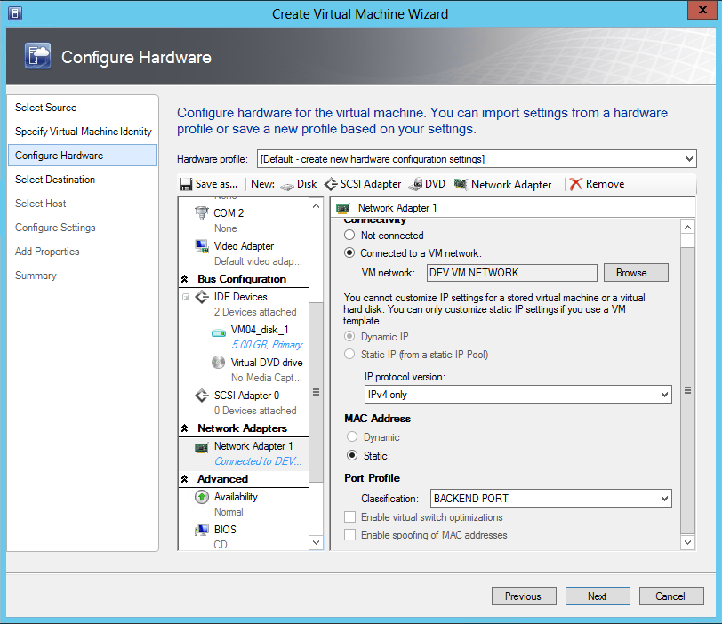

1. On the **Configure Hardware** page, select **Availability** under **Advanced** inthenavigationpane. In the **Availability** detail pane, select the **Make this virtual machine highly available** check box.

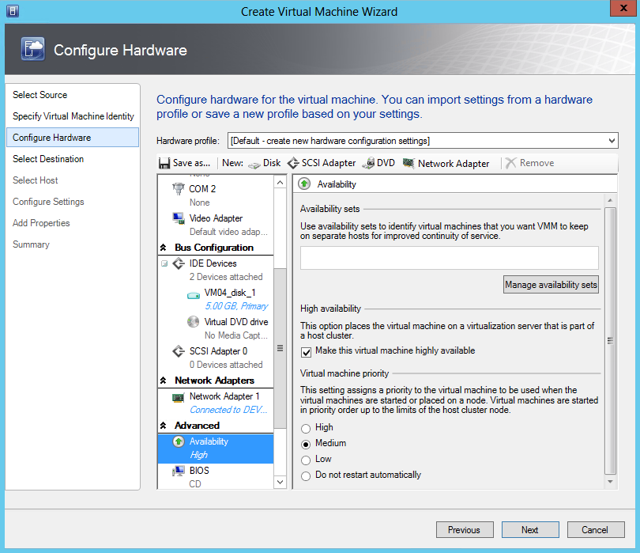

1. In the **Availability** detail pane, click **Manage availability sets**. A group of VMs that are in the same availability set with distribute themselves across different hosts as evenly as possible. This type of anti-affinity can be used to keep VMs with identical server roles (such as virtualized DCs) on different hosts to avoid a single point of failure.

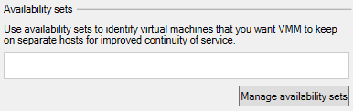

1. In the **Manage availability sets** dialog, click **Create**.

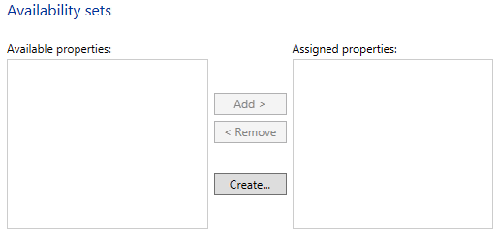

1. In the **Create Availability Set** dialog, type **Lab Availability Set** in the **Name** field and click **OK**.

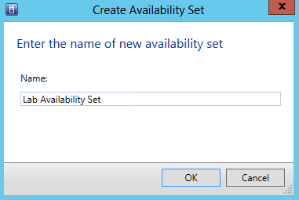

1. In the **Manage availability sets** dialog, click **OK.**

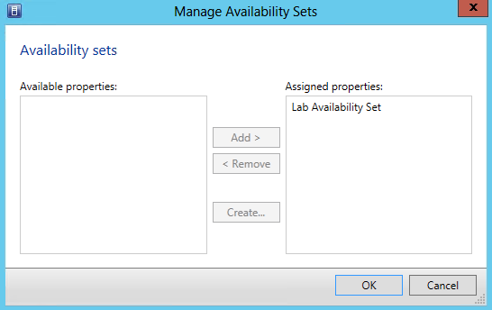

1. On the **Configure Hardware** page, click **Next**.

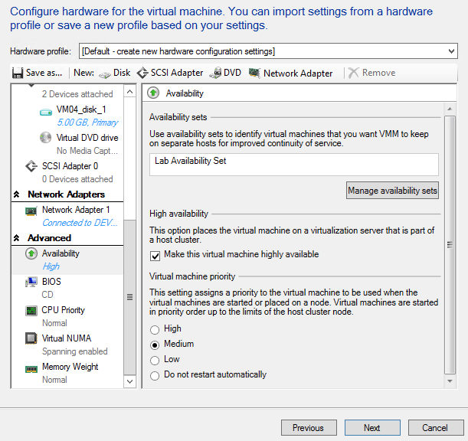

1. On the **Select Destination** page, ensure that the **Destination** is **All Hosts\PRODUCTION** and click **Next**.

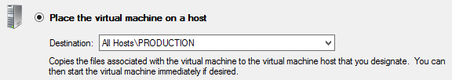

1. VMM will then scan each host for its current resource usage across CPU, Memory, Disk and Network, and rank each host based on these factors and the predicted needs of the VM. This is called **Intelligent Placement**. On the **Select Host** page, select **HYPER-V01** and click **Next**.

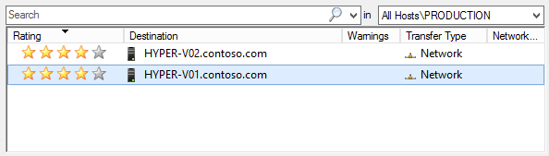

1. On the **Configure Settings** page, for the **virtual machine path**, click **Browse**.

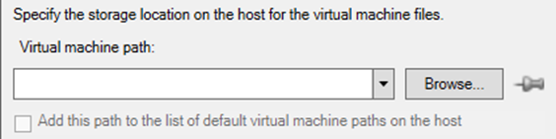

1. In the **Select a Destination Folder** dialog, expand **File Shares** and select **\\DC01.contoso.com\VMShare3** and click **OK**.

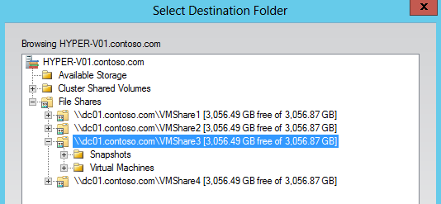

1. Note that the pushpin next to **Browse** in now active indicating that setting is now pinned to prevent Placement from changing the value.

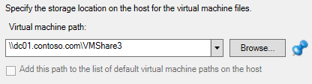

1. On the **Configure Settings** page, click **Network** **Adapter** **0** under **Networking** and in the **Network Adapter 0** detail pane, type **192.168.6.25** in the **IP Address** field for the **DEV IP POOL**.

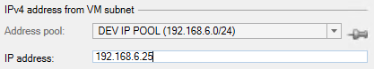

1. On the **Configure Settings** page, click **Virtual Hard Disk** under **Machine Resources** to review the placement details for the virtual hard disk. Ensure the Destination path reads: **\\dc01.contoso.com\VMShare3\** and then click **Next**.

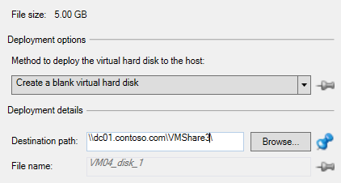

1. If a configuration error appears, click **OK** to ignore, and proceed.

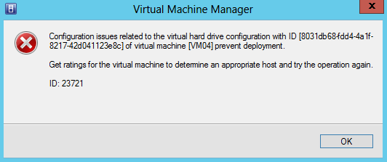

1. On the **Add Properties** page, leave the default setting and click **Next**.

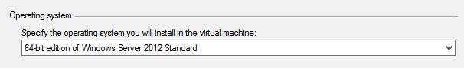

1. On the **Summary** page, review the settings. They should match those in the screenshot below.

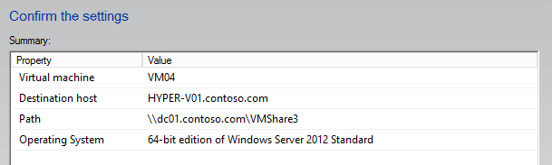

1. Ensure that **Start the virtual machine after deploying it** is not selected, andclick **View Script**.



1. **Notepad** will open displaying the PowerShell script that will be used to execute these actions. System Center 2012 Virtual Machine Manager is built on PowerShell so this feature is available at the end of VMM wizards. This makes it easier to learn PowerShell, and these scripts can be saved and updated when automating repetitive tasks. Click on this button throughout this lab to see the output from other wizards.

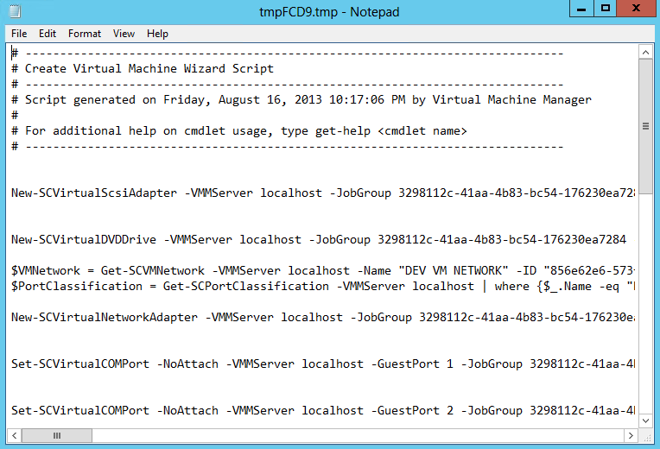

1. Close **Notepad**. Click **Create**.
2. On the **Jobs** page, click the **Create virtual machine** job that is running and review the job details at the bottom of the page.

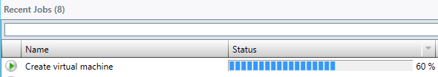

1. When the Job finishes running, close the **Jobs** page.

Exercise 11.2: Create a VM Template

**In this exercise, a template will be created in VMM that can be used to standardize and accelerate deployment of VMs into the environment.**

**Estimated time to complete: 10 minutes**

 *Perform the following on* ***VMM01***

1. Open **VMM01** then open the **Virtual Machine Manager Console**. If the **Connect to Server** window appear, ensure **Use current Microsoft Windows session identity** is selected, and click **Connect**.



1. Select the **Library** workspace.

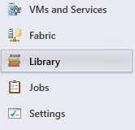

1. Click **Create VM Template** icon the ribbon menu.

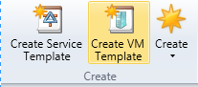

1. On the **Select a Source** page, select the **Use an existing VM template or a virtual hard disk stored in the library** radio button and click **Browse**.

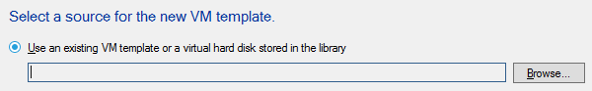

1. In the **Select VM Template Source** dialog, select **WS2012SYSPREP.vhdx** and click **OK**. Do not select any of the other VHDX files.

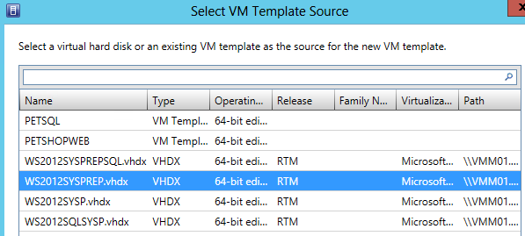

1. On the **Select a Source** page, click **Next**.

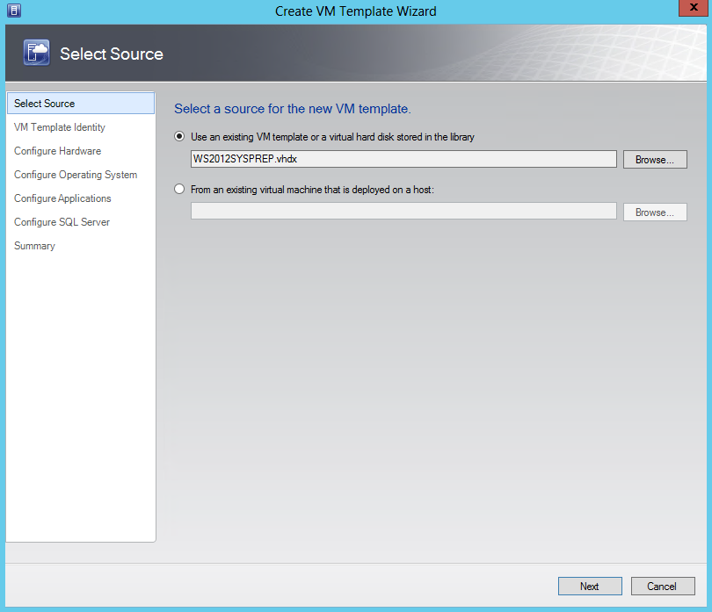

1. On the **VM Template Identity** page, type **VM Template** and click **Next**.



1. On the **Configure Hardware** page, in the **Compatibility** detail pane, select **Cloud Capability Profile,** and then select **Hyper-V**.

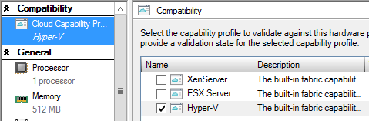

1. On the **Configure Hardware** page, under the **General** workspace, click **Memory** and in the **Memory** detail pane, select the **Dynamic** radio button and type **128** in the **Startup memory** field, type **64** in the **Minimum memory** field, and **192** in the **Maximum memory** field.

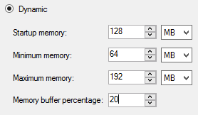

1. On the **Configure Hardware** page scroll down to the **Bus Configuration** workspace and click **WS2012SYSPREP.vhdx**.

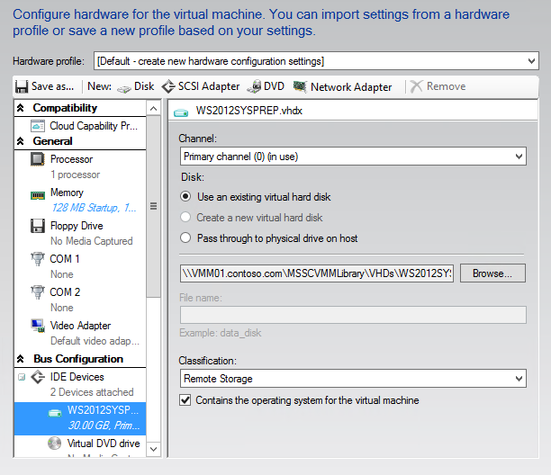

1. In the **WS2012SYSP.vhdx** details pane, select **Remote** **Storage** from the **Classification** drop-down menu.

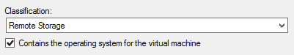

1. On the **Configure Hardware** page, scroll down in the navigation pane and select **Network Adapter** 1 under **Network** Adapters.

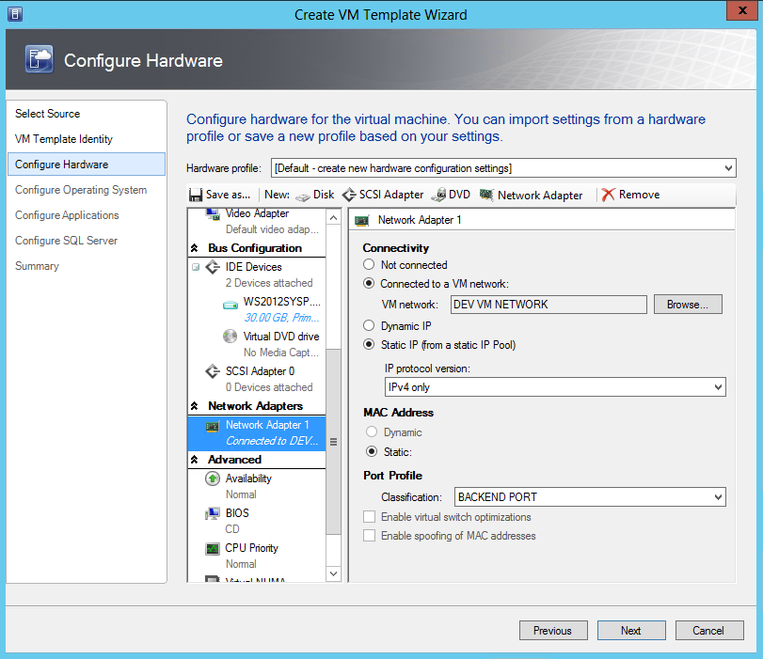

1. In the **Network Adapter 1** details pane, Under **Connectivity**, select the **Connect to a VM network** radio button, and click **Browse**.

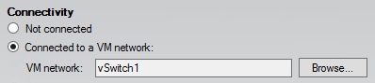

1. In the **Select a VM Network** dialog select **DEV VM NETWORK**. Click **OK**.



1. Still under **Connectivity,** select **Static IP (from a static IP Pool)** and ensure **IPv4 only** is selected for the **IP protocol version**.

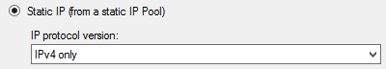

1. Under **Port Profile**, select the **BACKEND PORT** from the **Classification** drop-down menu.

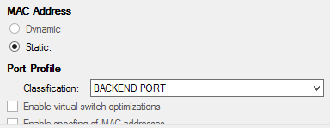

1. On the **Configure Hardware** page, select **Availability** under **Advanced** inthenavigationpane. In the **Availability** detail pane, select the **Make this virtual machine highly available** check box.

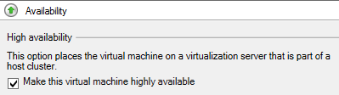

1. On the **Configure Hardware** page, click **Save as**.

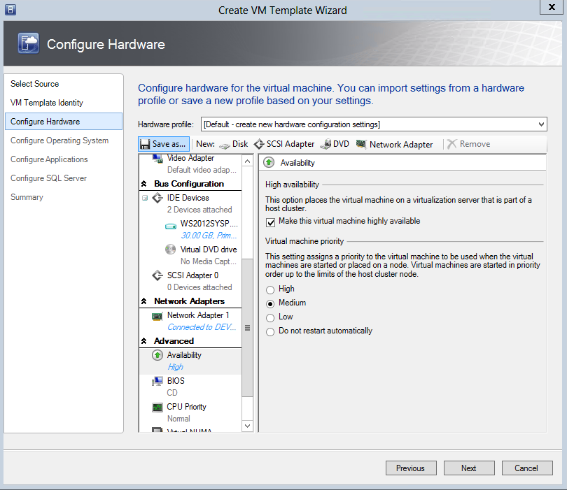

1. In the **New Hardware Profile** dialog, type **Lab Hardware Profile** in the **Name** field.

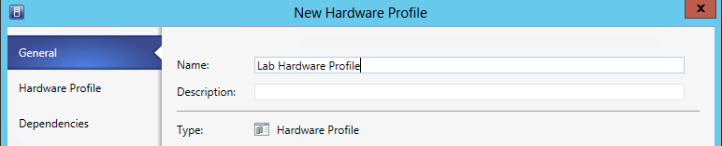

1. Click the **Hardware** **Profile** tab. Review the settings and click **OK.**

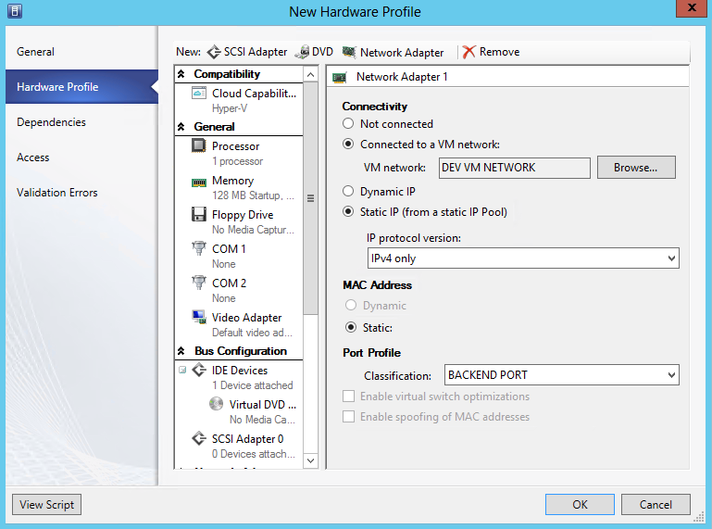

1. On the **Configure Hardware** page, click the **Hardware Profile** drop-down menu and note **Lab Hardware Profile** is now available.

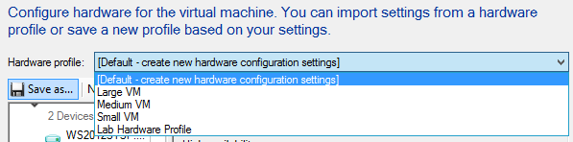

1. On the **Configure Hardware** page, click **Next**.

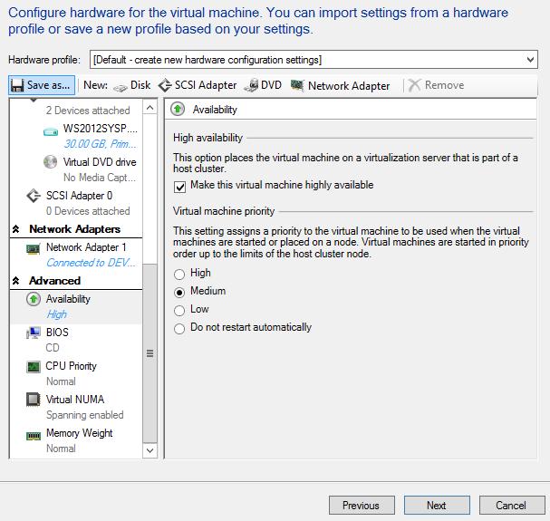

1. On the **Configure** **Operating** **System** page, select **Identity Information** workspace under **General Settings**, type **DEVVM##** in the **Computer name** field. This will increment the number in the name of the VM, such as DEVVM01, DEVVM02, etc.

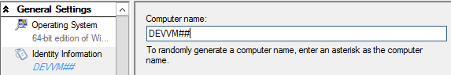

1. Select the **Admin Password** workspace, click the **Select a Run As account for the local administrator account** radio button and click **Browse**.

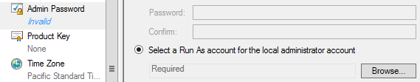

1. In the **Select a Run As account** dialog, select **VMM Admin** and then click **OK.**

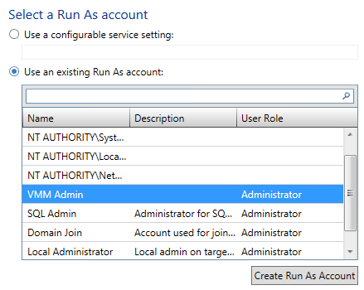

1. 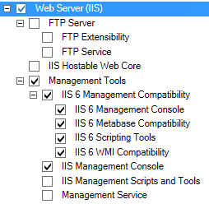Select the **Roles** workspace under **Roles and Features**. Inthe **Roles** details pane, scroll down to **Web Server (IIS)** and select the following:
   1. **Web Server (IIS)**
   2. **Management Tools**
   3. **IIS 6 Management Console**
   4. **IIS 6 Metabase Compatibility**
   5. **IIS 6 Scripting Tools**
   6. **IIS 6 WMI Compatibility**
   7. **IIS Management Console**
2. In the **Roles** detail pane, scroll down to **Web Server** and select the following:
   1. 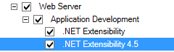**Web Server**
   2. **Application Development**
   3. **.NET Extensibility**
   4. **.NET Extensibility 4.5**
3. Select the **Features** workspace under **Roles and Features**. Inthe **Feature** details pane, select the following:
   1.** 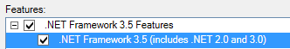.NET Framework 3.5 Features**
   2. **.NET Framework 3.5 (includes .NET 2.0 and 3.0)**
4. Select the **Domain** **/** **Workgroup** workspace under **Networking**, select the **Domain** radio button and type **contoso.com** in the **Domain** field.

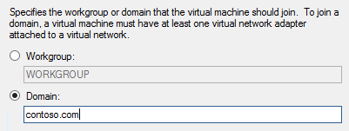

1. Select the **Select the Run As account to use for joining the domain** radio button and click **Browse**.

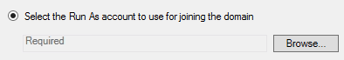

1. In the **Select a Run As account** dialog, select **Domain Join** and click **OK.**

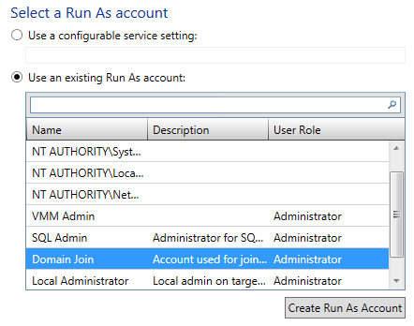

1. Select the **Answer File** workspace under **Scripts**, review the options in the details pane, and then click **Next**.

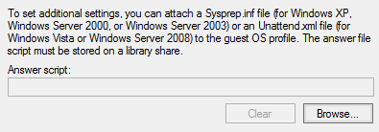

1. On the **Configure** **Applications** page, leave the default settings and click **Next**.

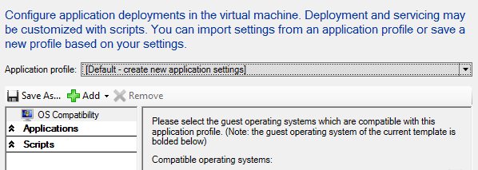

1. On the **Configure** **SQL Server** page, leave the default settings and click **Next**.

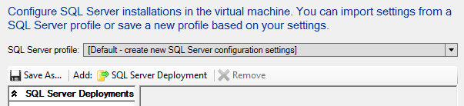

1. On the Summary page, review the settings and click **Create.**

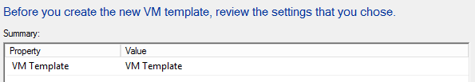

1. **Review** the completed jobs on the **Jobs** screen, and then close the window.

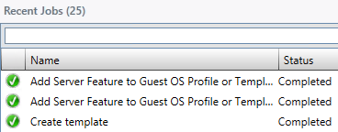

Exercise 11.3: Explore a SQL Server Profile

**In this exercise, a pre-created SQL Server Profile will be reviewed. SQL Server profiles provide instructions for customizing an instance of SQL Server for a SQL Server Data Application Tier (DAC) when deploying a virtual machine as part of a service. A service is a collection of virtual machines that may represent a multi-tiered enterprise application.**

**Estimated time to complete: 5 minutes**

 *Perform the following on* ***VMM01***

1. Open **VMM01** then open the **Virtual Machine Manager Console**. If the **Connect to Server** window appear, ensure **Use current Microsoft Windows session identity** is selected, and click **Connect**.



1. Select the **Library** workspace.



1. From the left hand navigation, expand and select **Templates.**

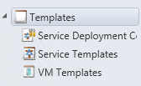

1. Click **PETSQL** in the details pane and click **Properties** from the ribbon menu.

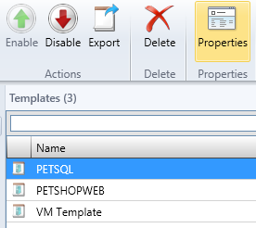

1. On the **PETSQL** **Properties** page, select the **SQL** **Server** **Configuration** workspace.

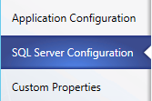

1. On the **SQL Server configuration** page, next to **SQL Server profile,** use the drop down list to select a pre-configured **SQL Profile.**

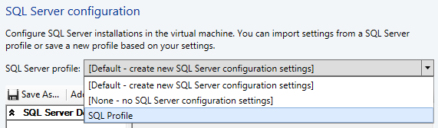

1. In the **PETSQL** **Properties** dialog, select the **SQL Server Deploy…** and review the settings in the details pane.

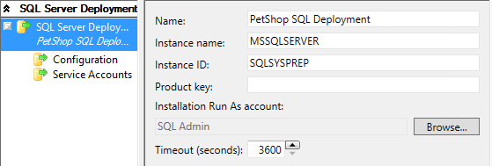

1. In the **PETSQL** **Properties** dialog, select the **Configuration** workspace and review the settings in the details pane. The **Media Source** is a path within the VHD(X) file attached to this template, where the SQL media files are stored. The accounts will be created as SQL Server administrators.

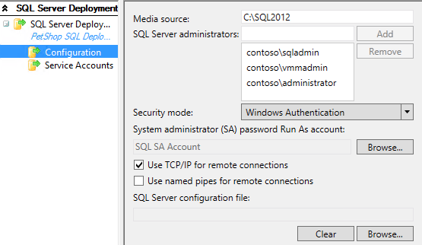

1. In the **PETSQL** **Properties** dialog, select the **Service Accounts** workspace and review the settings in the details pane.

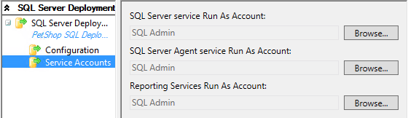

1. In the **PETSQL** **Properties** dialog, select **Application Configuration**.

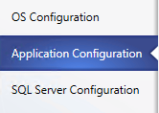

1. Select the **SQL Server Data** workspace and review the settings in the details pane. First, click on **SQL Server Data…** directly under **OS Compatibility**. These settings include DAC packages which contain the database schema and some server-level objects required in order to support the database, like logins. The DAC does not include the data inside a database. This **Application Configuration** is pointing at a number of DACs residing in the VMM’s library.
   * **Note:** If the Application Configuration does not display identical data as data below, simply click OK to close the PETSQL Properties window, and reopen. This will refresh the view.

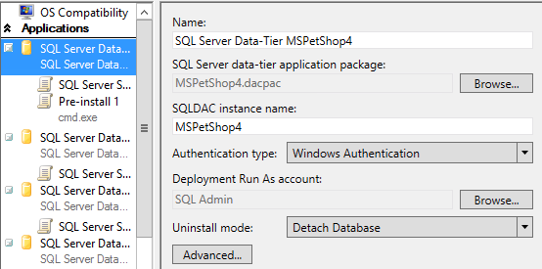

1. Directly below **SQL Server Data…** select **SQL Server Scripts** and review the two scripts that will be run along with this DAC, along with their **deployment order**. VMM will automate this.

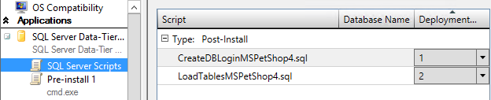

1. In the **SQL Server Scripts** workspace, Select **CreateDBLogin** in the details pane and click **Edit**.

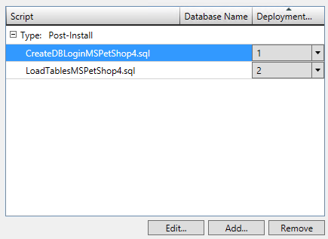

1. In the **SQL** **Server** **Scripts** **Properties** dialog, review the settings then close the properties dialog and then click **OK.**

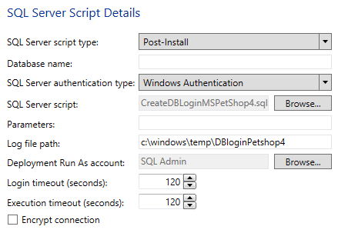

1. Select the **Pre-install 1** workspace and review the settings in the details pane. In this case, a pre-installation action is run which launches cmd.exe, passes it parameters, and then another script file is called.

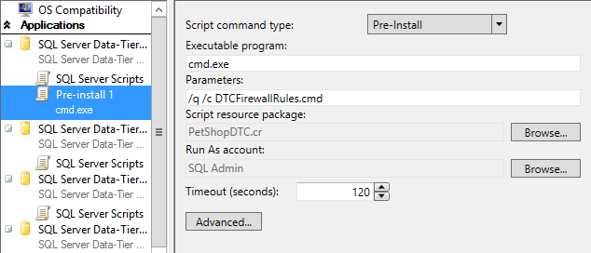

1. On the **PETSQL** **Properties** page, click **OK**.

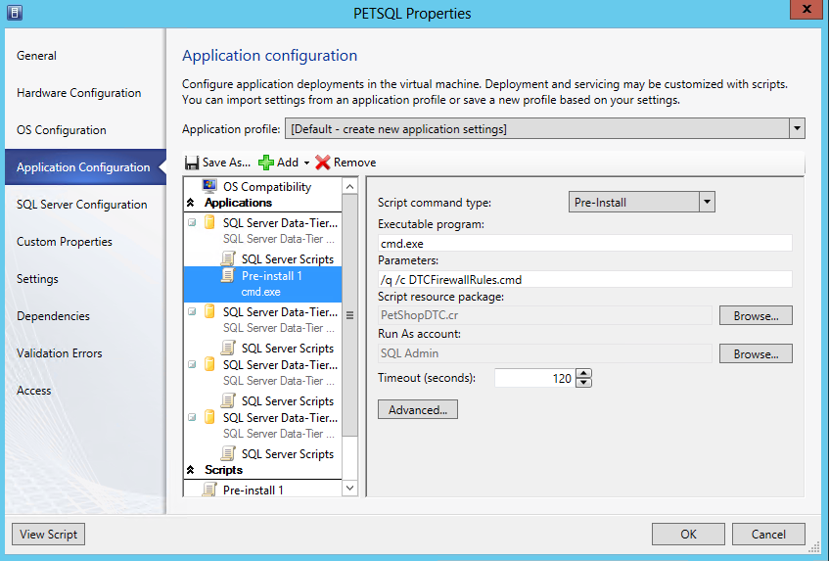

Exercise 11.4: Explore a Web Application Profile

**In this exercise, an Application Profile for a web server will be reviewed. This enables IT admins and developers to deploy new web servers, along with pre-defined web sites, rapidly, and in a standardized manner.**

**Estimated time to complete: 3 minutes**

 *Perform the following on* ***VMM01***

1. Open **VMM01** then open the **Virtual Machine Manager Console**. If the **Connect to Server** window appear, ensure **Use current Microsoft Windows session identity** is selected, and click **Connect**.



1. Select the **Library** workspace.



1. From the left hand navigation, expand and select **Templates.**



1. Click **PETSHOPWEB** in the details pane and click **Properties** from the ribbon menu.

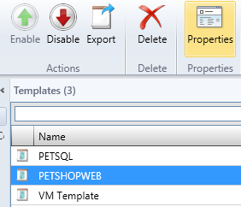

1. Under **Application Configuration,** select **Web Application**. Review the details pane. The Web Application is contained within a Web Deploy package. Web Deploy (msdeploy) simplifies deployment of Web applications and Web sites to IIS servers. Administrators can use Web Deploy to synchronize IIS servers or to migrate to newer versions of IIS. Web Deploy Tool also enables administrators and delegated users to use IIS Manager to deploy ASP.NET and PHP applications to an IIS server.
   * **Note:** If the Application Configuration does not display identical data as data below, simply click OK to close the PETSQL Properties window, and reopen. This will refresh the view.

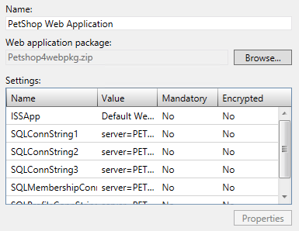

1. Under **Scripts,** click **Pre-install 1** and review the details. Part of the pre-install process VMM is going to run cmd.exe and deploy the Web Deploy capability inside the Guest OS, before applying the specific Web Deploy files and settings to transform this Windows Server into a fully functional IIS Server with pre-configured web site(s).

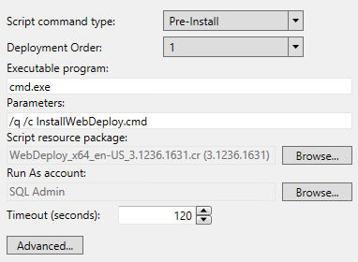

1. Back on the **PETSHOPWEB** **Properties** page, click **OK**.

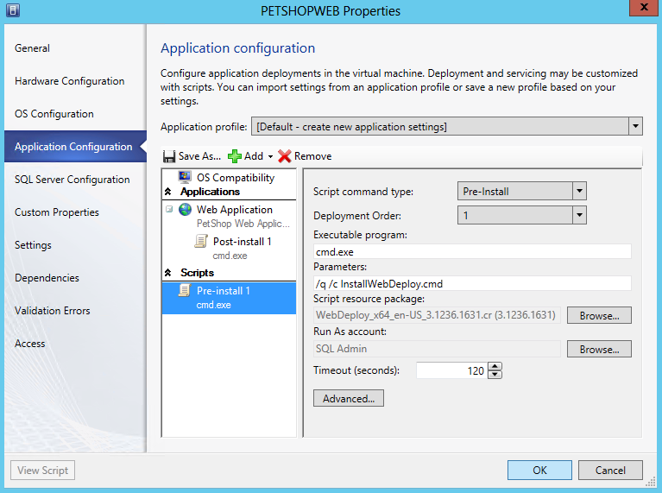

Exercise 11.5: Create a VM from a Template

**In this exercise, a VM will be deployed from the newly created template. This process enables the standardized and accelerated deployment of VMs from a known configuration source.**

**Estimated time to complete: 5 minutes**

 *Perform the following on* ***VMM01***

1. Open **VMM01** then open the **Virtual Machine Manager Console**. If the **Connect to Server** window appear, ensure **Use current Microsoft Windows session identity** is selected, and click **Connect**.



1. Select the **Library** workspace.



1. From the left hand navigation, expand and select **Templates.**
2. 
3. In the details pane, right-click the **VM Template** and click **Create** **Virtual** **Machine**.

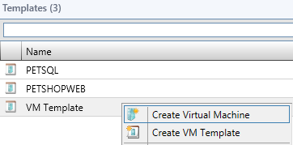

1. On the **Specify** **Virtual** **Machine** **Identity** page, Type **VM05** and click **Next**.



1. On the **Configure** **Hardware** page, review setting and click **Next**.

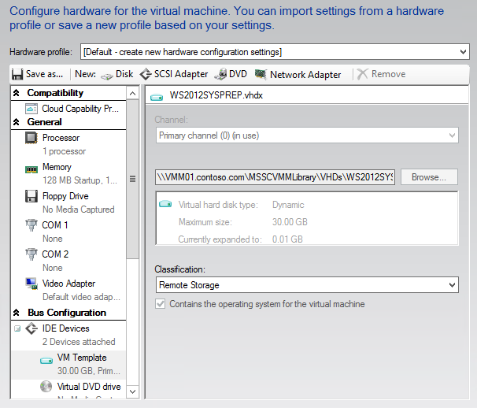

1. On the **Configure** **Operating System** page, review settings and click **Next**.

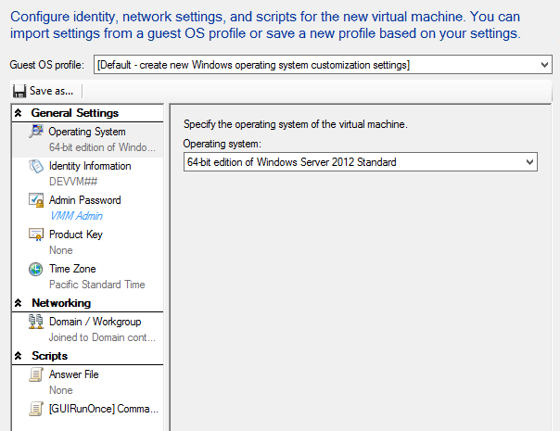

1. On the **Select Destination** page, review settings and click **Next**.

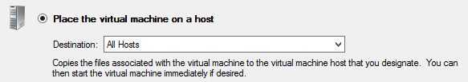

1. On the **Select** **Host** page, select **HYPER-V01** and click **Next**.

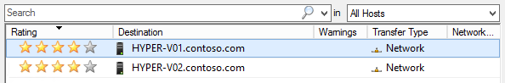

1. On the **Configure Settings** page, click **Virtual Machine Location** and for the **virtual machine path**, click **Browse**.

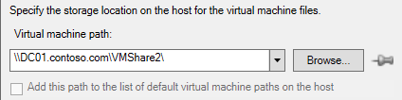

1. In the **Select a Destination Folder** dialog, expand **File Shares** and select **\\DC01.contoso.com\VMShare3** and click **OK**.

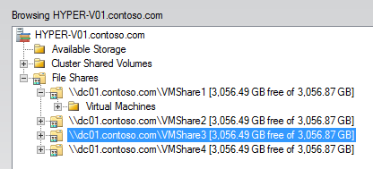

1. Note that the pushpin next to **Browse** in now active indicating that setting is now pinned to prevent Placement from changing the value.

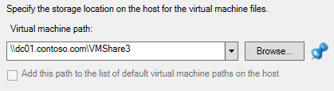

1. On the **Configure Settings** page, select the **Network** **Adapter** **0** tab under **Networking**, and review the settings.

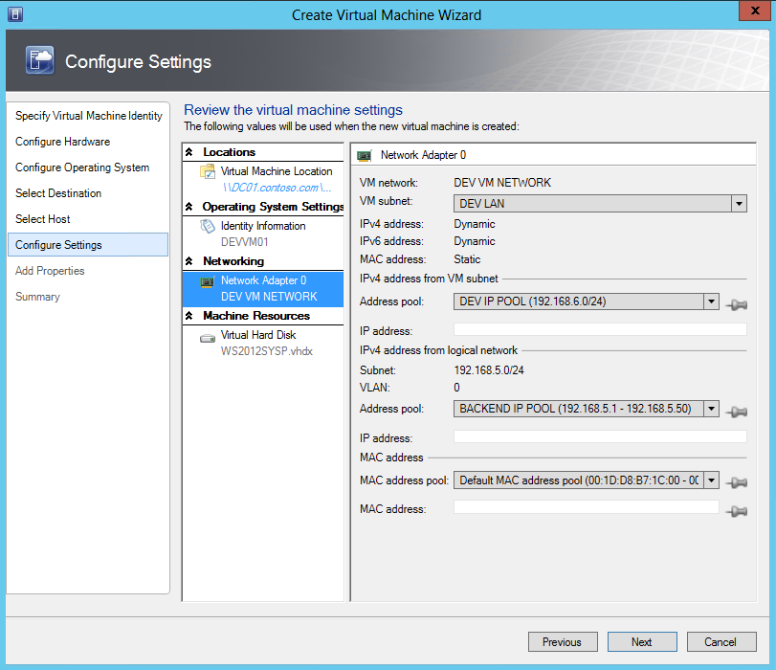

1. Under **Machine Resources**, click **Virtual** **Hard** **Disk** and under **Destination Path**, click **Browse**.

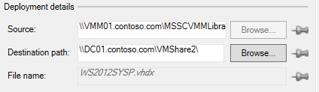

1. In the **Select a Destination Folder** dialog, expand **File Shares** and select **\\DC01.contoso.com\VMShare3** and click **OK**.



1. On the **Configure Settings** page, click **Next**.

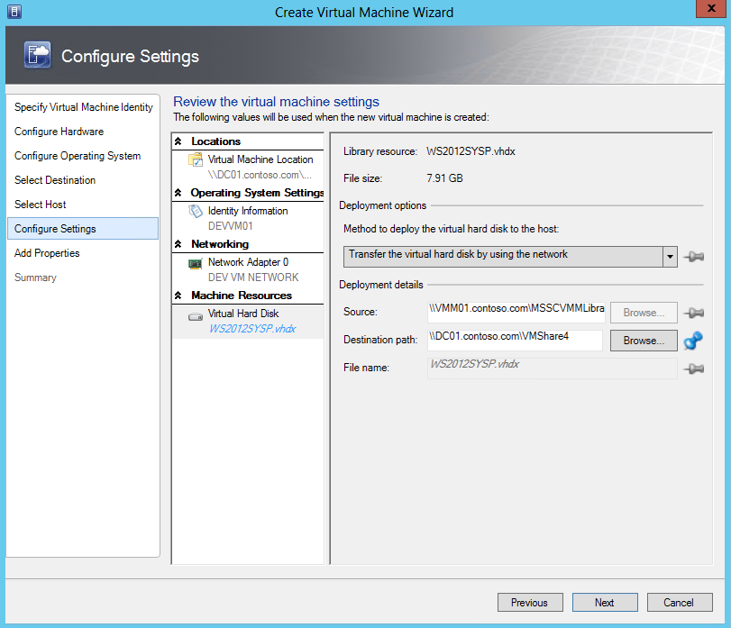

1. If a configuration error appears, click **OK** to ignore, and proceed.



1. On the **Add Properties** page, leave the default settings for PRO and click **Next**.

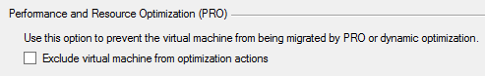

1. On the **Summary** page, review the settings, and then click **Create**.
   * Note: The deployment will fail, and this is expected in this virtualized lab environment. This lab is built using virtual machines. It is not possible to run VMs within Hyper-V VMs (“nested virtualization”). A user can create and configure VMs, but cannot start the VM.

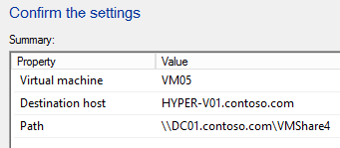

------------------------------------------------------------END OF LAB 11------------------------------------------------------------

**Lab 12: Create Service Templates with VMM**

Exercise 12.1: Create a Service Template

1. **In this exercise, a Service Template will be created. In VMM a service is a collection of virtual machines that may represent a multi-tiered enterprise application. These virtual machines are configured and deployed together, and then they are managed as a single entity. For example, a multi-tier line-of-business application could consist of a database backend, an application tier, and a web frontend. Each of these tiers can also be scaled out to meet demand.**
2. **Estimated time to complete: 10 minutes**

 *Perform the following on* ***VMM01***

1. Open **VMM01** then open the **Virtual Machine Manager Console**. If the **Connect to Server** window appear, ensure **Use current Microsoft Windows session identity** is selected, and click **Connect**.



1. Select the **Library** workspace.



1. Expand **Library Servers,** right-click **VMM01.contoso.com** and click **Properties.**

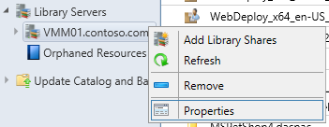

1. In the **VMM01.contoso.com Properties** window, under **Host Group** select **PRODUCTION** from the drop down list**.** Select **all** of the **VM Networks** and select the box for **Allow unencrypted transfers,** then click **Browse.**

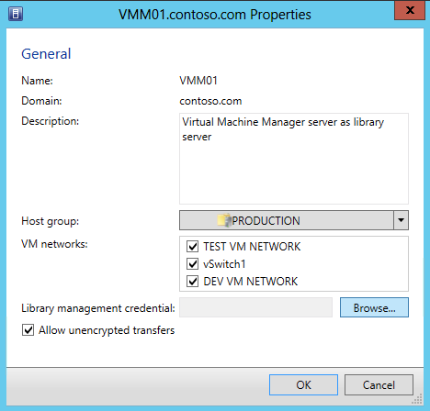

1. In the **Select a Run As Account** window**,** select **VMM Admin** and click **OK**.

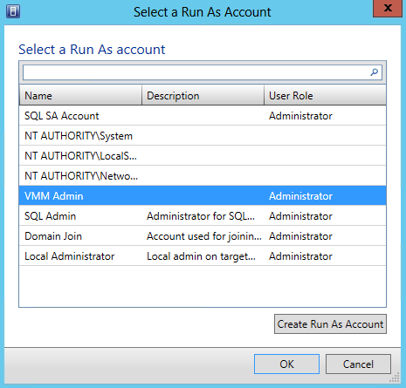

1. After returning to the **VMM01.contoso.com Properties** window, click **OK**.

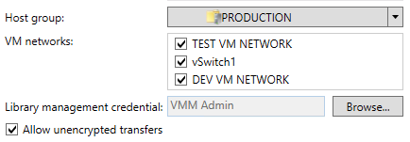

1. In the **Library** workspace, select **Templates** and click **Create** **Service Templates** on the ribbon menu.

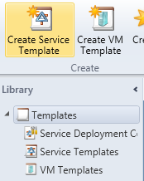

1. In the **New Service Template** dialog, type **PetShop** in the **Name** field and **1.0** in the **Release** field. Select **Two Tier Application (v1.0)** and click **OK**.

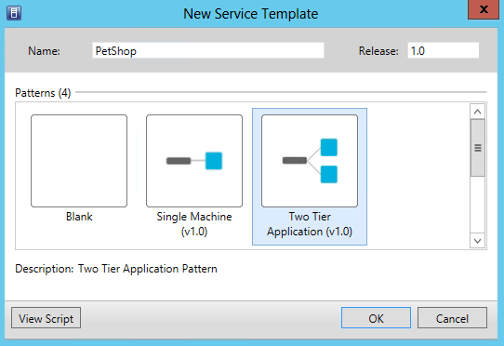

1. Maximize the **Service Template Designer**, then, from the **VM Templates** pane on the left hand navigation, click and drag **PETSHOPWEB** to the **First Tier** box.

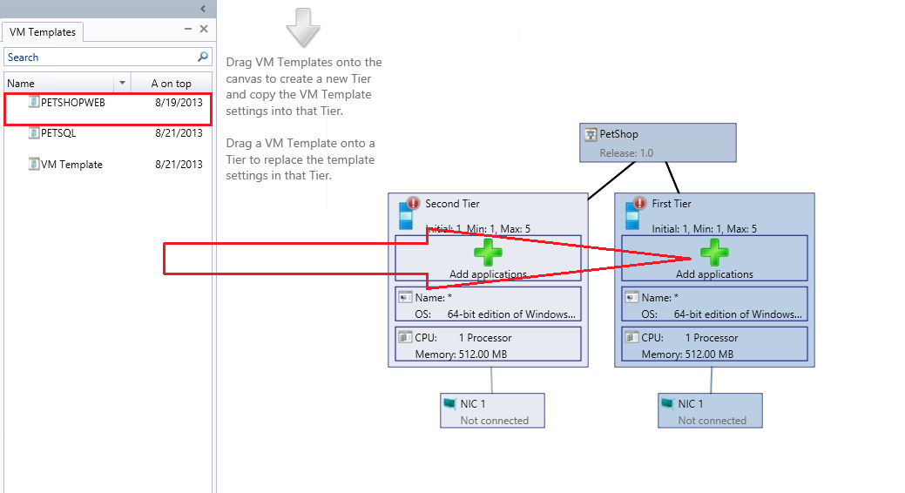

1. From the **VM Templates** pane, click and drag **PETSQL** to the **Second Tier** box.

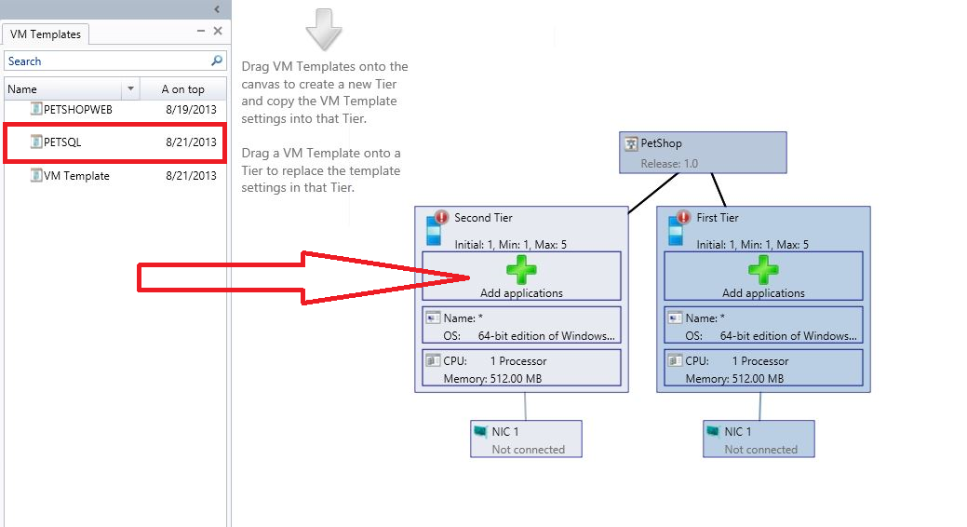

1. In the top left of the navigation ribbon, click **Save and Validate**.

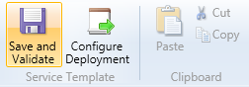

1. Notice that there is an Alert present in **PETSHOPWEB - Machine Tier 1**. Click on **PETSHOPWEB** in the main Service Template Designer, and **review the alert details** at the bottom of the window.



1. Double-click **PETSHOPWEB – Machine Tier 1** to open the Properties.

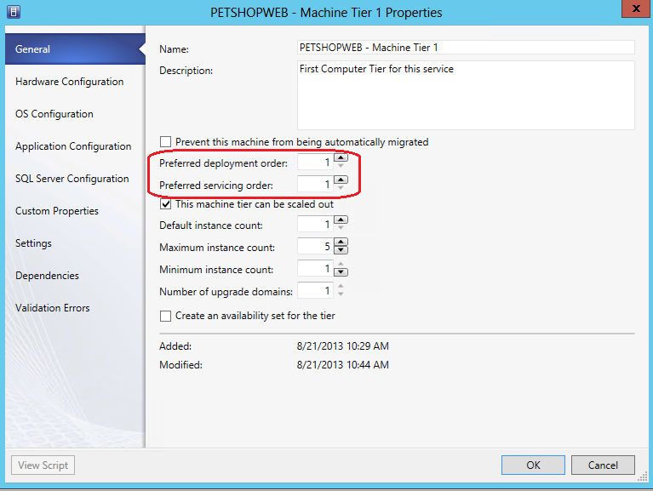

1. Review theinformation on the **General** page. Notice that this tier can be scaled out, and currently has a default instance (number of VMs) count of 1, and a maximum that it can scale to, of 5. These are configurable by the administrator. Admins can also define the order in which this tier is deployed in relation to other tiers, and in which order the tiers are serviced. Set the **preferred deployment order** to **2,** and the **preferred servicing order** to **2.**

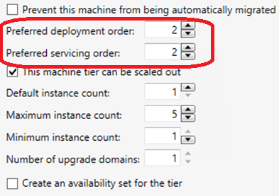

1. Still in the **PETSHOPWEB – Machine Tier 1 Properties**, click on **Hardware Configuration.**

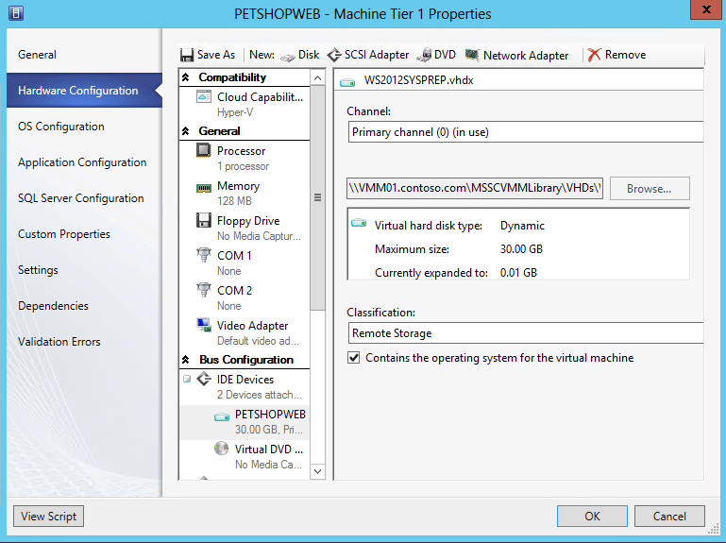

1. Scroll down to **Network Adaptor**. In the **Network Adaptor 1** details pane, under **Connectivity**, select **Connected to a VM network**, click **Browse** and select **DEV VM NETWORK**.

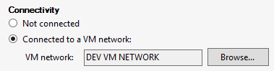

1. Under **Port Profile**, for **Classification**, use the drop down list to select **BACKEND PORT**, and then click **OK**.

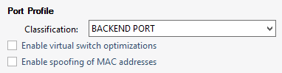

1. In the top left of the navigation ribbon, click **Save and Validate**. Notice that the warning alert for **PETSHOPWEB – Machine Tier 1** disappears.



1. Click on **PETSQL – Machine Tier 1** in the main Service Template Designer, and **review the alert details** at the bottom of the window.



1. Double-click **PETSQL – Machine Tier 1 Properties** page, uncheck the **This machine tier can be scaled out** check box.

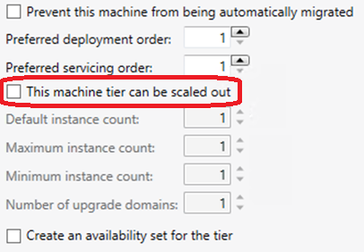

1. Still in the **PETSQL – Machine Tier 1 Properties**, click on **Hardware Configuration.**

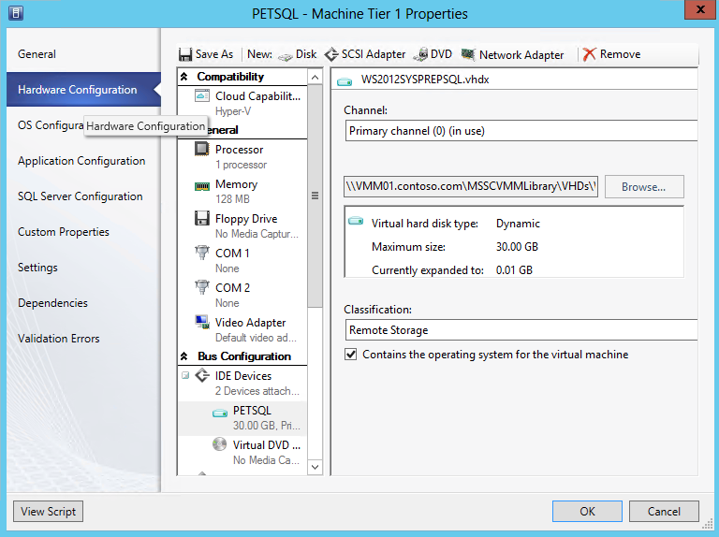

1. Scroll down to **Network Adaptor**. In the **Network Adaptor 1** details pane, under **Connectivity**, select **Connected to a VM network**, click **Browse** and select **DEV VM NETWORK**.



1. Under **Port Profile**, for **Classification**, use the drop down list to select **BACKEND PORT**, and then click **OK**.



1. In the top left of the navigation ribbon, click **Save and Validate**. Notice that the warning alert for **PETSQL – Machine Tier 1** disappears, and then close the **Service Template Designer.**



1. Back in the **Templates Detail** pane, select **PetShop** and on the ribbon navigation, click **Publish.**

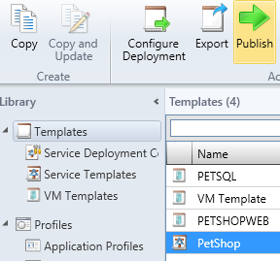

Exercise 12.2: Deploy a Service Template

**In this exercise, a service will be deploying from a Service Template. Note that the deployment will fail, and this is expected in this virtualized lab environment. This lab is built using virtual machines and it is not possible to run VMs within Hyper-V VMs (“nested virtualization”). A user can create and configure VMs, but they cannot start them.**

**Estimated time to complete: 5 minutes**

 *Perform the following on* ***VMM01***

1. Open **VMM01** then open the **Virtual Machine Manager Console**. If the **Connect to Server** window appear, ensure **Use current Microsoft Windows session identity** is selected, and click **Connect**.



1. Select the **Library** workspace.



1. In the **Library** workspace, select **Templates**. Click on **PetShop** from the main **Templates Details** pane, and then click on **Configure Deployment** from the navigation ribbon.

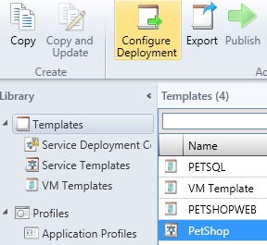

1. Type **PetShop 1.0** in the **Name** field, select **PRODUCTION** from the **Destination** drop-down menu and click **OK**.

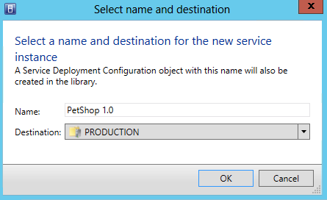

1. The **Deploy Service –PetShop 1.0** window will open. **Maximize** this window, then click **Refresh** **Preview** in the top left of the navigation ribbon.

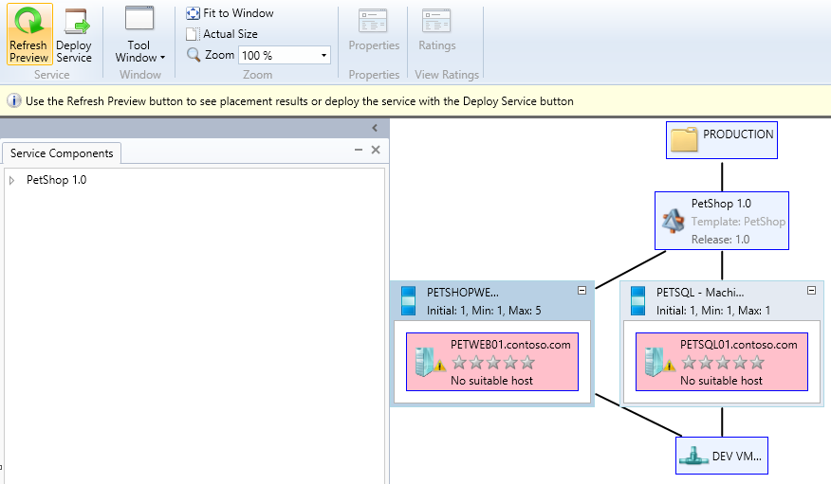

1. The **Placing Service** dialog box will appear. Once complete, the service should have suitable host(s) defined.

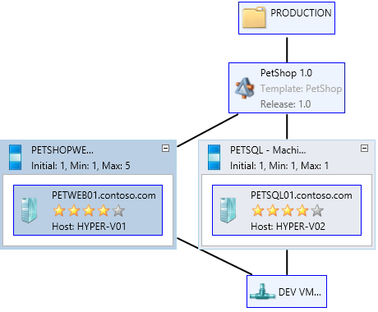

1. Click **Deploy Service** on the ribbon menu. In the **Deploy service** dialog, click **Deploy**.
   * Note: The deployment will fail, and this is expected in this virtualized lab environment. This lab is built using virtual machines. It is not possible to run VMs within Hyper-V VMs (“nested virtualization”). A user can create and configure VMs, but cannot start the VM.

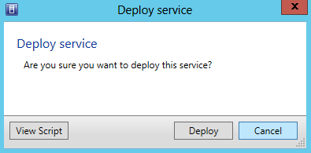

1. The **jobs** window may appear. Review the executing job then close the **Jobs** window.
2. Select the **VMs and Services** workspace.



1. Select **All Hosts** from the left hand navigation, and ensure that **VMs** is selected in the navigation. There will be a list of newly created VMs, but they will fail during creation. This failure is expected due to limitation of the virtualized lab environment.

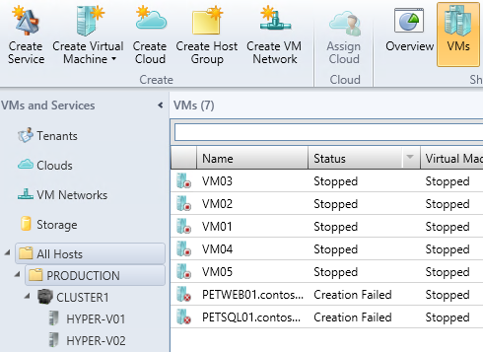

------------------------------------------------------------END OF LAB 12------------------------------------------------------------

**Lab 13: Create Roles & Clouds with VMM**

Exercise 13.1: Create User Roles

* 1. **In this exercise, a new Self-Service User Role for a member of the Development team will be created. This account will have certain permissions and capabilities delegated to it.**
  2. **Estimated time to complete: 4 minutes**

 *Perform the following on* ***VMM01***

1. Open **VMM01** then open the **Virtual Machine Manager Console**. If the **Connect to Server** window appear, ensure **Use current Microsoft Windows session identity** is selected, and click **Connect**.



1. Select the **Settings** workspace.

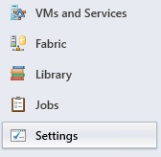

1. Expand **Security** and click **User Roles**. In the ribbon, click **Create User Role**.

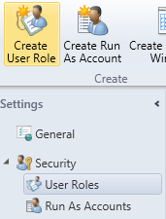

1. In **Name** box, type **Dev User** and click **Next**.

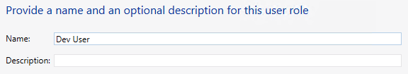

1. On the **Profile** page, ensure **Application Administrator (Self-Service User)** is selected, and click **Next**.

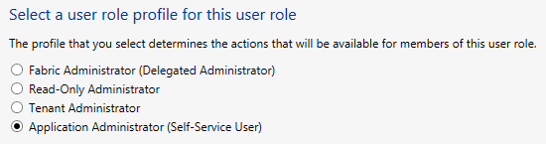

1. On the **Members** page, click **Add** and type in **devuser**, click **Check Names** then click **OK**. This should resolve to **CONTOSO\devuser**.

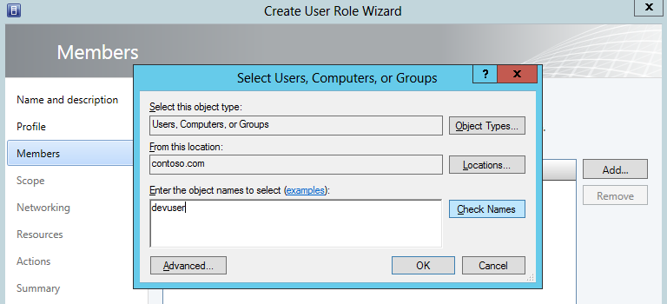

1. Back on the **Members** page**, CONTOSO\devuser** should belisted**.** Click **Next**.

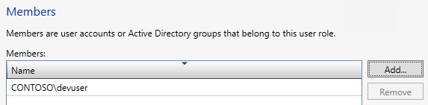

1. On the **Scope** page, note that there are currently no clouds, and then click **Next**.

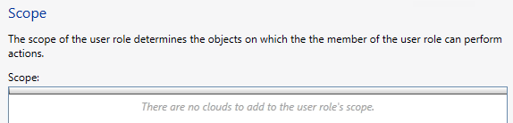

1. On the **Networking** page click **Add**. Select the **DEV VM NETWORK** from the list and click **OK**.

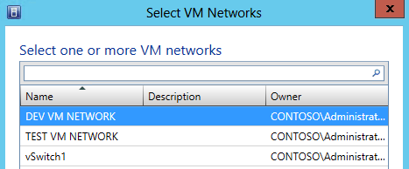

1. Back on the **Networking** page**,** the **DEV VM NETWORK** should be listed, then click **Next.**

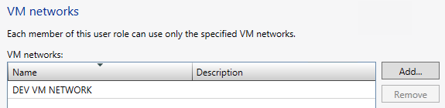

1. On the Resources page, click **Add** and select **PetShop** from the list, then click **OK.**

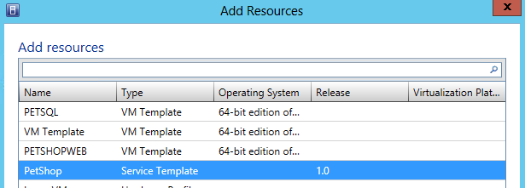

1. Back on the **Resources** page,ensure that **PetShop** is displayed, thenclick **Next**.

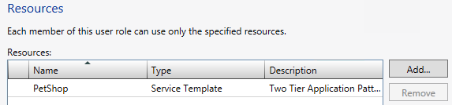

1. On the Actions page, select **Deploy (From template only**), **Local Administrator**, **Pause and resume**, **Remote connection**, **Shut down, Start a**nd **Stop**, then click **Next.**

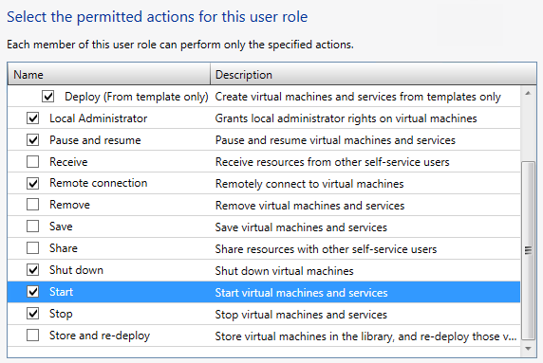

1. On the **Run As accounts** page, click **Add**, select **VMM Admin** from the list, and click **OK**.

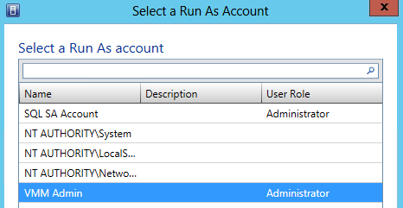

1. Back on the **Run As Accounts** page, confirm **VMM Admin** is listed, then Click **Next**.

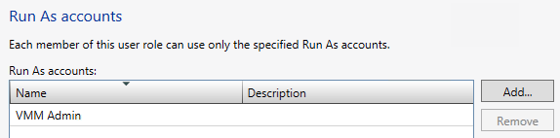

1. On the **Summary** screen,ensure the settings match those in the screenshot below, and thenclick **Finish**.

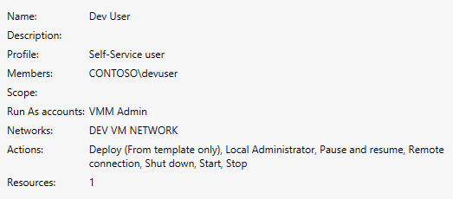

1. **Review** the completed jobs on the **Jobs** screen, and then close the **Jobs** screen.

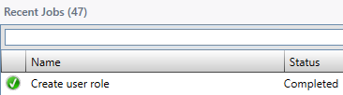

Exercise 13.2: Create a Cloud

* 1. **In this exercise, a Cloud will be created. In VMM the private cloud is deployed using an organization’s own hardware to leverage the advantages of the private cloud model. Through VMM, an organization can manage the private cloud definition, access to the private cloud and the underlying physical resources, including self-service, resource pooling, opacity, elasticity and optimization.**

**Estimated time to complete: 5 minutes**

 *Perform the following on* ***VMM01***

1. Open **VMM01** then open the **Virtual Machine Manager Console**. If the **Connect to Server** window appear, ensure **Use current Microsoft Windows session identity** is selected, and click **Connect**.



1. Select the **VMs and Services** workspace.



1. In the ribbon navigation, click **Create Cloud**.

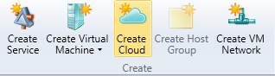

1. In the **General** page in the **Name** space type **Dev Cloud** and click **Next**.

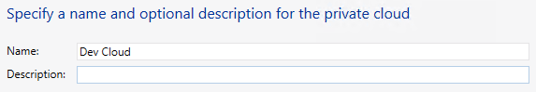

1. On the **Resources** page, check mark **Production** and click **Next**.

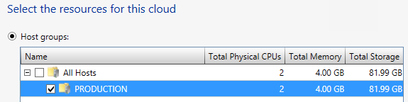

1. On the **Logical Networks** page, check mark **BACKEND** and click **Next**.

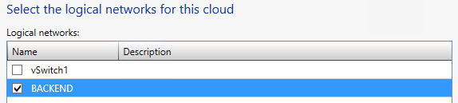

1. On the **Load Balancers** page, leave the default and click **Next**.

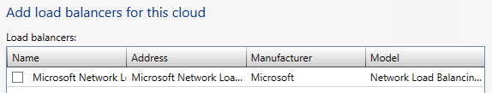

1. On the **VIP Templates** page, click **Next**.

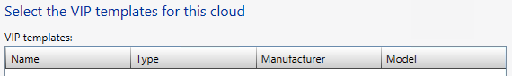

1. On the **Port Classifications** page, check mark **BACKEND PORT** and click **Next**.

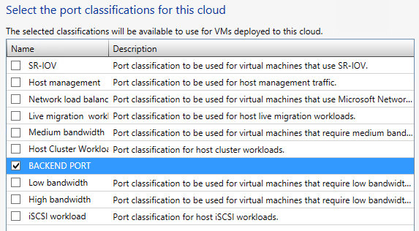

1. On the **Storage** page, check mark **Gold Tier** and click **Next**.

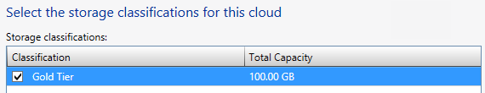

1. On the **Library** page, leave all defaults, and click **Next**.

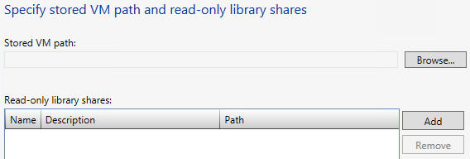

1. On the **Capacity** page, **uncheck** all the **Use Maximum** checkboxes, enter the following values, then click **Next**.

* **Change** the Assigned Capacity for **Virtual CPUs** to 4
* Leave the Assigned Capacity for **Memory** at 1
* **Change** the Assigned Capacity for **Storage** to 100
* Leave the Assigned Capacity for **Custom quota** at 10
* **Change** the Assigned Capacity for **Virtual machines** to 4

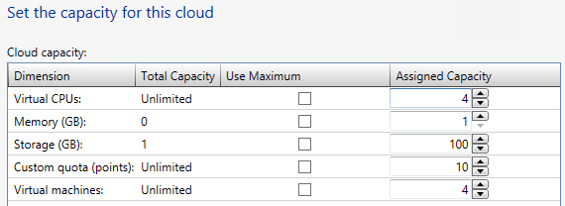

1. On the **Capability Profiles** page, select **Hyper-V** and then click **Next**.

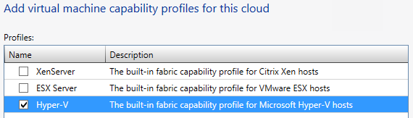

1. On the Summary page, ensure the settings match those in the screenshot below, then click **Finish**.

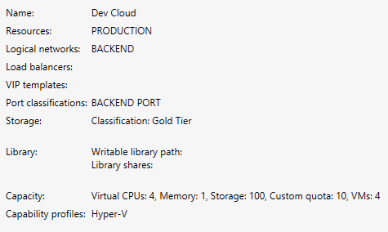

1. **Review** the completed jobs on the **Jobs** screen, and then close the **Jobs** screen.

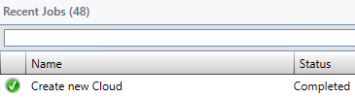

Exercise 13.3: Delegate Access to a Cloud

**In this exercise access privileges will be assigned to the newly created cloud for the Dev User role. The Dev User will then log into VMM and observe the limited management scope that this user role has.**

**Estimated time to complete: 6 minutes**

 *Perform the following on* ***VMM01***

1. Open **VMM01** then open the **Virtual Machine Manager Console**. If the **Connect to Server** window appear, ensure **Use current Microsoft Windows session identity** is selected, and click **Connect**.



1. Select the **VMs and Services** workspace.



1. Expand **Clouds**, right-click **Dev Cloud** and click **Assign Cloud**.

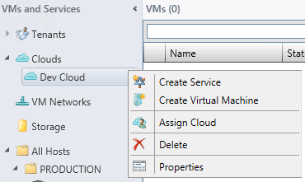

1. In the **Use an existing user role** dropdown, select **Dev Users – Self-Service user** and click **OK**.

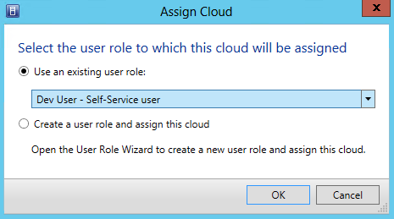

1. The **Dev User Properties** window should open. Click the **Quotas for the Dev Cloud** tab.

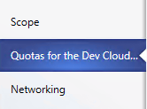

1. In the upper **Role level quotas** section, deselect all of the **Use Maximum** check boxes

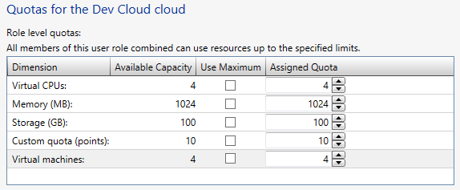

1. In the lower **Member level quotas** section, deselect all of the **Use Maximum** check boxes. Next change the **Virtual CPUs Assigned Quota** to **2**, and **Virtual machines Assigned Quota** to **2**, then click **OK**.

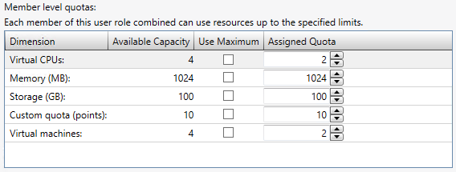

1. In the top left of the **Virtual Machine Manager Console**, click the **File** menu, and click **Open New Connection**

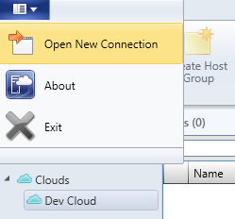

1. In the **Connect to Server** page, select Specify credentials, and enter the following:
   * **User name**: **contoso\devuser**
   * **Password**: **Passw0rd!**

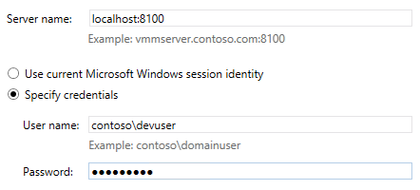

1. There will now be two **Virtual Machine Manager Console** windows open. To identify which is the correct window, look in the top left corner. Ensure that the connection is using **Dev User – VMM01.contoso.com.**

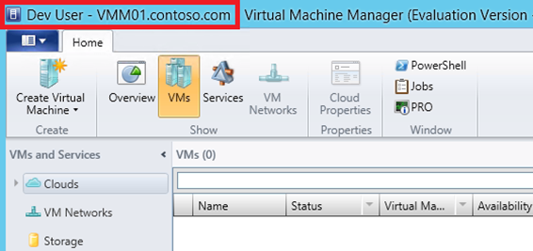

1. Select the **VMs and Services** workspace. Notice that the **Fabric** workspace is missing for this **Dev User**. This is by design, so the user only has to focus on their VMs and applications, but not the underlying infrastructure.

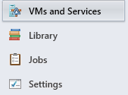

1. Expand **Clouds**, click **Dev Cloud**, and then from the navigation ribbon, click **Overview**.

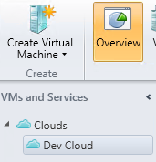

1. On the navigation ribbon, click on **Create Virtual Machine**.

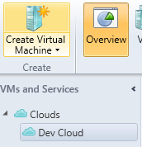

1. On the **Select Source** page, select **Create the new virtual machine with a blank hard disk** and click **Next.**

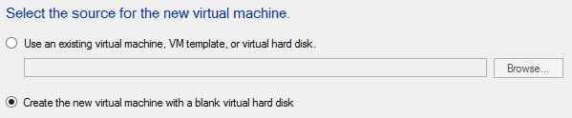

1. For the **Virtual machine name**, enter VM05 and click **Next**.

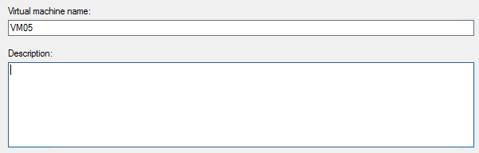

1. On the **Configure Hardware** page, accept the defaults and click **Next**. An error message will appear because Dev User does not have permission to create a new VM unless it comes from a template. Click **OK** to close the error window and click **Cancel** to exit the **Create Virtual Machine Wizard.**

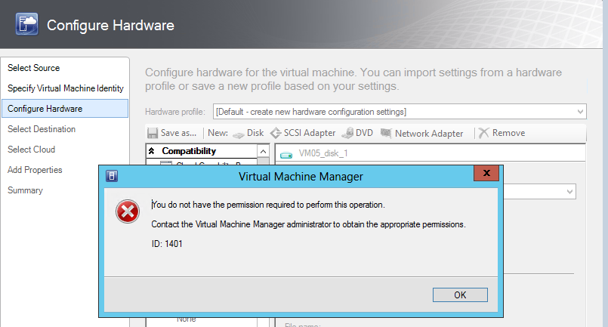

1. Click **Yes** to accept the cancellation.

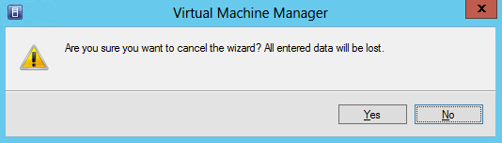

1. From the bottom left navigation, click **Library**.

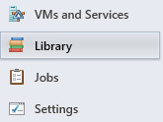

1. From the left navigation, click **Templates**, click **PetShop**, and then on the navigation ribbon, click **Configure Deployment**.

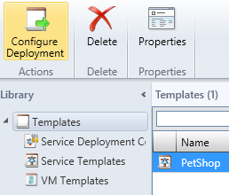

1. Type **DevPetShop** in the **Name** field. Notice, the only destination that can be selected from the drop down list, is **Dev Cloud**. Click **OK**.

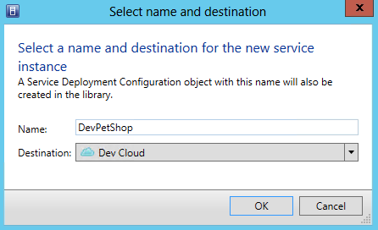

1. The **Deploy Service – DevPetShop** window will open. Maximize this window, then click **Refresh** **Preview** in the top left of the navigation ribbon.

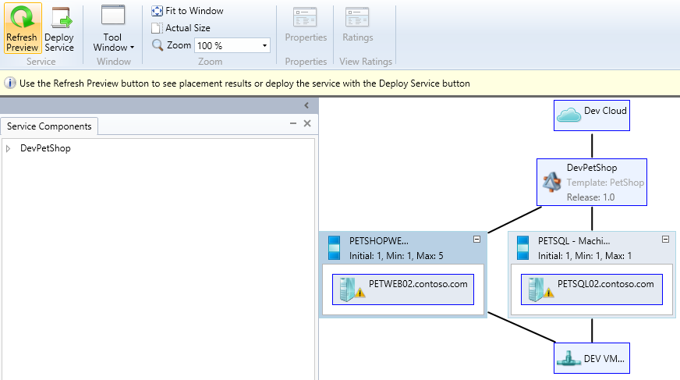

1. The **Placing Service** dialog box will appear. Once complete, the service should have suitable host(s) defined.
2. Click on the **PETSQ02.contoso.com inside the PETSQL – Machine Tier 1**.

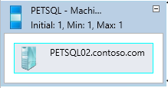

1. On the navigation ribbon, click **Ratings.**

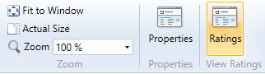

1. Note that placement provides the **Dev Cloud** instead of the specific hosts as it had in previous exercises, so the Dev User is only informed whether the cloud is suitable. Click **OK**.

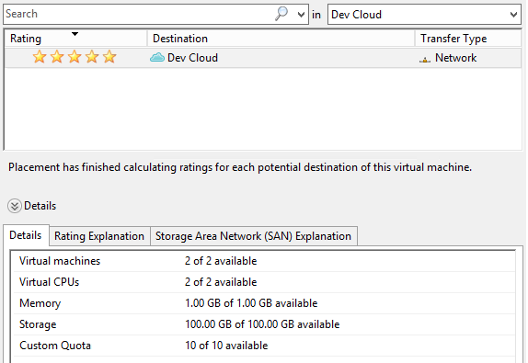

1. Click **Deploy Service** on the ribbon menu. In the **Deploy service** dialog, click **Deploy**.
   * Note: The deployment will fail, and this is expected in this virtualized lab environment. This lab is built using virtual machines. It is not possible to run VMs within Hyper-V VMs (“nested virtualization”). A user can create and configure VMs, but cannot start the VM.



1. Close **Deploy Service – DevPetShop** page, and click **Save** at the **Close window** prompt**.** This will keep the configuration for future use.

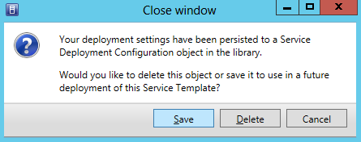

------------------------------------------------------------END OF ALL LABS------------------------------------------------------------